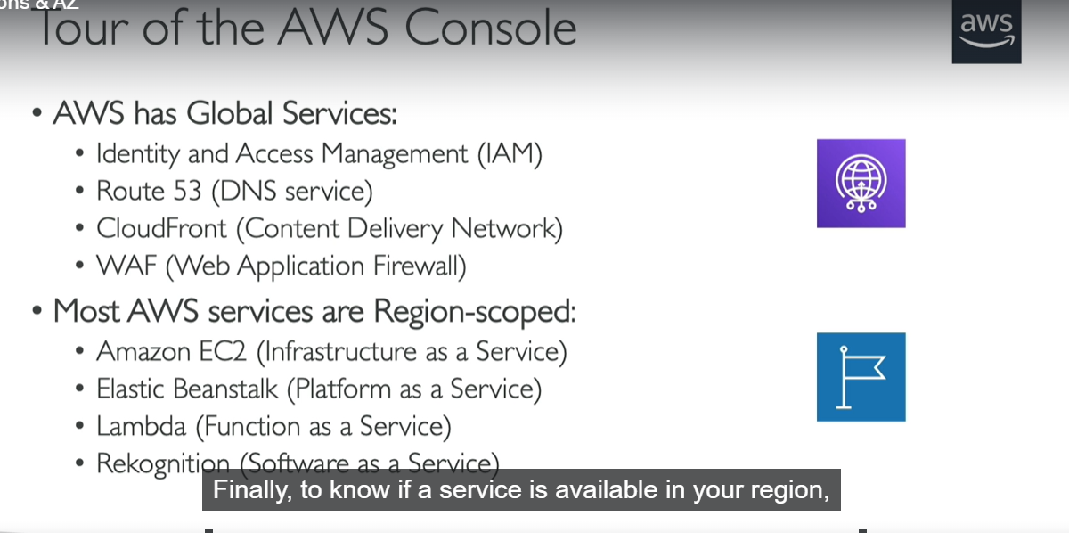

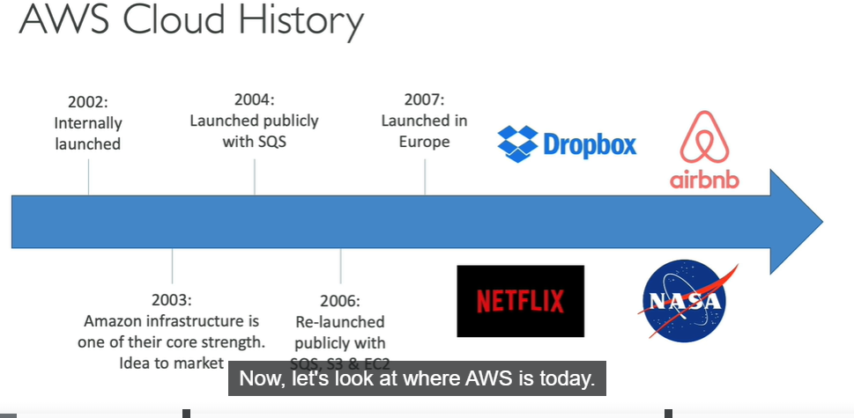

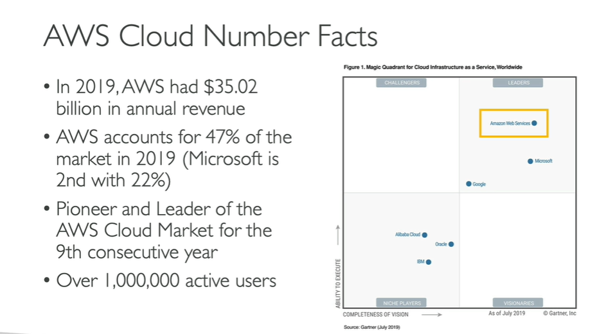

GRAVITON IS THE NEW AWS PROCESSOR WHICH IS CREATED BY AWS BUT ITS ONLY WORKS WITH LINUX



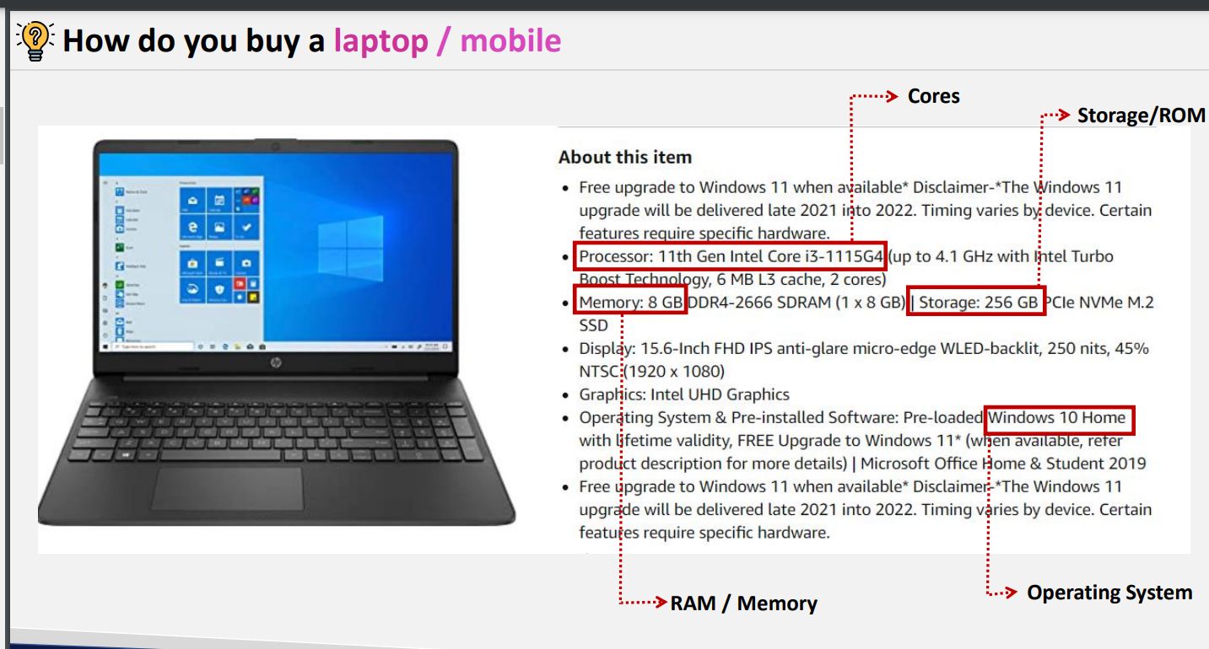

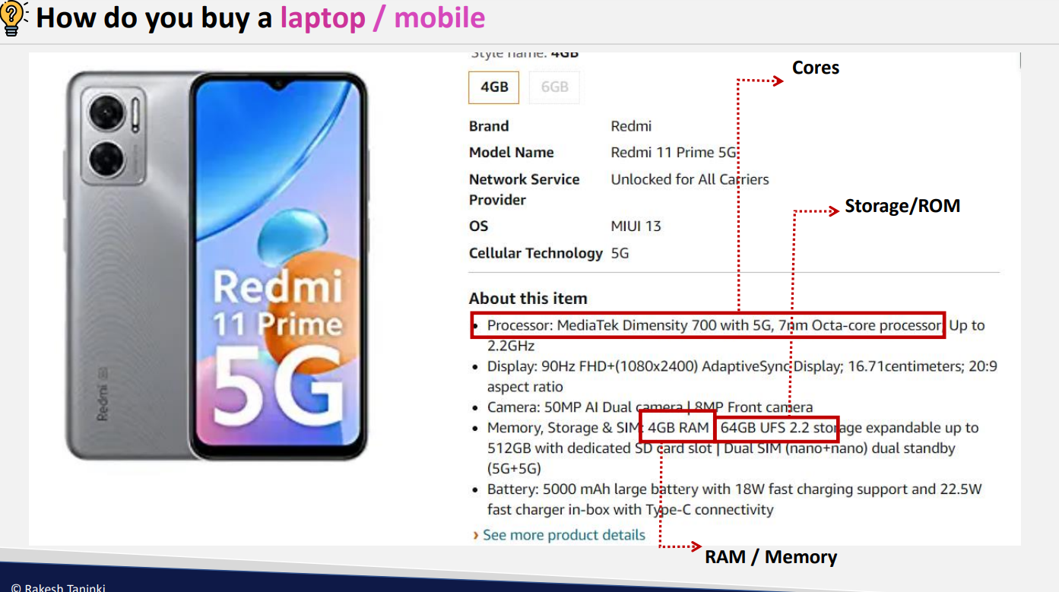

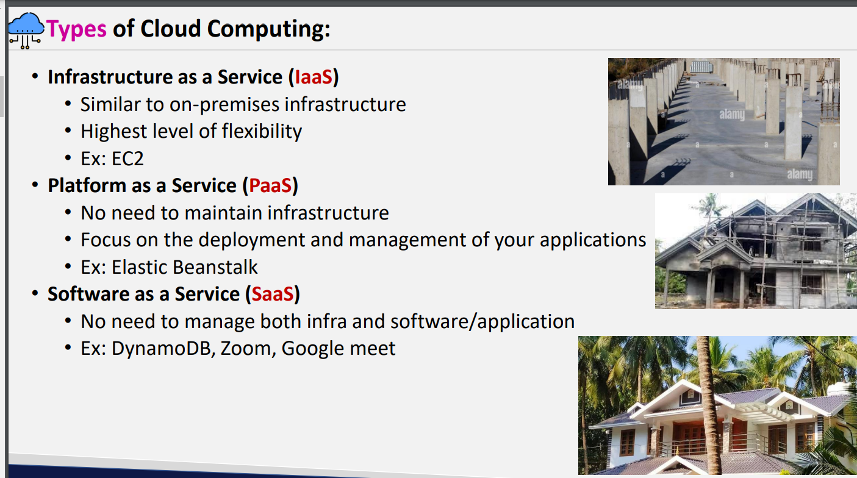

Infrastructure as a service: every thing should be managed by us starting from base

Paas: half infrastructure is built already and rest part needs to be managed by us just you need give application code and data

Saas: Everything is managed by cloud ……just we need use it .

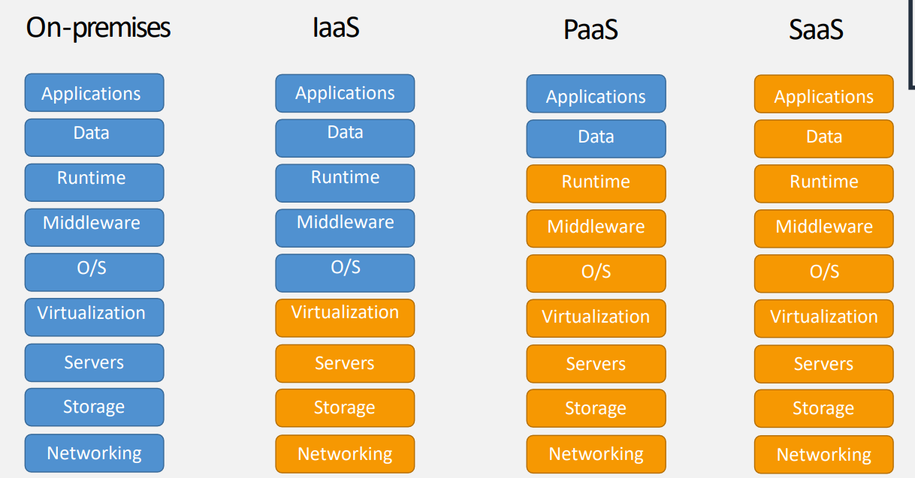

Pricing model:

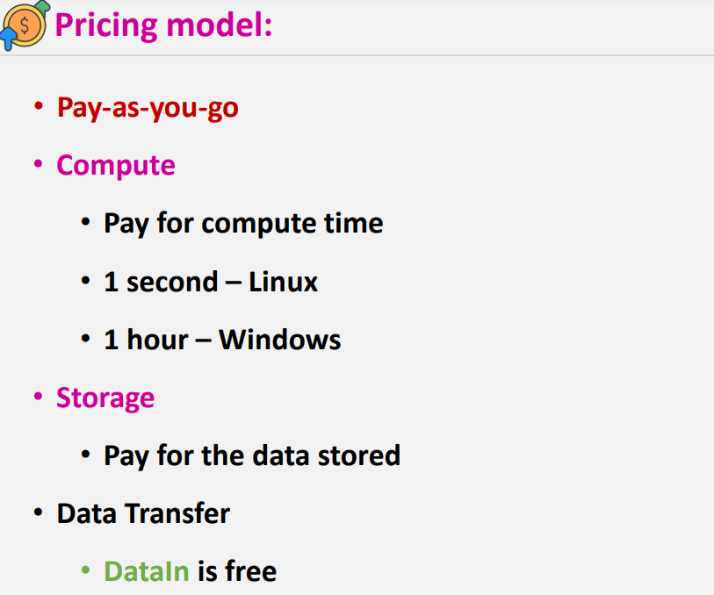

* Linux pricing is bit less when compare to windows bcz as windows is licenced & it needs to pay some amount to Microsoft for windows
* **Storage :** storage will be for some services it will be like disk cost for ex: if you are taking 10gb hard disk and if you are utilizing only 5 gb you need to pay for entire 10gb like “**EBS”,”FSX” etc**

**Ex2**: for some services it will be like pay as you go model like **S3 its scable**

Data in into the AWS is free and data out from AWS will be charged

* Example if you are uploading 1 GB of data in to the AWS it will be free and if you are downloading 1Gb of data from AWS it will be charged

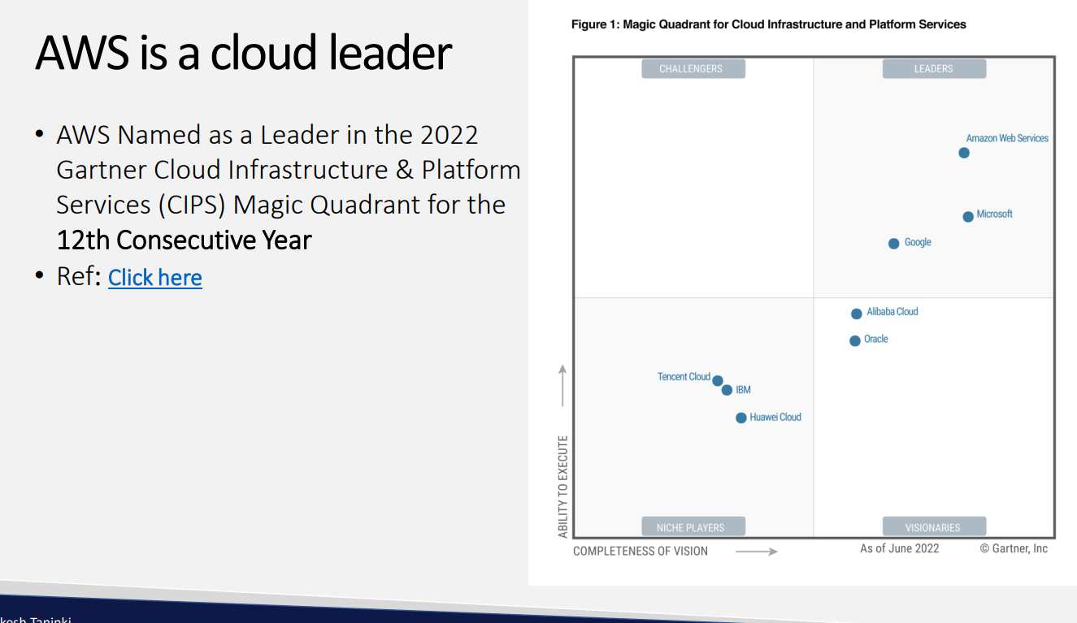

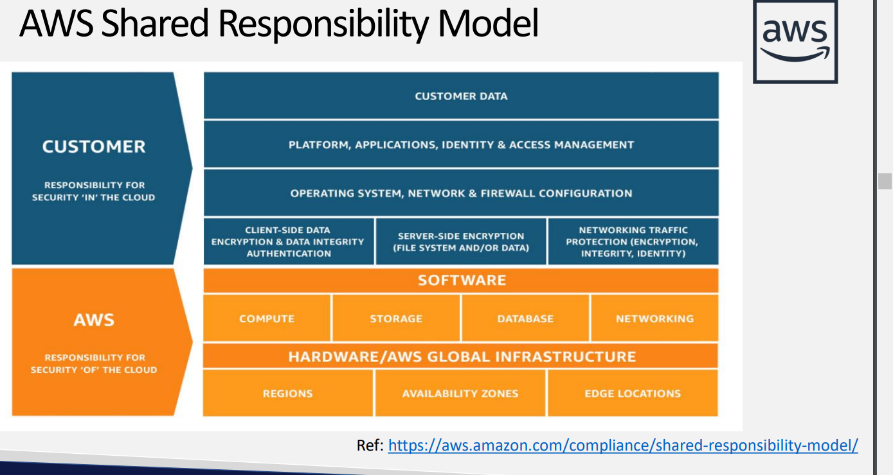

https://aws.amazon.com/compliance/shared-responsibility-model/

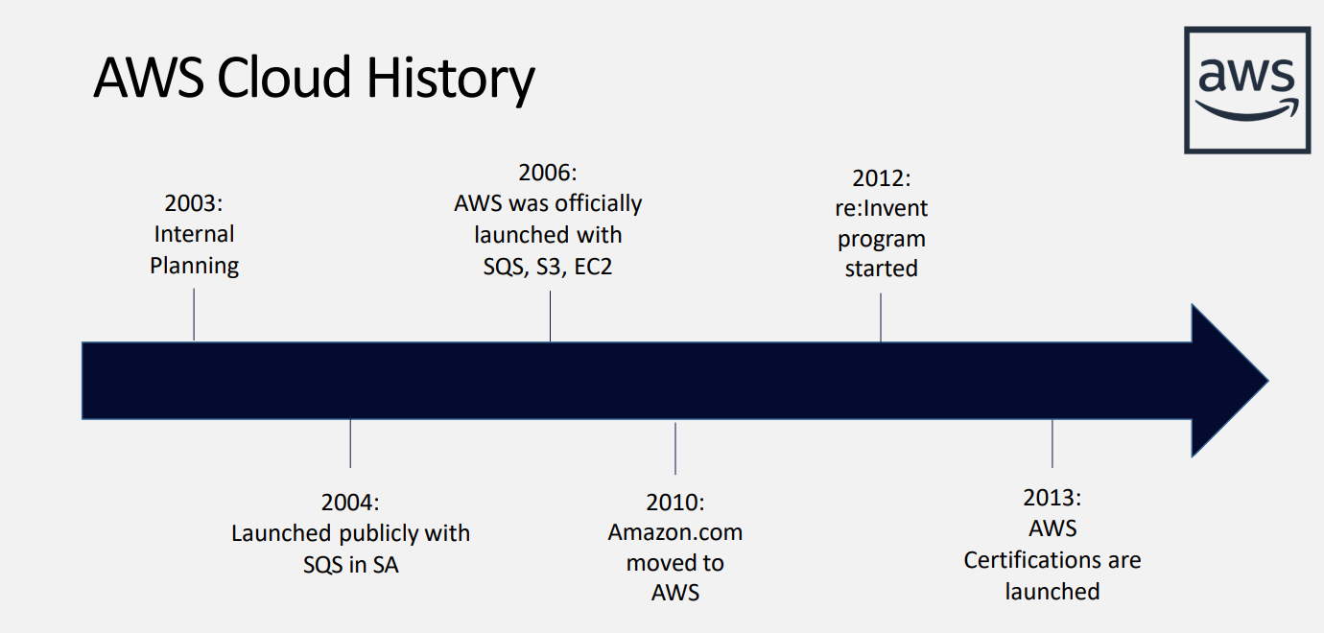

From 2012 on wards aws is launching reinvent program they will update the services and the features over this reinvent program

Every year they will update some features

For pricing click on pricing

* For resources docs click on resources
* For user guides **ex aws s3 user guide**
* Services cost differ from region to region
* **FREE TIER LIMITS : https://aws.amazon.com/free/?all-free-tier.sort-by=item.additionalFields.SortRank&all-free-tier.sort-order=asc&awsf.Free%20Tier%20Types=*all&awsf.Free%20Tier%20Categories=*all&all-free-tier.q=key&all-free-tier.q_operator=AND**

Best practices for root account

1. Setup MFA – hands on

2. Never share your root account password or access keys bcz if you share it your data which is created in your act might be mislead as root act have every access

3. Use strong password policy

4. Create users to perform tasks

5. Don't create access keys for the root (Only for certain tasks root account will have access keys its for billing purpose , organization services and for joining 3, 4 aws account etc etc as root account has unlimited access.

Budget plan : you can set budget plans so that aws sends you a notification trigger if you exceed that budget

* Youcan set budgets even for services separately
* You can add thresholds for sending alarms after exceeding %
* In bills section you can get the details for which service you got charged
* Invoice will be account wise

Regions and availability zones

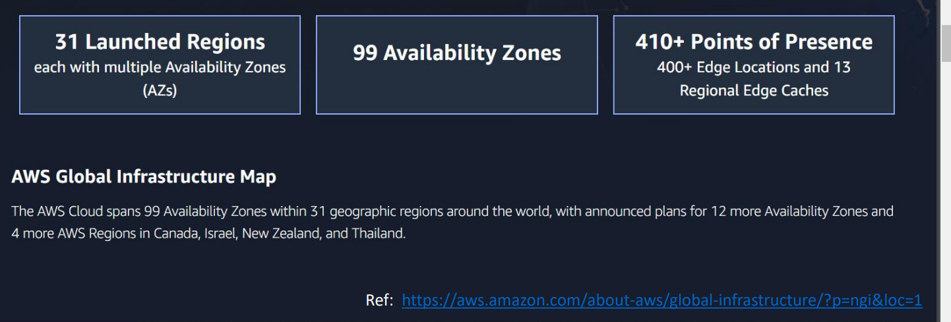

Ref : <https://aws.amazon.com/about-aws/global-infrastructure/?p=ngi&loc=1>

* Coming soon regioions

Regions

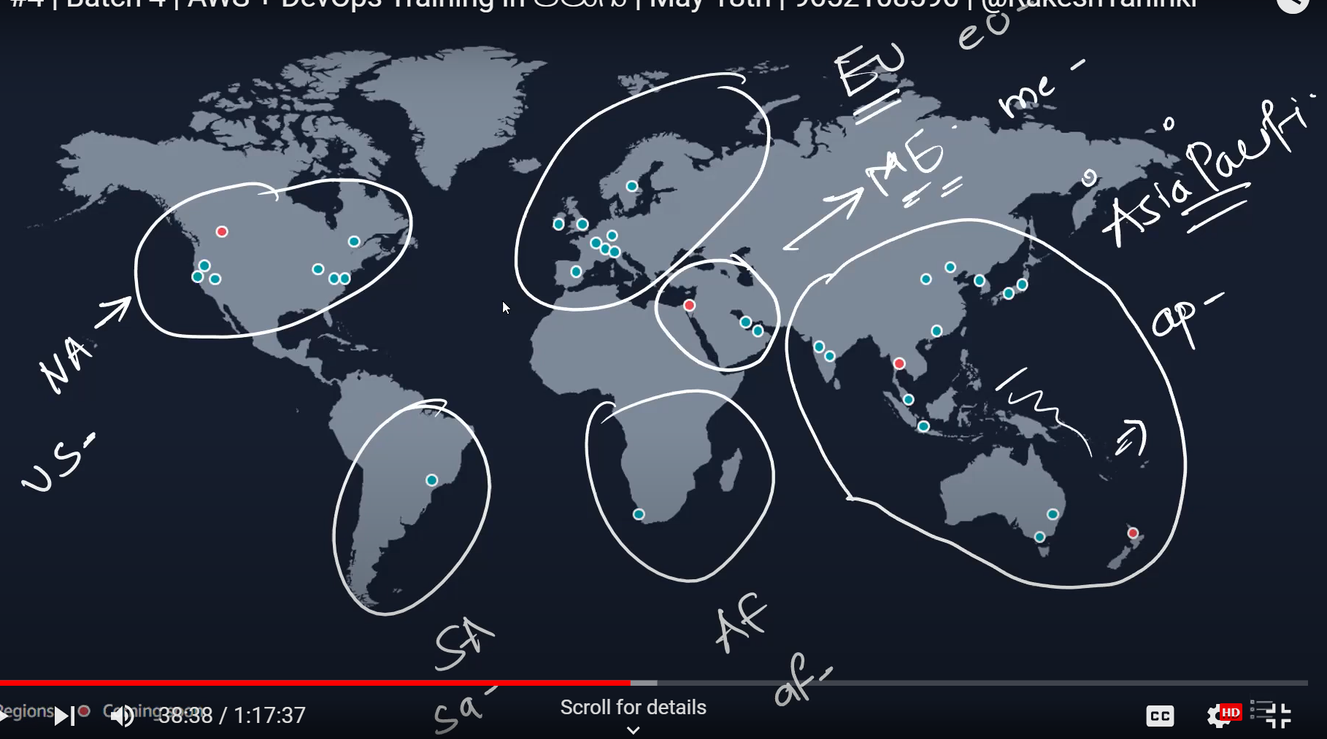

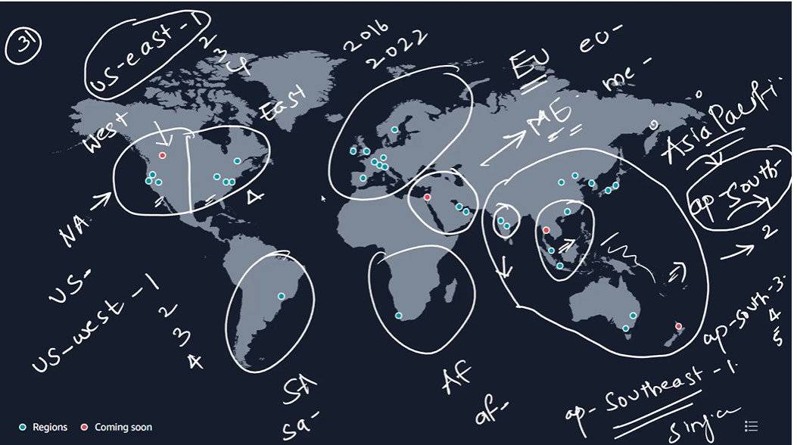

Based on region age new services which will release in event every year it will be launched in old regions not in every region for testing purpose

With in six months those services will be available in other regions too

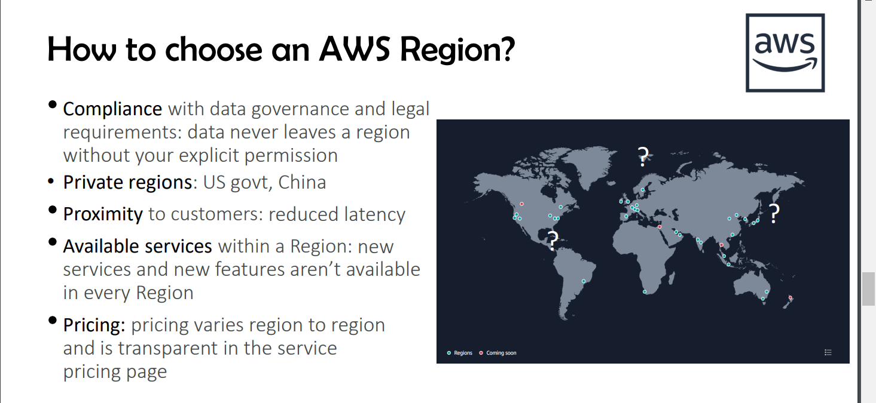

Compliance : example for every country there will be sensitive data so they don’t want to expose outside from there country

Private regions: it wont be accessible publicly as they want private access for there environment

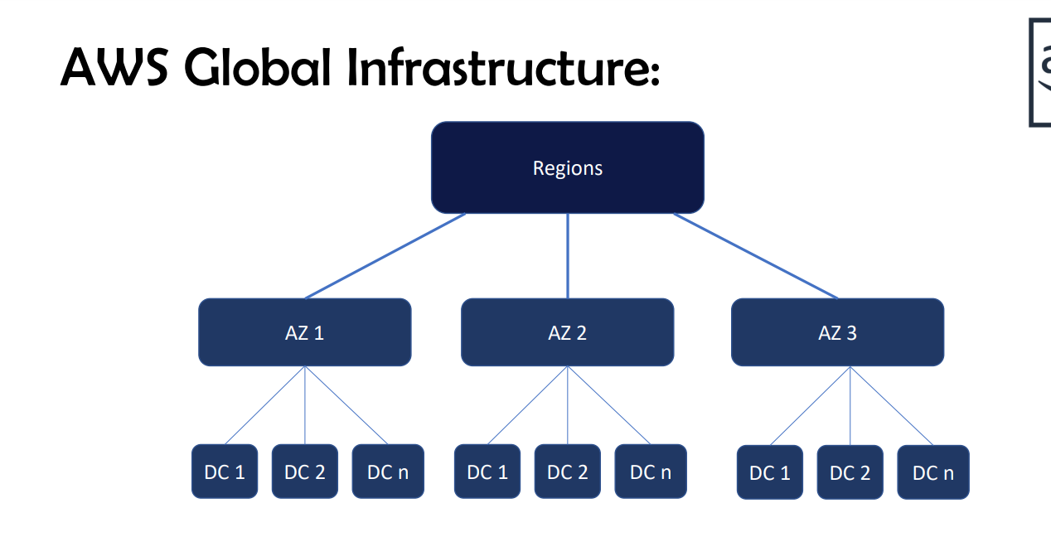

Regions : group of AZ

Az’s: group of data centers

AWS maintaions minimum 100 KMS Distance between 1 AZ to another AZ as they should not affect grouply by natural calamities

So that we can get back up from another AZ

Cooling system will be there to cool data centers so that they cant balst bcz of high heat

* Every region has MINIMUM three AZ’S
* 1AZ is effected means all the DC’S gets effected as its main hub
* If you want to store your in data in multiple AZ’s you will be charginging accordingly
* Between the dc’s there is wired connection
* There is region HA where you can pay for it to store multiple az’s and also you have High AZ availability where you can store in multiple dc’s



**BOTO3 is a python library which connects aws using python**

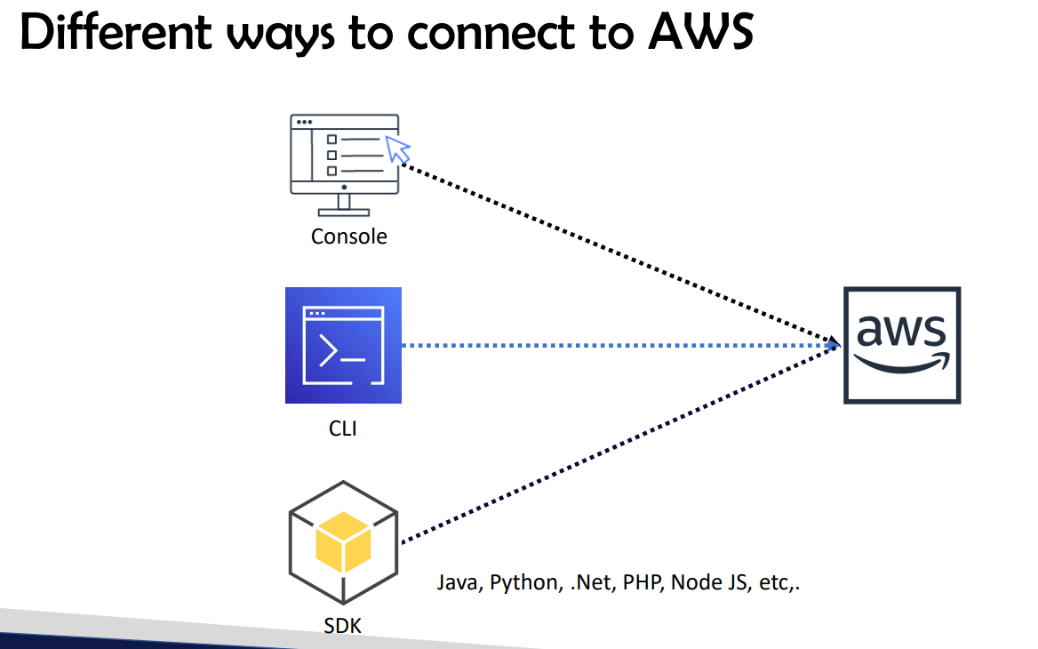

**For devops engineer aws console and aws cli will be enough**

* **If you want to become developer you need to have knowledge on aws sdk as they use sdk for automations**
* **Http apis also you can perform operations**
* **For infrastructure automation will use cloud formation**
* **95% you can use console for aws services work rest sdk ,cli,api’s you can use 100% for aws services**
* **For creating and modifying aws infrastructure will use terraform and cloud formation but for read purpose and any other purpose it wont be useful**
* **For management you will be using console, sdk ,cli, Http APi’s**

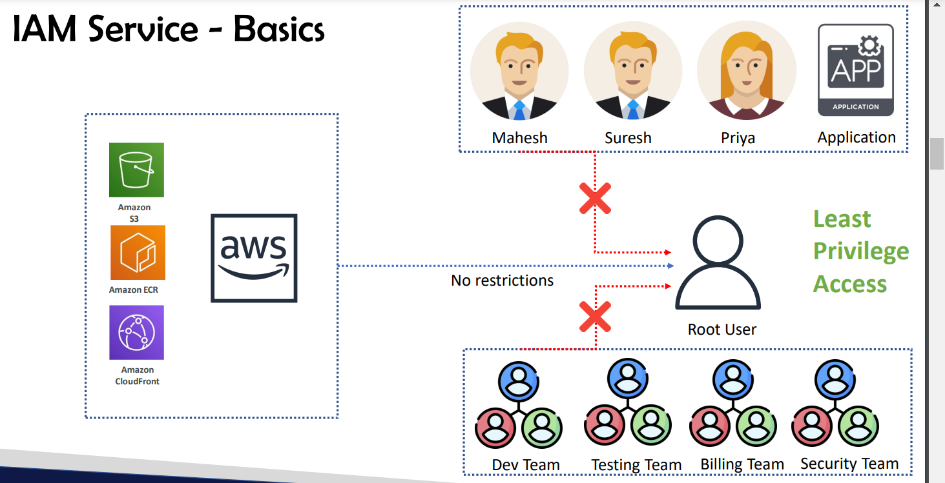

**IAM : Identity and access management**

* **We need to give least privilege access to the users**
* **That’s the best practice for the aws security**
* **AS root user has all the access**

**CRUD -Create read update delete permissions**

* **So You can give access according to the employee designation**
* **So you can give access for particular services as well according to project requirement**

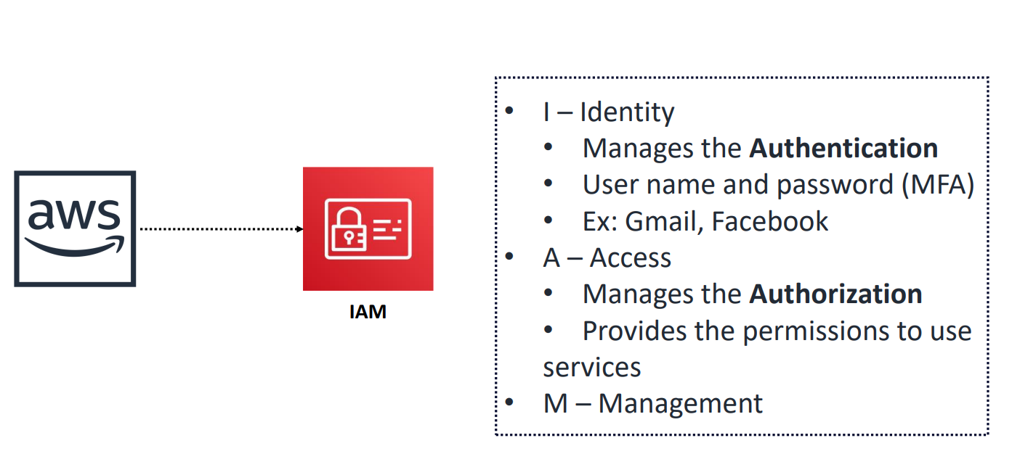

**Identity:** identity is for only authentication i.e, user name and password verification

**Access : Manges the Authorization i.e, giving permissions for the users for particular services like Read write permissions**

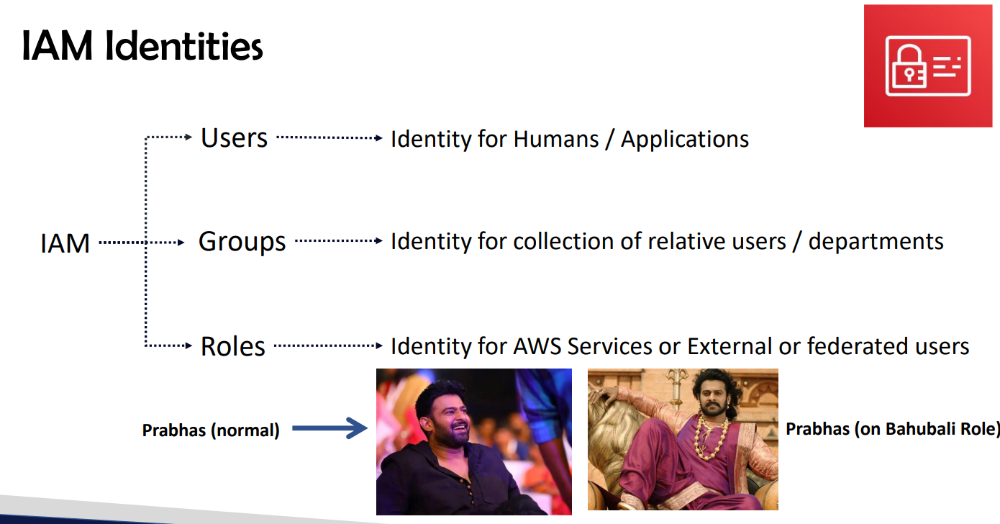

**Users: for humans/applications humans: user name & pwd applications: access keys**

**Groups: to keep users in in that particular departments**

* **Dev groups users belongs to developer background wil be pushed in to this group**

**To manage permissions in groups will be easier**

* **Role :when you assume role you will get all the permissions of roles and existing permission will be waived off and when you come out of roles you will get normal permissions**
* **Role is temporary credentials or temporary permissions**
* **For one service to another service connectivitiy we use roles(within the connectivity between services)**
* **Ex: EC2 S3 (Giving role to EC2 I.e to upload and download files from S3)**
* **For federated users that means people who are working on on premise they will be added to groups directly And they will be assigning to roles ex:1000 ppl are added to 50 groups and each group will be assigning one role**
* **Only if you are part of users then only you can go and check whether you are having permission to roles are not**
* **Roles is temporary access**
* **Users cannot be assigned to multiple roles at a time they will be assigned to single role at a time**

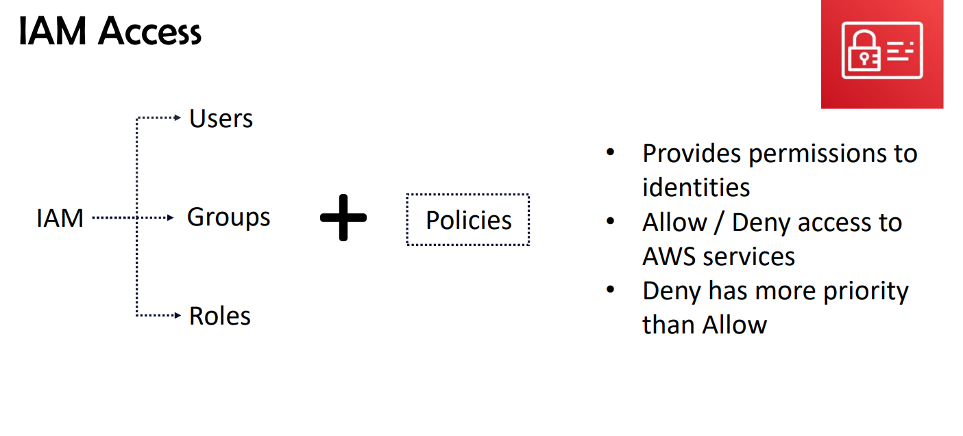

* **For identities you wont be getting permissions until and unless you attach policies**

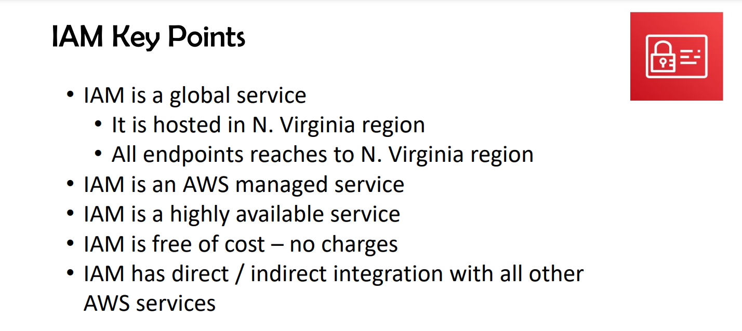

* **Services are of two types**

1. **Regional service**
2. **Global service**

* **Iam is a global service**
* **Gloabal services are hosted in north virginia**

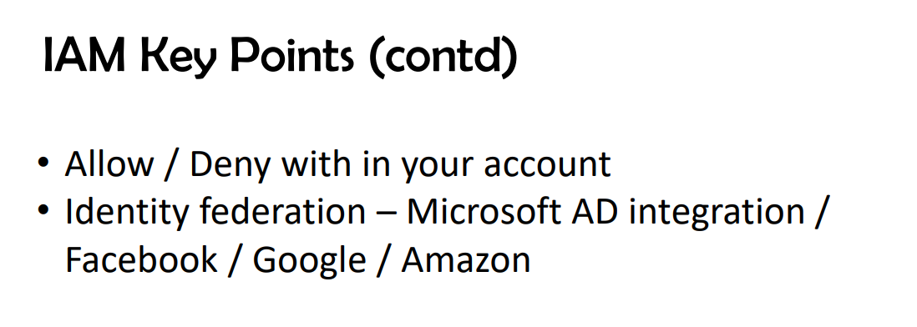

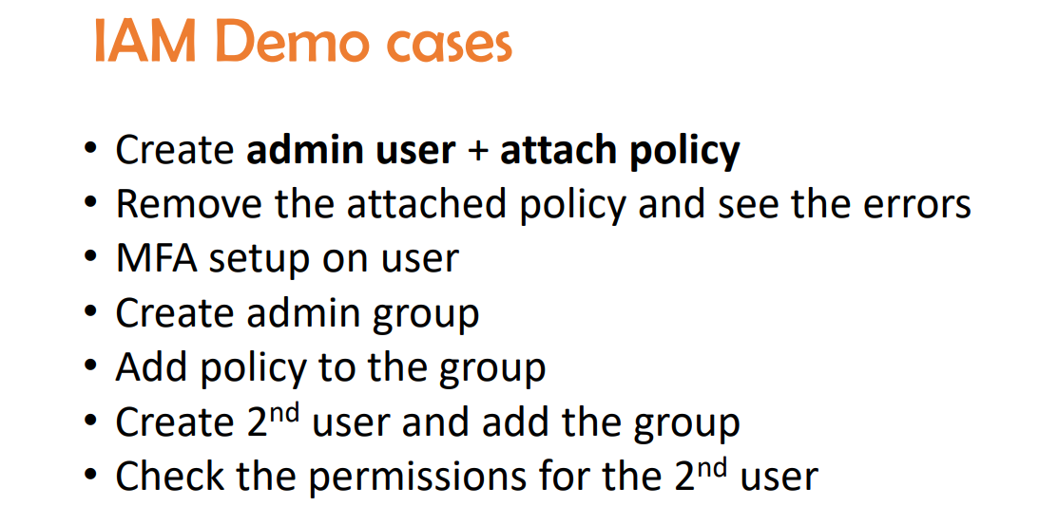

**For 1 user max 10 policies we can attach**

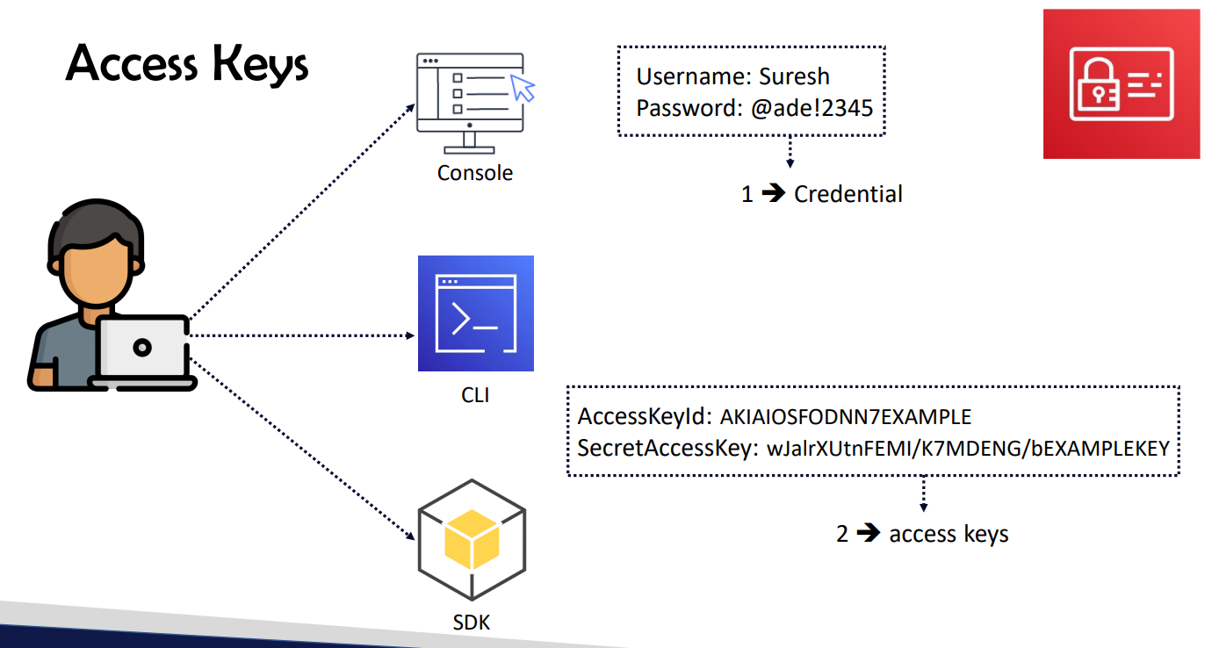

**You can generate 2 secrect access for one user**

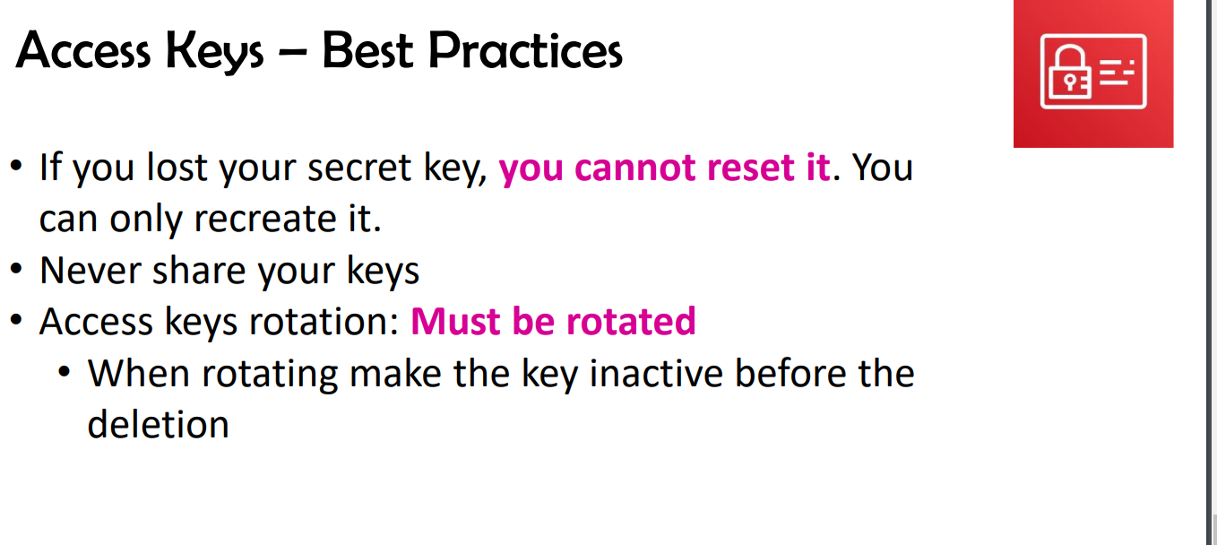

**If you lost the secret access you cannot retrieve you need to create 1 more access keys**

* **If you have 1 secret access for one access key you can generate one more secret access for the same access key**
* **As 2 secrest access is maximum number which we can create for one user**
* **For best practice access key should be changed for every three months first inactive the previous key**

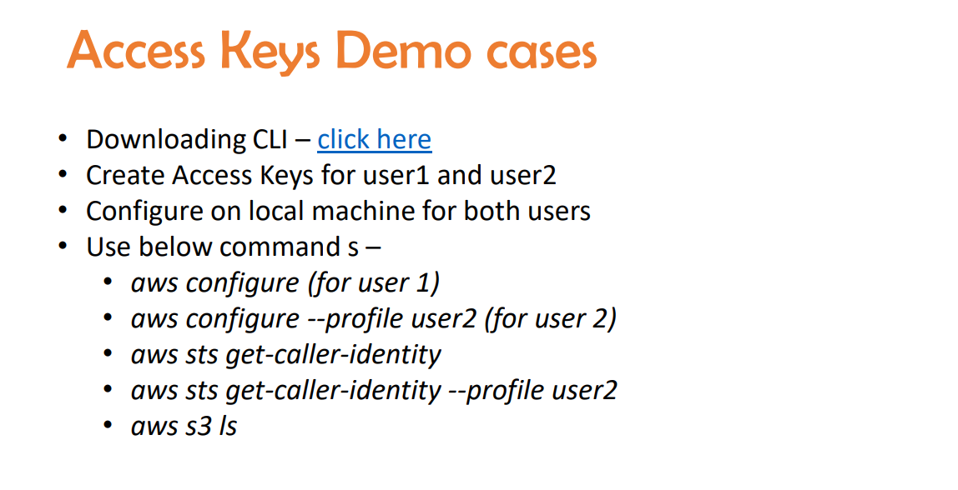

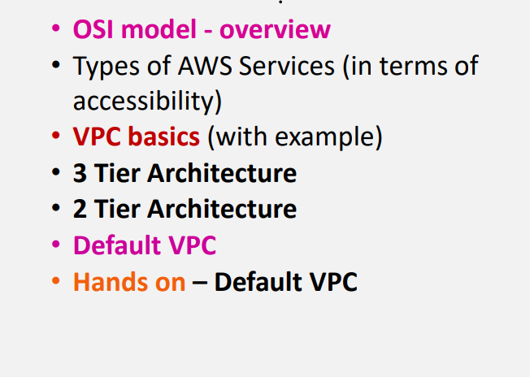

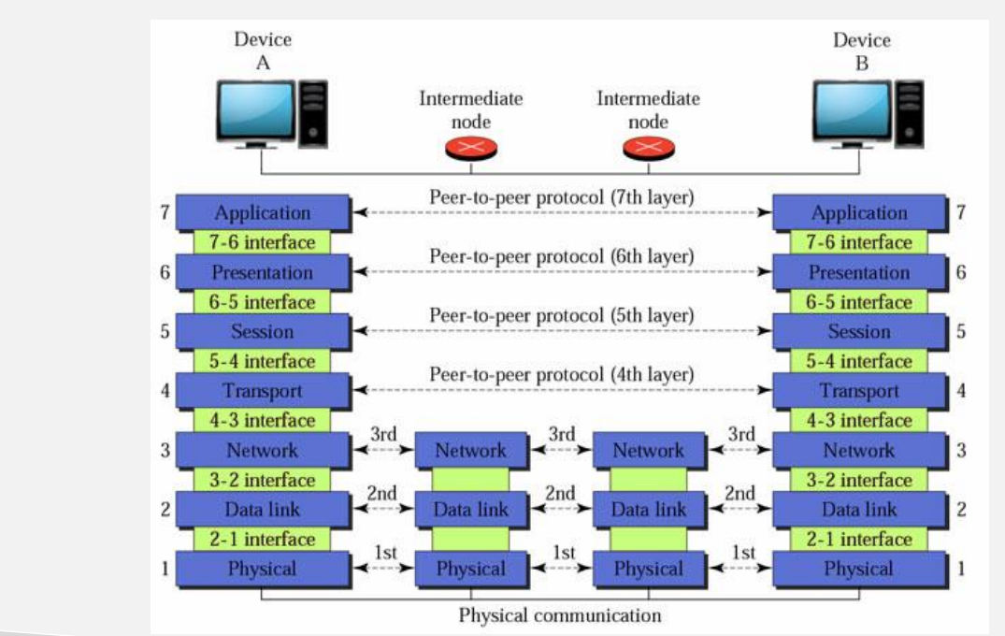

**OSI MODEL :Open system inter connection its one of the standard model for networking**

**Lets take example of whatsapp**

1. **Only 7 th step which you can do rest of the steps will automatically done based on 7th step**
2. **If you send a msg**
3. **6 th step will perform encryption**
4. **Session will create a session for that particular chat**
5. **Next 7th ,6th ,5th steps will be done in our mobile later the steps will continued in transportation part from source to destination**

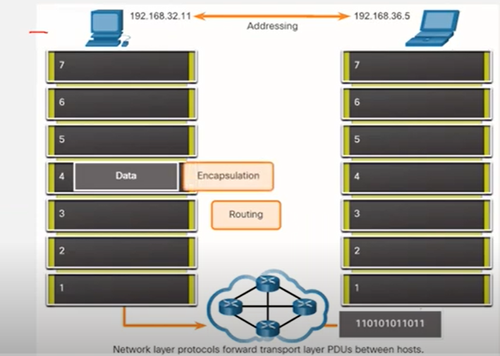

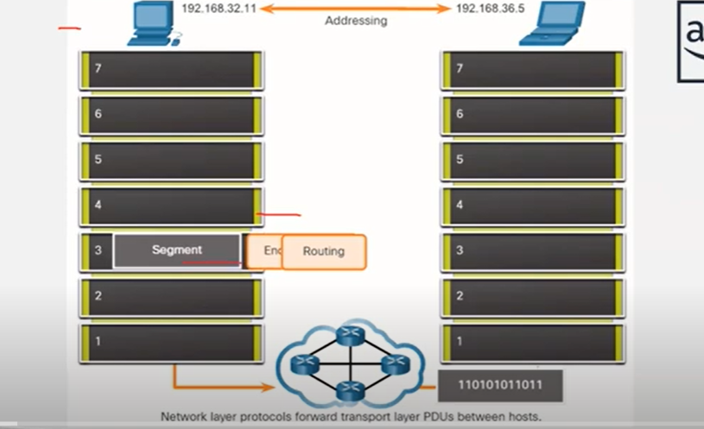

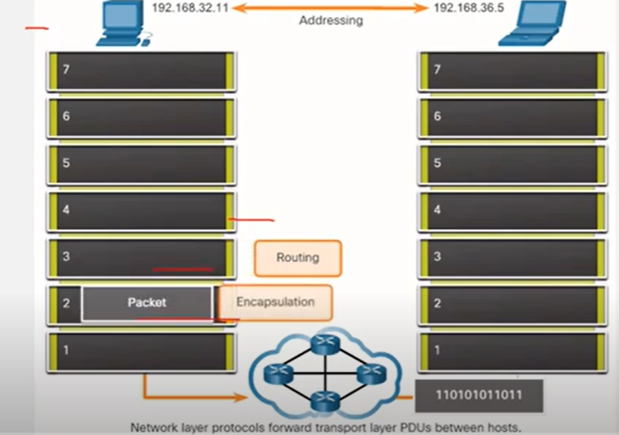

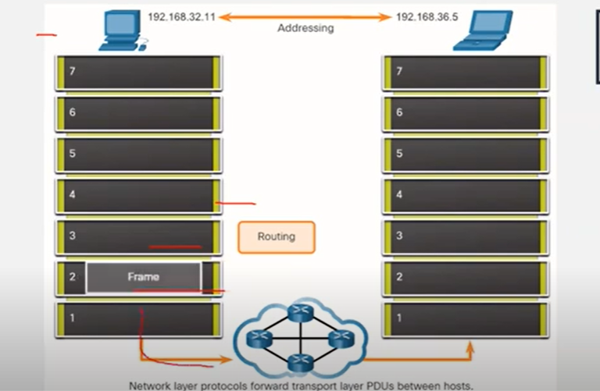

**Packet will get travelled to physical cable to the destinatination part and in the destination part steps strt from reverse from 1st step to 7th step**

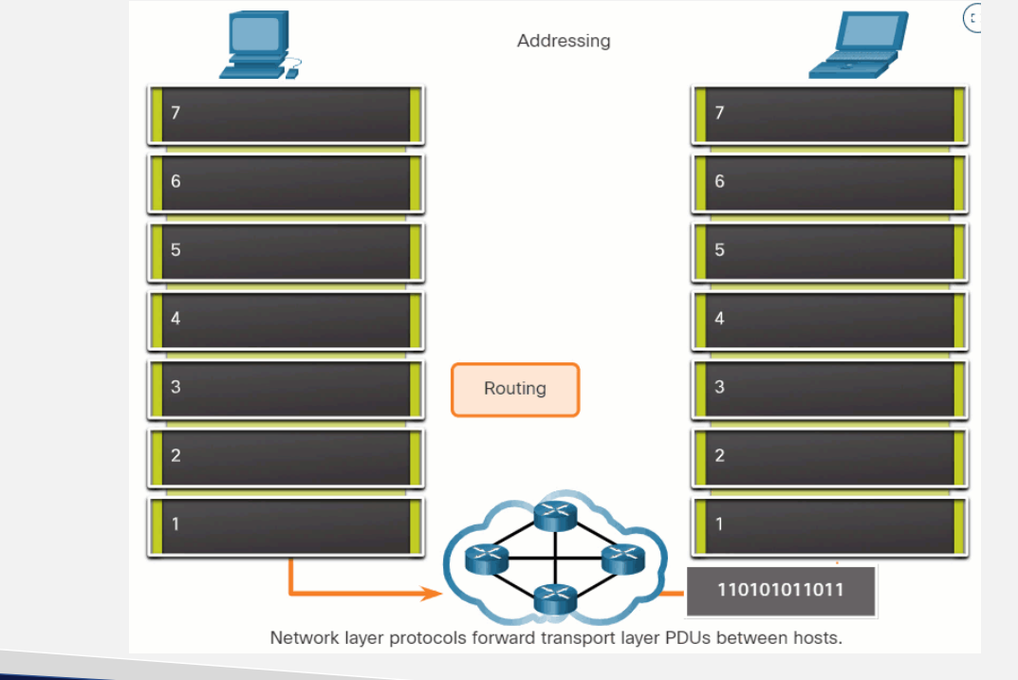

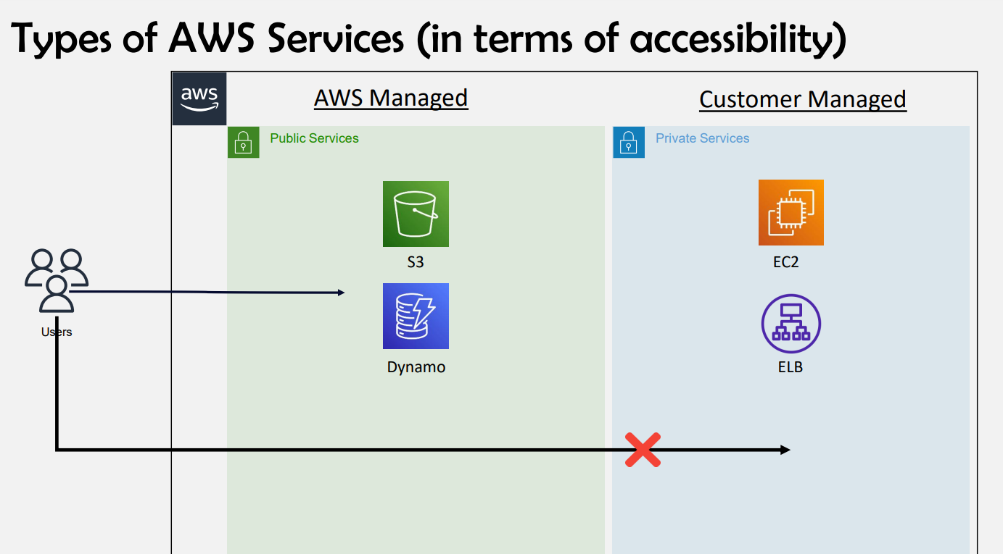

**Users can’t directly access EC2 & Elb as its customer managed until you create network**

* **Vpc will be must and should for accessing customer managed accessibility**

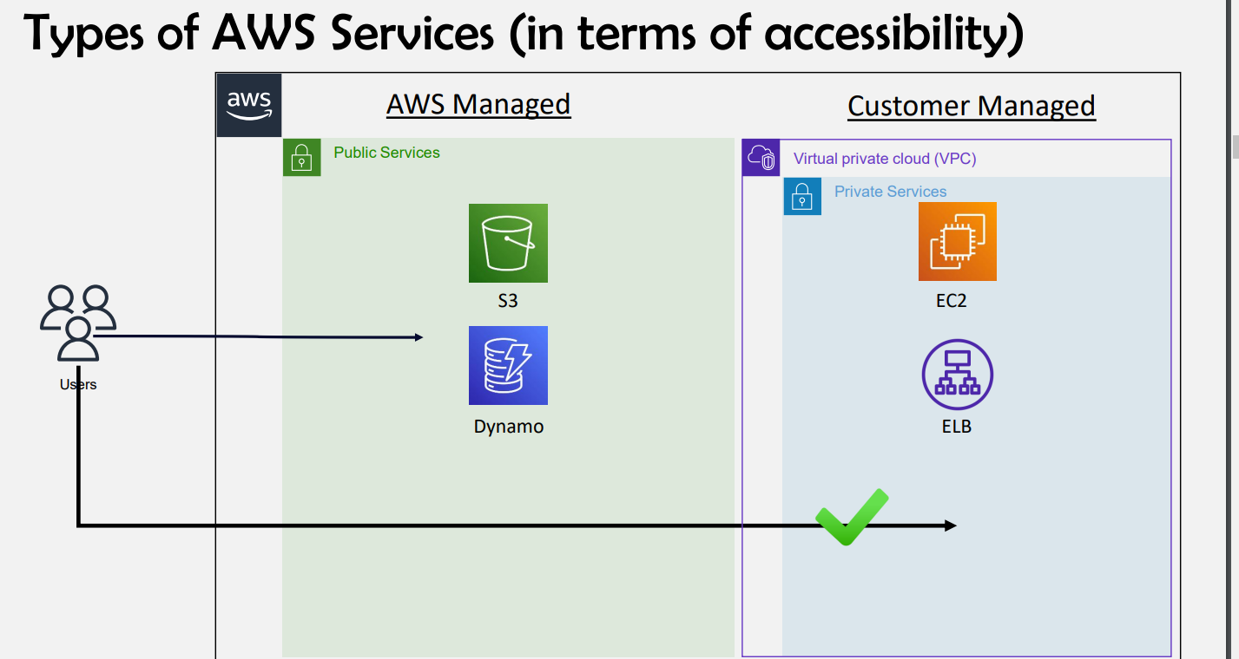

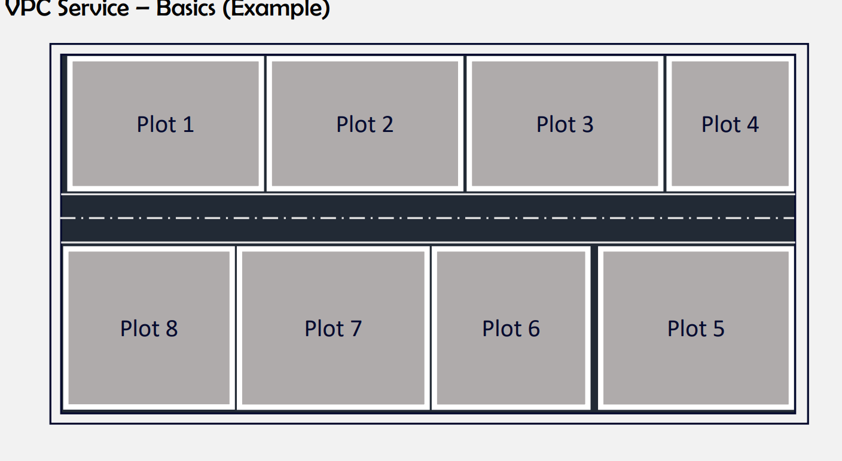

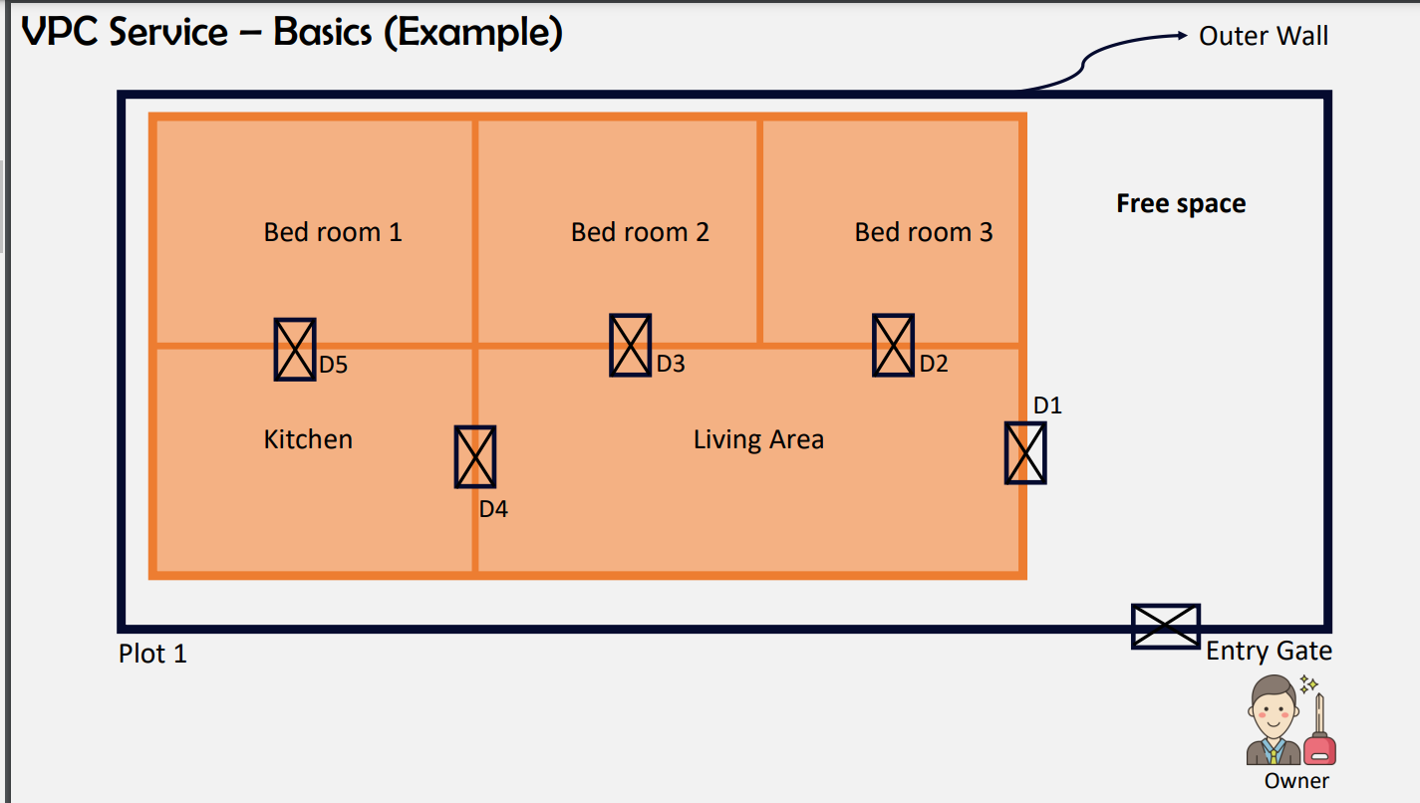

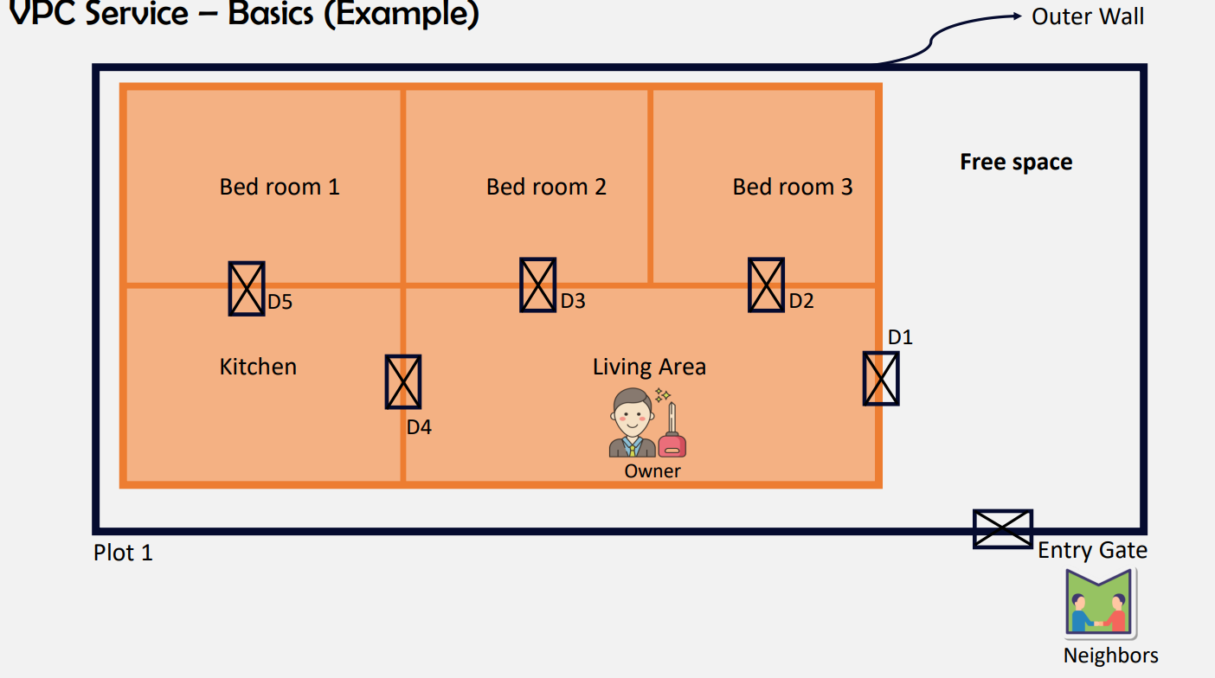

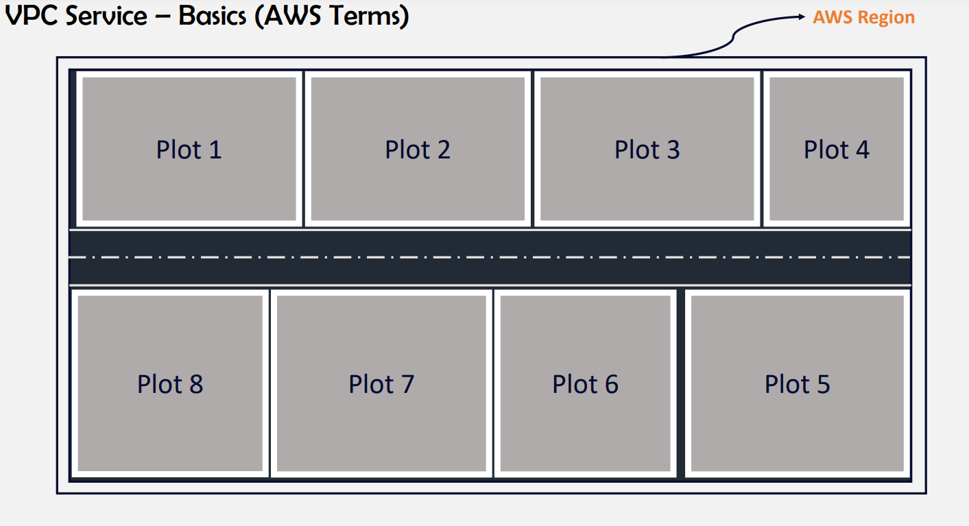

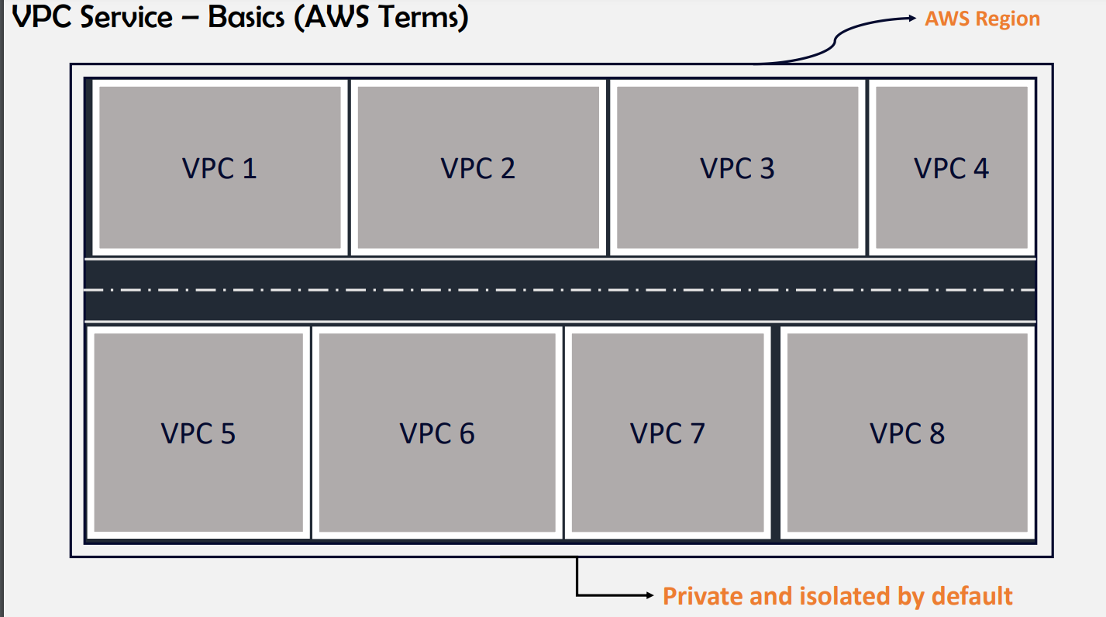

**If we want to connect one vpc to another vpc we have vpc peering option**

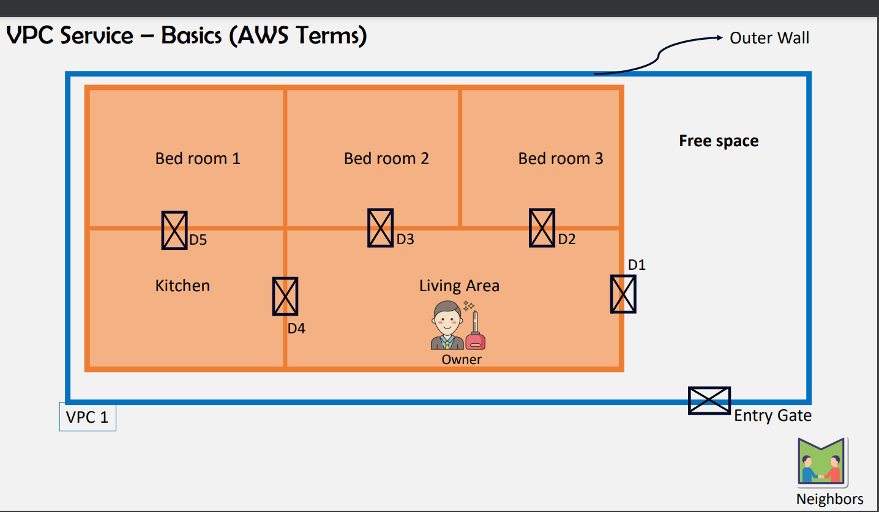

**For 1 region you can create 5 vpcs**

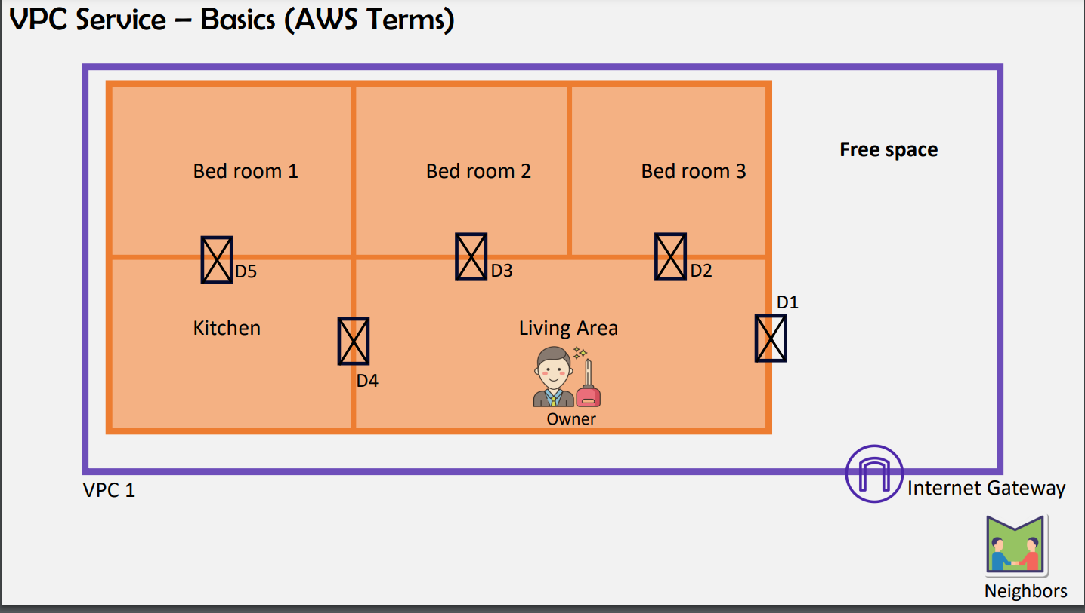

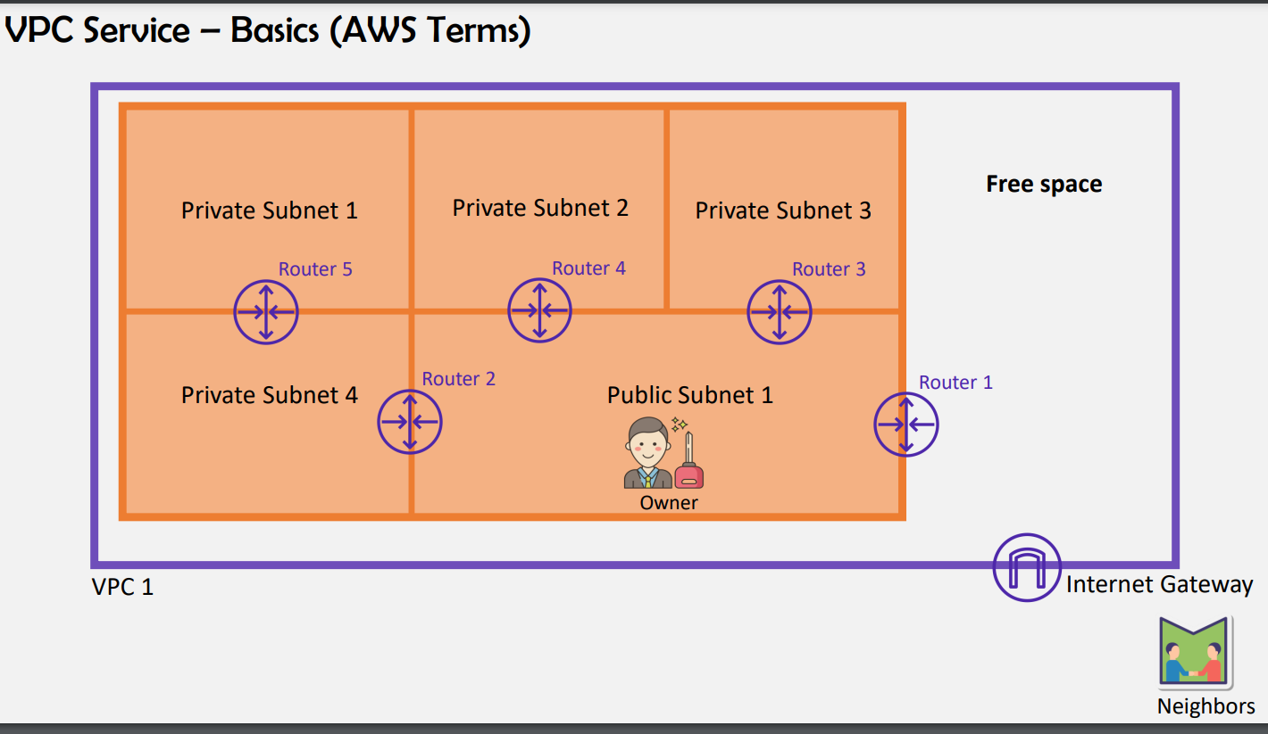

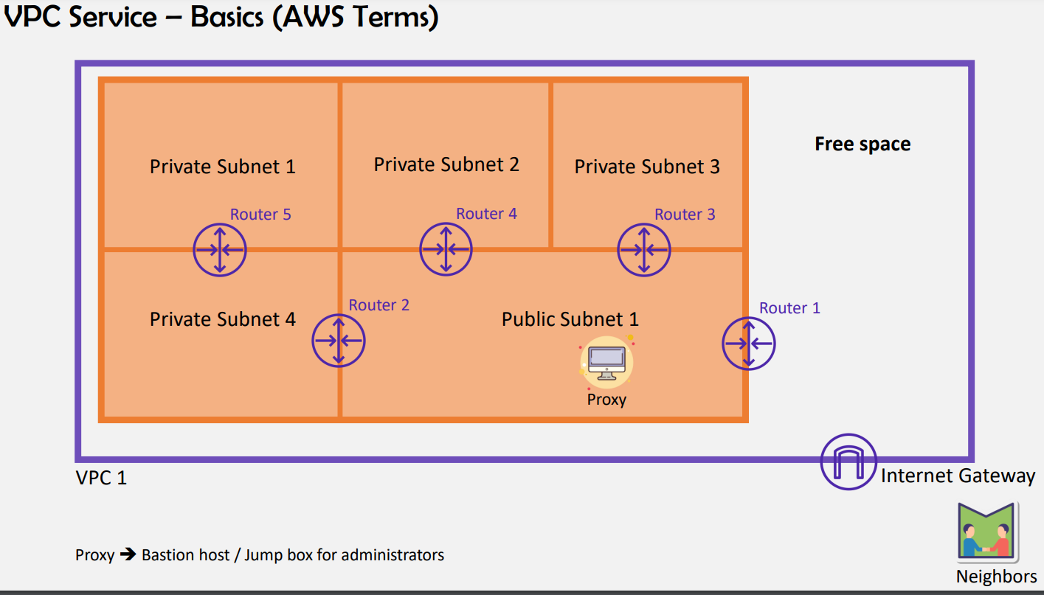

**We cant directly connect to private subnet**

* **If we want to connect we need to go to proxy in public subnet then only we can able to connect private subnets from public subnet**
* **Through proxy administrators will get connected to backend and database**
* **We can only create subnets but we cant say whether its public or private as we can only create subnets**
* **The subnet which is attached to igw is public subnet**
* **You can create only one route table for entire subnets or else you can create route table for each subnet or else for best practice will create one route table for public subnet and one route table for private subnets**

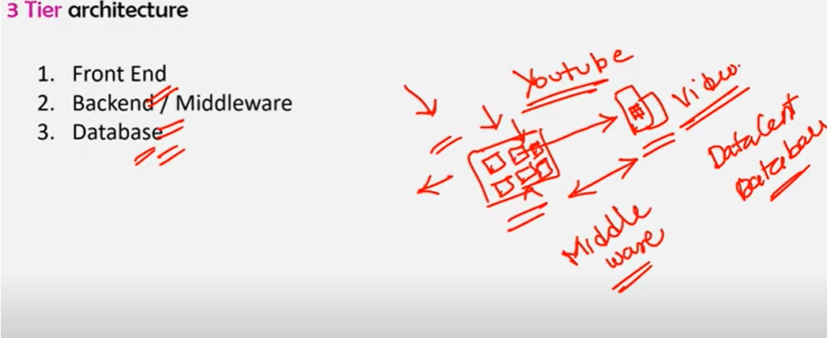

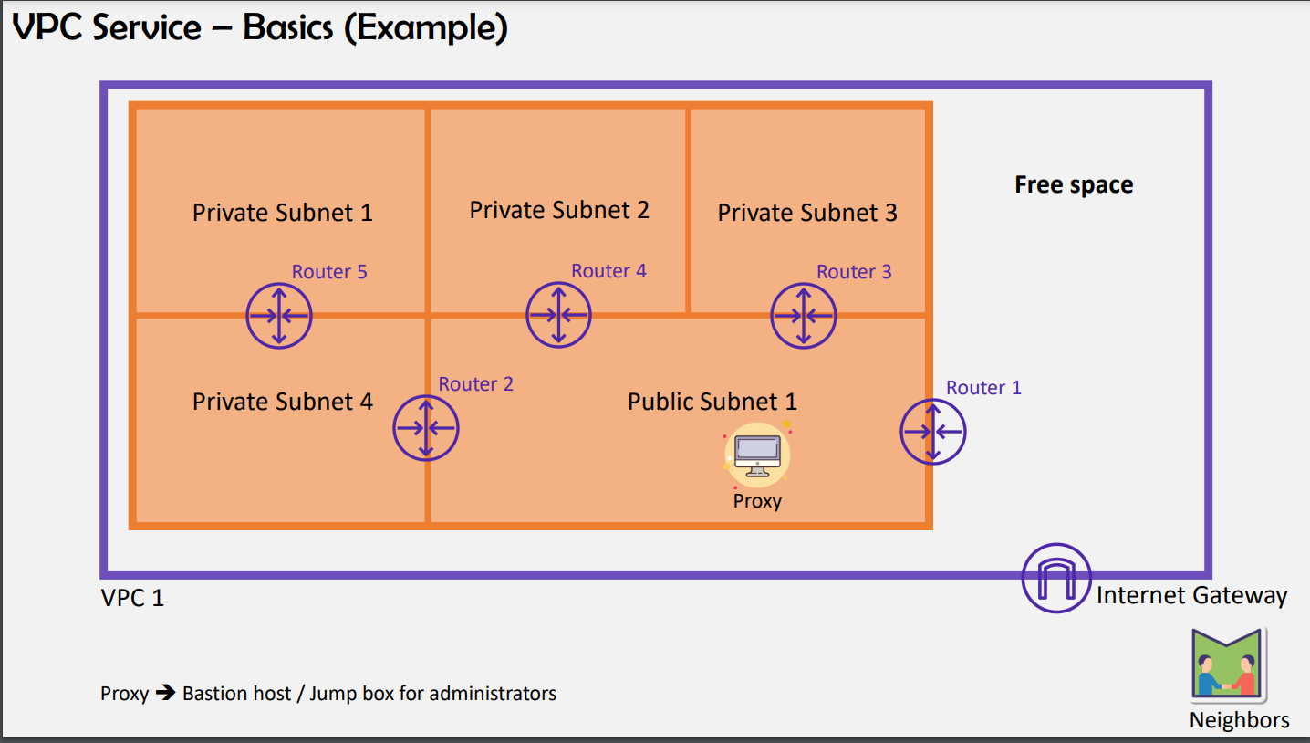

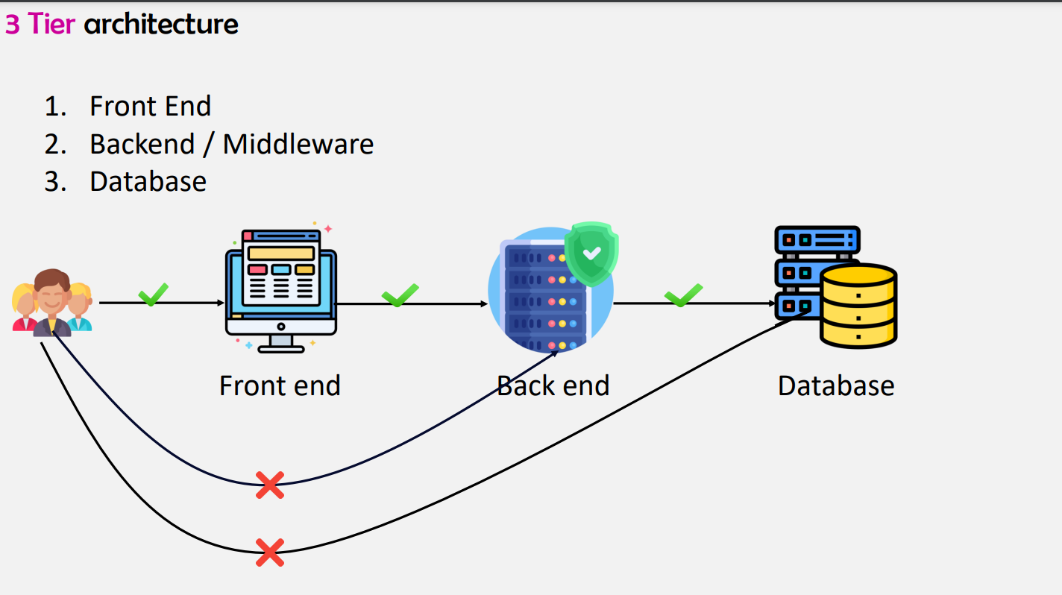

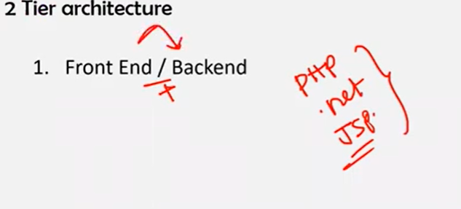

**For php ,.net , jsp we only required front end and backend**

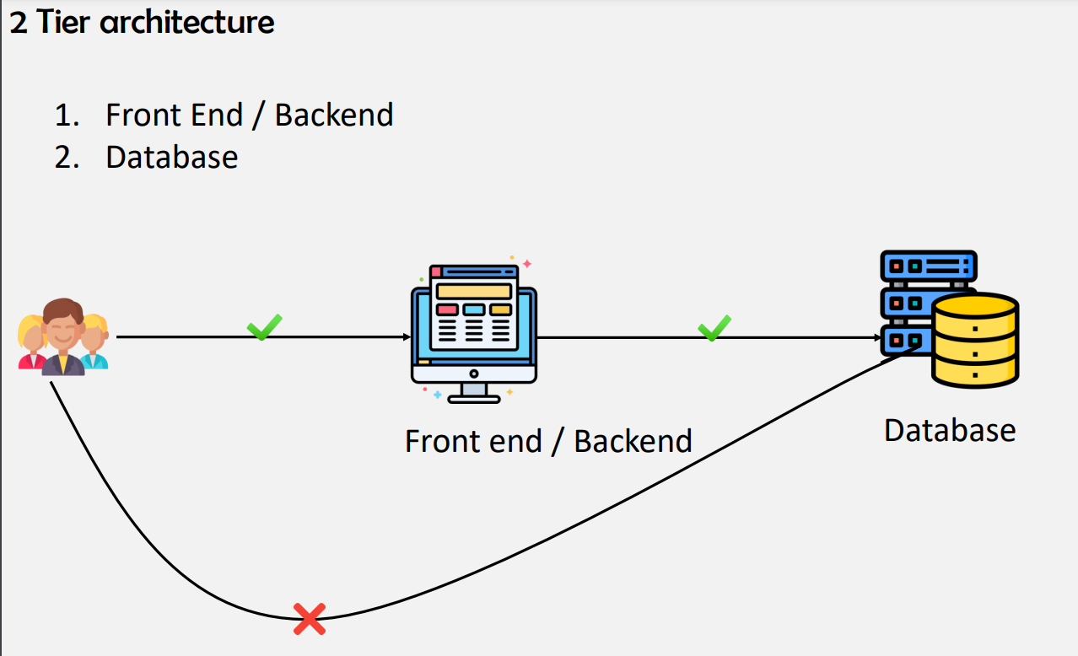

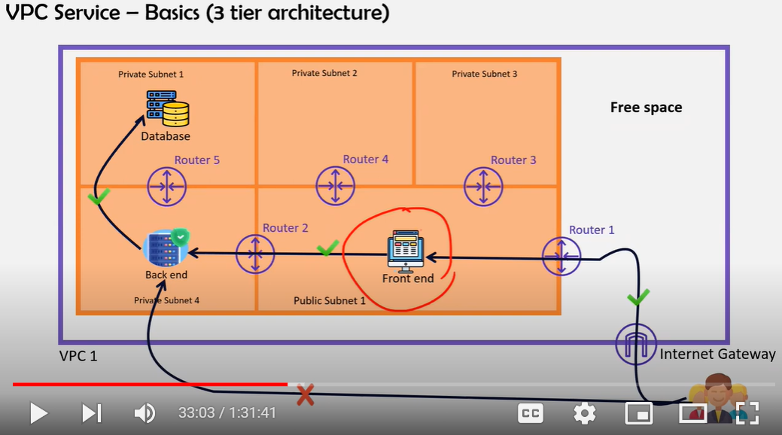

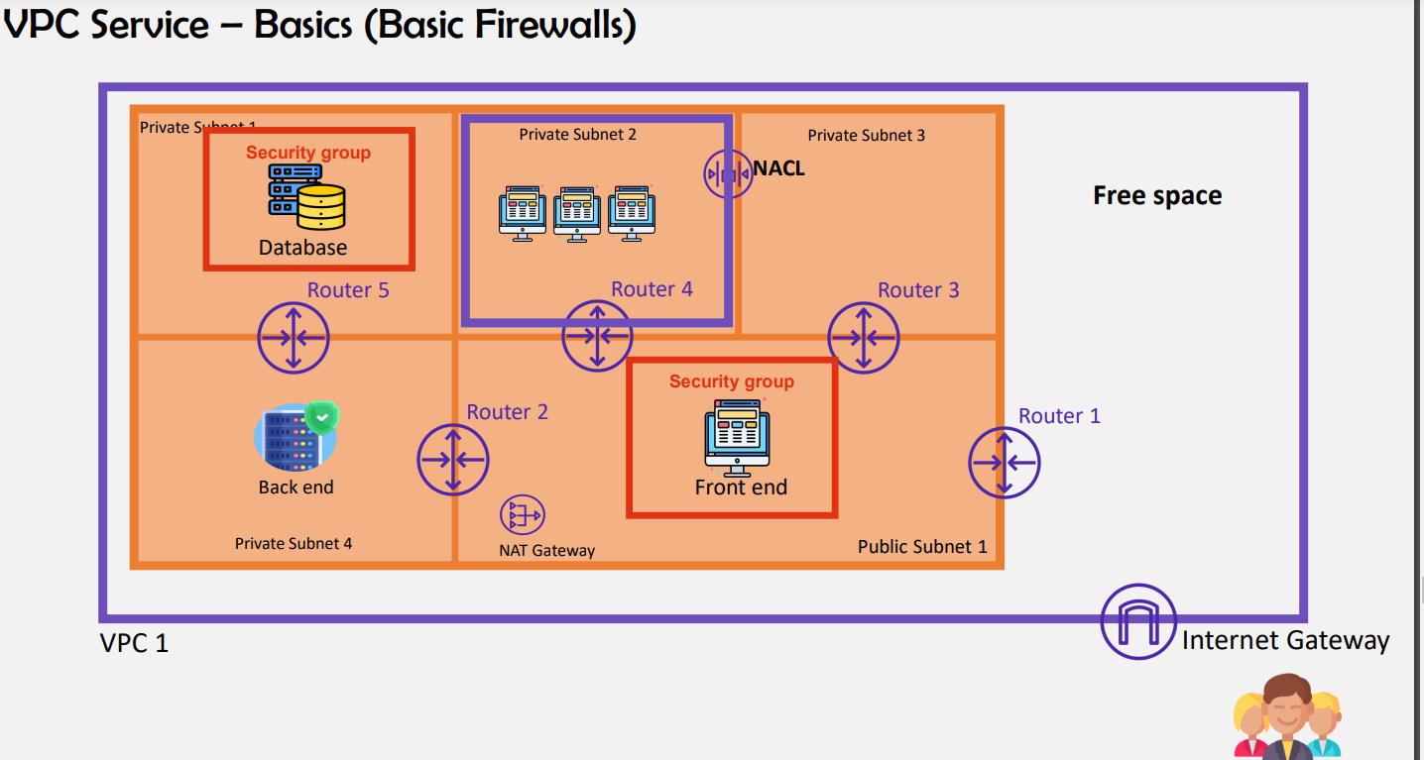

**IMP QUESTION :Natgateway will be placed in public subnet as it needs internet**

**If we place natgateway in private as it don’t have access to the internet we wont get private subnets data**

* **We need security protocols for hosting an application so for users http & https will be security protocols for ( end users) this will for those who connect from application layer**
* **For administrator who are going to configure http & https wont be useful for administrator**
* **Administrator – for linux machine he use SSH & for windows they need to use RDP he need to connect to these protocols these are called administrator protocols or developer protocols**

**2 types of firewall is needed to protect subnets 1. Security groups**

**2.NACL**

* **Security groups: security groups are server level firewall**
* **Nacl: subnet related firewall**

**Server level for each server we need to add each security group that might be difficult**

**So if we add subnet level firewall in that subnet if we have 50 servers that 50 servers will be having same security group as we are creating Nacl firewall(subnet level firewall)**

* **Free space is used for future purpose**
* **Whe Vpc is created by default NACL AND SECURITY GROUPS WILL GET CREATED**

**ORDER OF EVALUATION OF Security groups**

**IGW**

**RT**

**NACL**

**SG**

**SERVER**

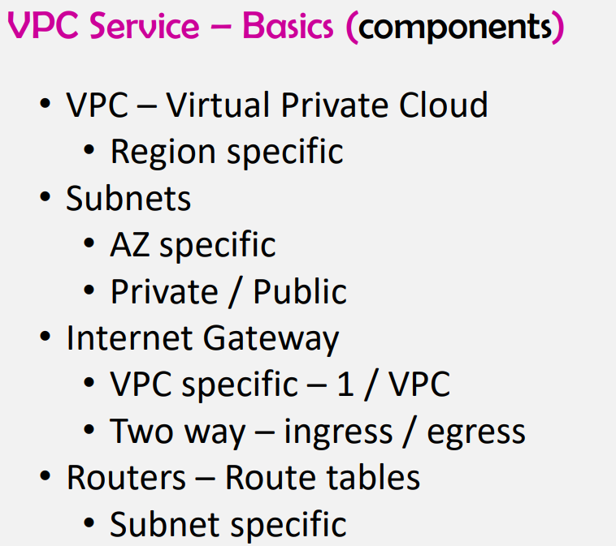

* **For 1 IGW you can attach 1vpc**

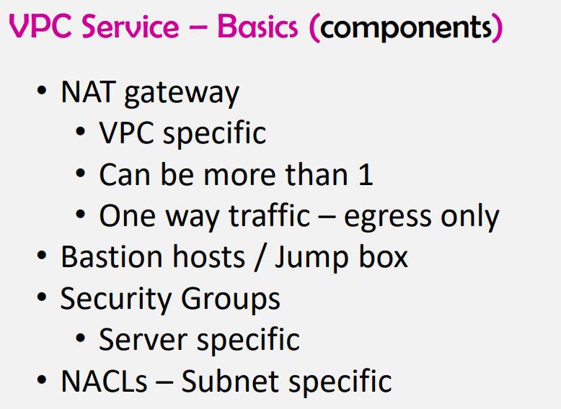

**For one natgateway you can attach more than 1 vpc**

* **Vpc is free**
* **Subnets is free**
* **Igw is free**
* **Natgateway is chargeable monthly (20$) for one natgateway yo will be having 10GBps of bandwidth**
* **(Bastion host/jumpbox/proxy) chargeable and its for the administrators purposewho wants to go in to the server and update the configurations**
* **NACL: Network Access control list**
* **Natgateway is different from Bastion host as its for administrators who want to connect to server and update the configurations**

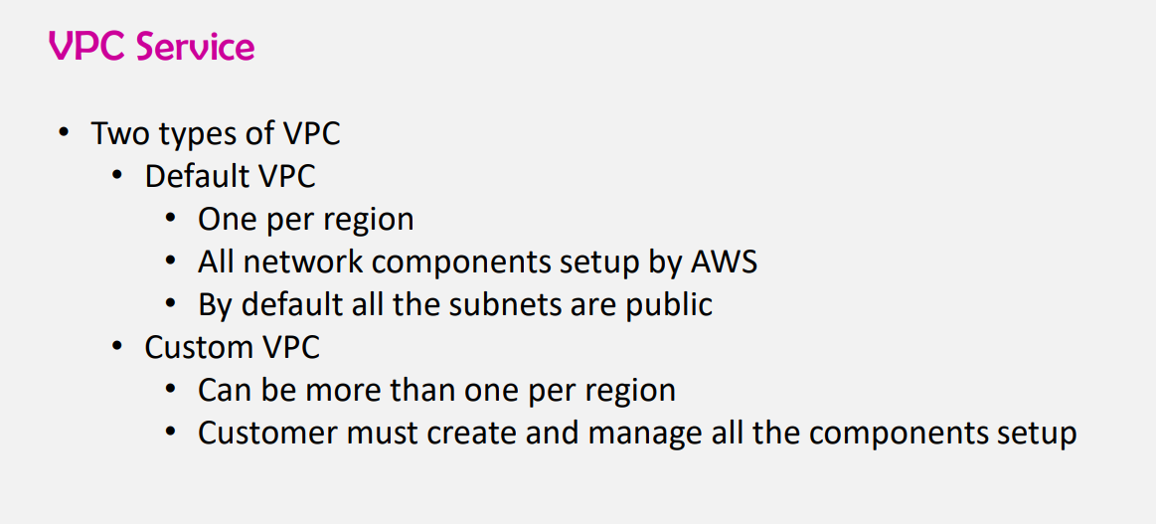

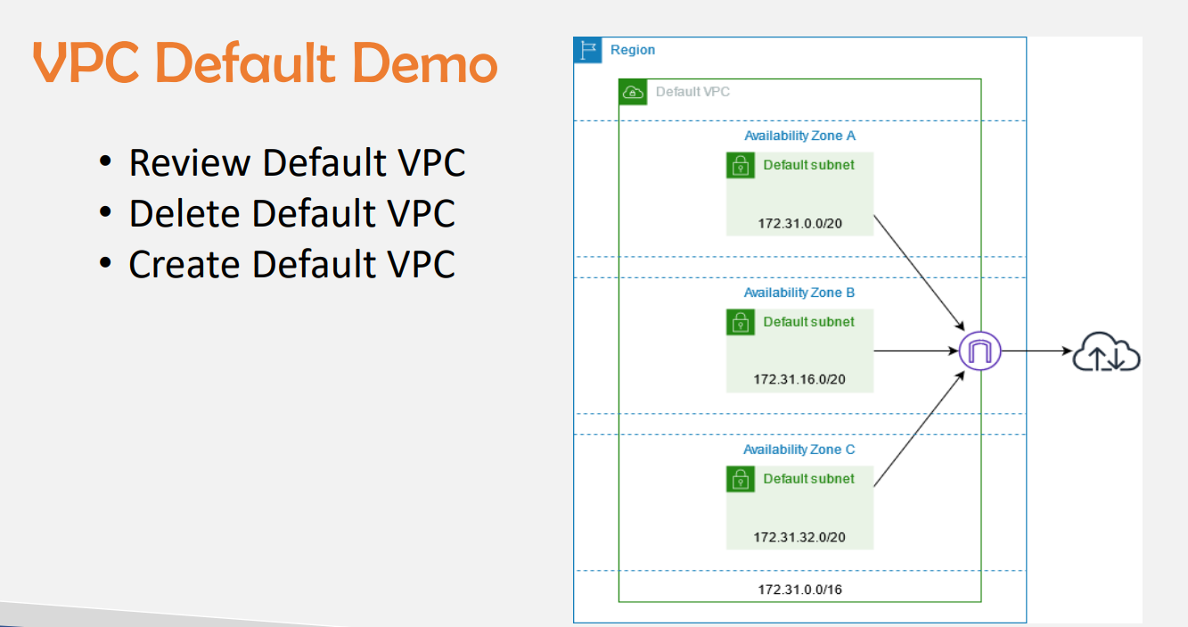

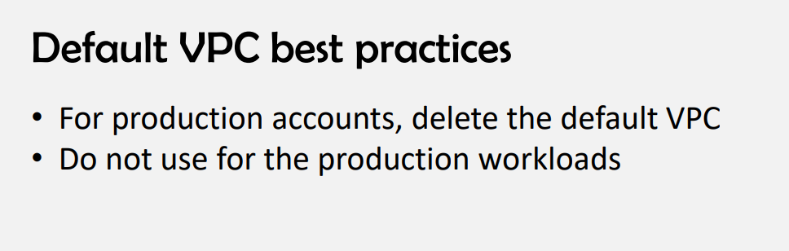

**For 1 region you can create only 5 vpcs (1 default +4 custom)**

* **If you want to delete default vpc you can create 5 vpcs for 1 region**
* **Vpc’s per region will be 5 if you want to increase the number of vpcs u need to drop a mail to support team with genuine reason**
* **For configuration of private subnets we use NATGATEWAY (for administrator purpose)just to download the dependencies .**

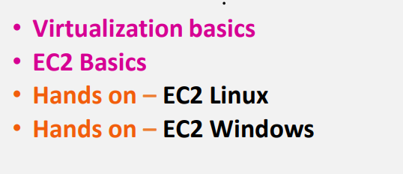

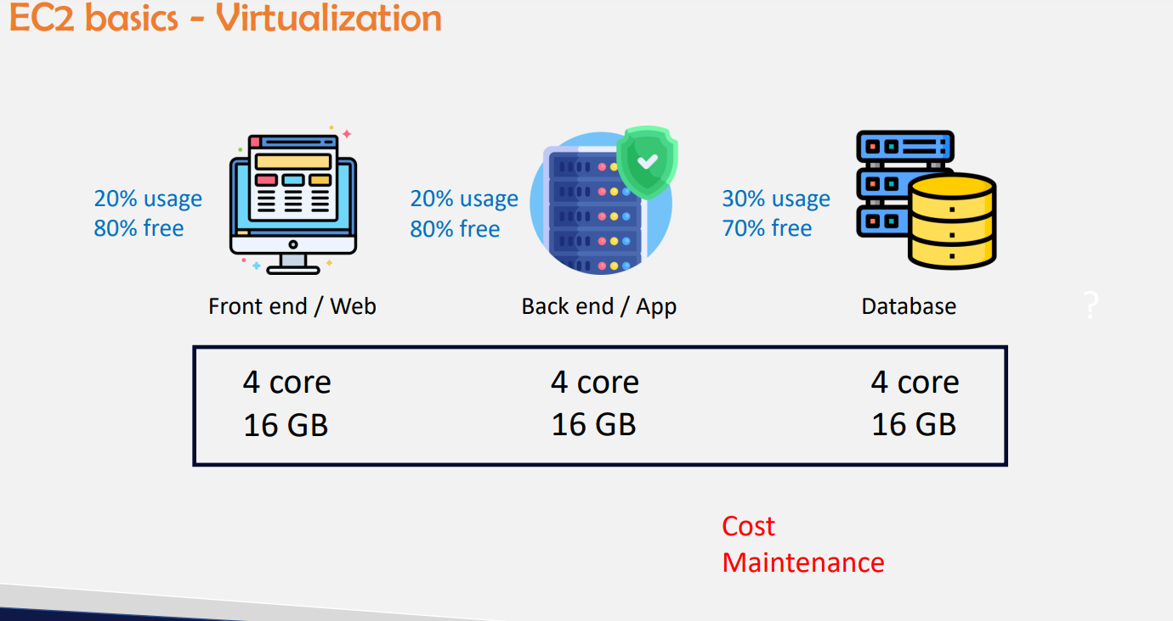

**Previously we need to mainitain cpu and Ram for each app i.e, Front end we need to maintain separately**

* **For backend we need to maintain separate cpu & ram**
* **For Database we need to maintain separate core & Ram**

**So previously it will be wasted as we can see from above picture that we only utilize 20-30% out of 100% utilization**

* **Actual utilization will be less and wastage will be more**
* **So cost will be more & maintenance will be more in terms of power cables ,cooling systems**
* **Again operational engineers should maintain this**
* **Cost -Total cost of ownership(capex)**
* **Maintenance – operational expenditure (Opex)**

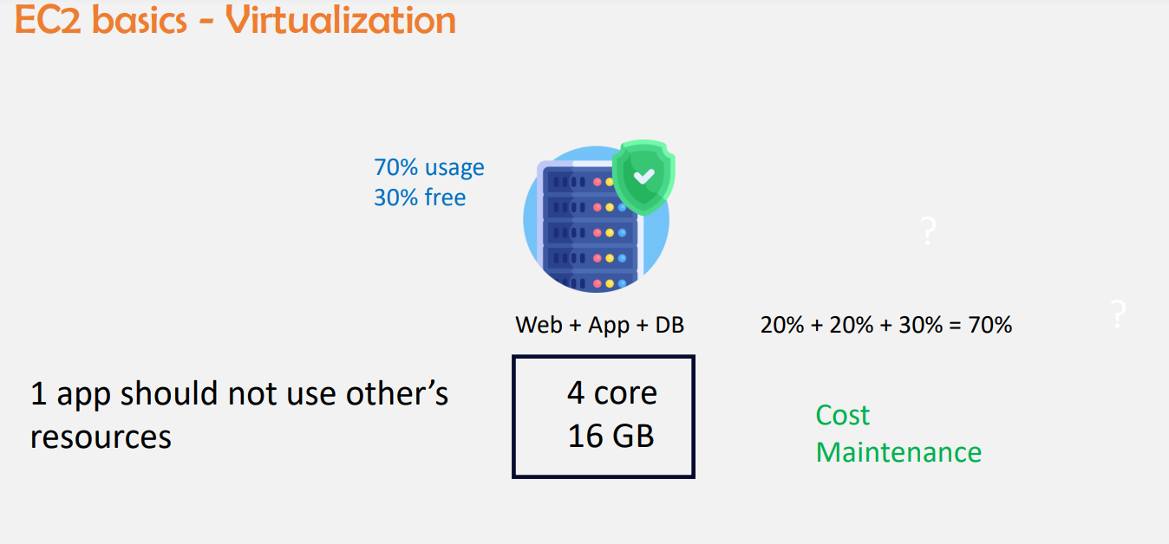

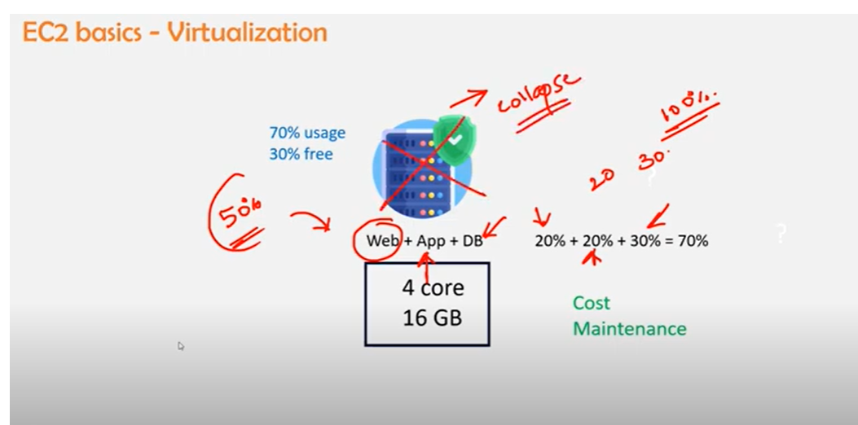

**If its placed in only one if web server is assigned only 20% but it consumed 50% of utilization that means that server might run slow to the users and it might be collapsed due to high utilization**

* **So what ever is assigned it should consume the same utilization <100%**
* **1 tier should not consume other tier utilization for example pubg if we have less storage in our phone and we download pubg mobile gets hanged as it consumes more utilization**

**No connection in between then**

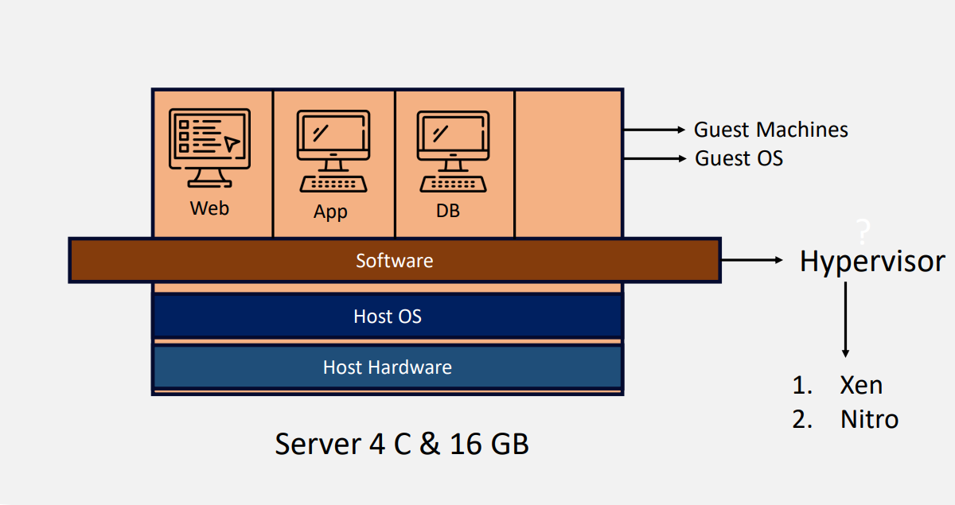

* **Physical servers**
* **Hypervisor is a software which allows 3 tier architecture to utilize only allotted cpu and ram**
* **It allows what you have allotted in Host os i.e in host os if you specify web should utilize only 1c1G Hypervisor duty is that it wont exceeds what ever is mentioned in Host OS**
* **Xen hypervisor is a open source hypervisor and it’s a 3rd party tool**
* **Nitro hypervisor is aws own hypervisor created by aws for high efficiency and performance**
* [**https://www.brendangregg.com/blog/2017-11-29/aws-ec2-virtualization-2017.html**](https://www.brendangregg.com/blog/2017-11-29/aws-ec2-virtualization-2017.html) **link for hypervisors**

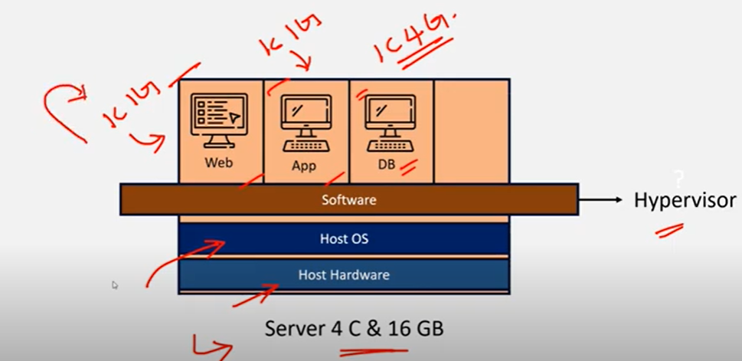

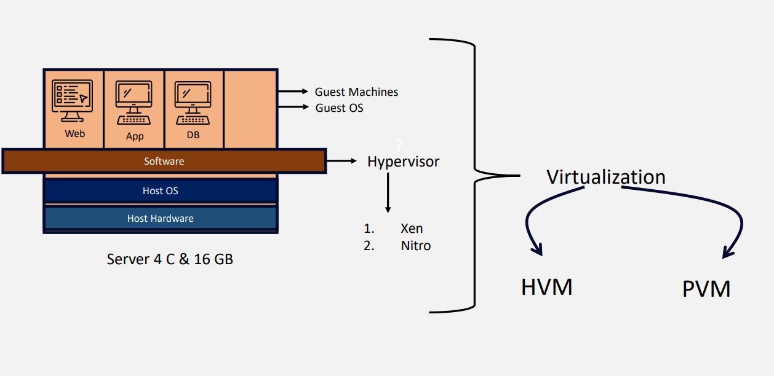

**SR-IOV**

**Hardware Virtualization: 100% virtualization and high performance when compare to PVM**

**Para virtualization**

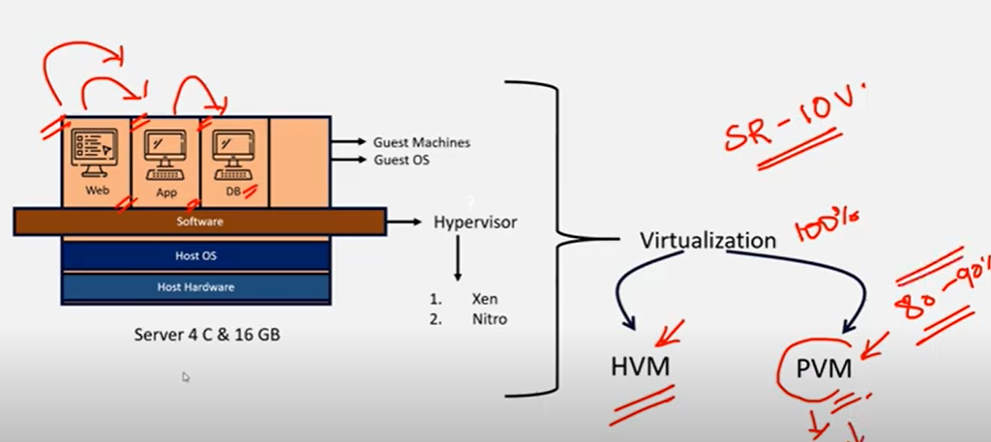

**In para virtualization 80-90% of the virtualization takes place becz from one tier to another tier it connects**

**So complete virtualization doesnot takes place**

* **NOW PVM is not using by aws as its giving less performance**
* **SR-IOV(Single route input ouput virtualization) for embedded machines we use this type of virtualization**
* **EC2: Virtualized machine after virtualization**
* **Baremetal : without virtualization physical server is called baremetal**
* **On ec2 if you perform virtualization it wont give much performance as it’s already virtualized**
* **On baremetal you can perform virtualization**
* **AWS +VMWARE (3rd party)**
* **Vmware is virtualisation software**
* **Vmware taked baremetal and his own hypervisor and makes it virtualized**
* **Ec2 previously are two types**

1. **EC2 classic (without vpc you can create servers) but now it has been removed from aws**
2. **Ec2 vpc**

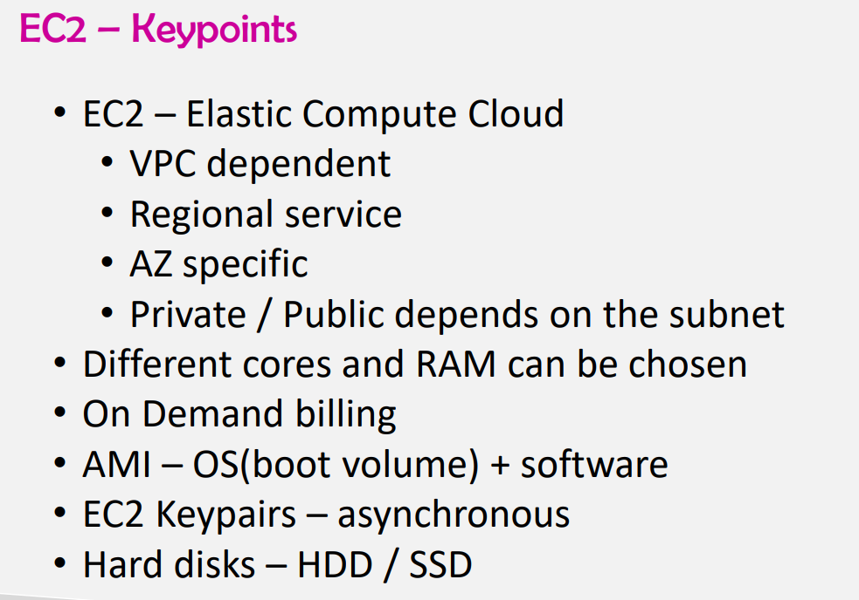

**If you create servers in public subnet then it is public server or else its private server**

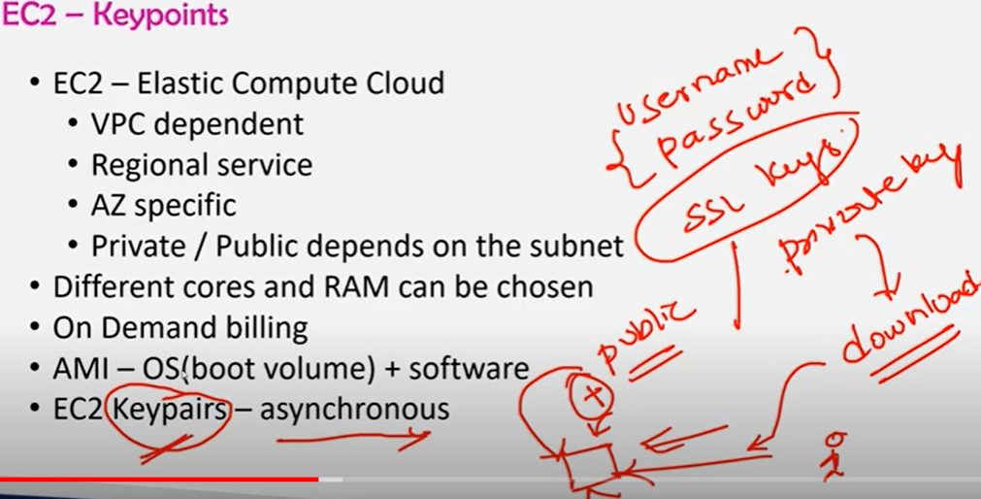

**Ec2 keypairs (synchronous key pairs is user name & pwd)**

**Asynchronous key pairs are SSL KEYS**

1. **SSL KEYS ARE OF 2 types**
2. **Public keys & private keys**

* **Private key while creating you need to download**
* **Public key will be stored in the server which u r creating then when you give private key to the server then you will get access to the server**
* **After creating server you can also change cpu ram**

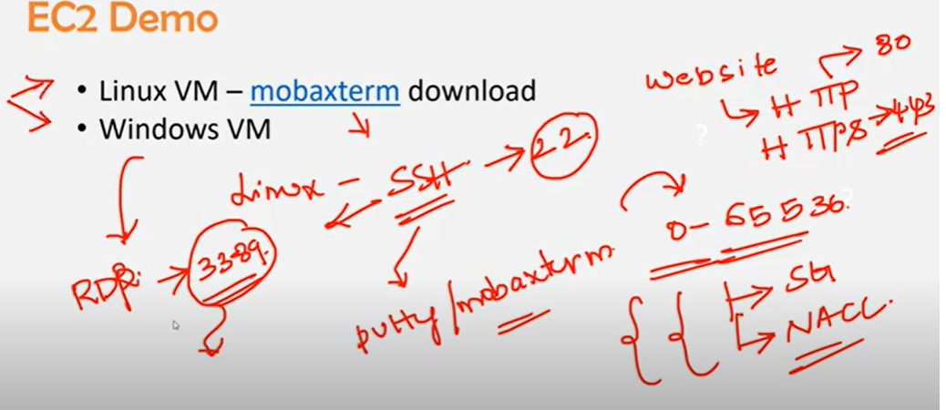

**For every website to get opened there will be https & http protocol**

**1)Http – portno 80**

**2)Https – port no 443**

**Linux machine to get runned on windows we need to have either putty/ mobaxterm**

**Linux protocol is SSH -port no 22**

**For windows RDP- 3389**

**This protocols need to be added in security groups if not it wont work**

**Ls-a list all files**

**Cd – change directory**

**Ls -list**

**Only putty uses ppk file rest use .pem**

**To create an EC2 instance steps**

**1)Instance Name**

**2)AMI (Amazon Machine Image)**

**3)Instance Type(cpu memory)**

**4)Keypair**

**5)Network settings(Vpc, subnets,Auto assign public ip ,security groups)**

**Security groups**

* **Security group name**

**Inbound security group**

* **Type, protocol,port range**
* **Source type source description**

**6)Configure storage**

If create you linux server in security group by defaultly ssh protocol wil be there and its port no 22

If create you linux server in security group by defaultly ssh protocol wil be there and its port no 22

* when you create server private keys will be there from downloads and public keys will be server
* Creating linux server(After creation )

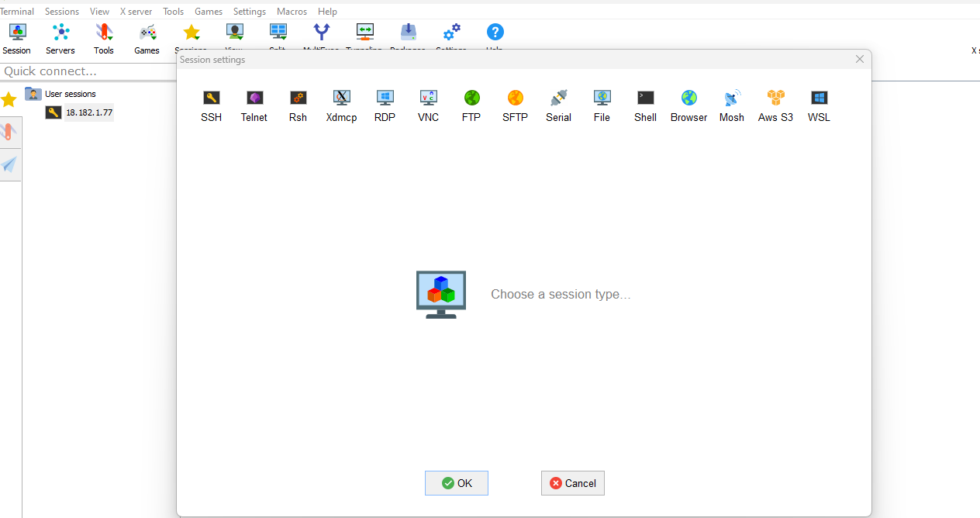

In mobaxterm application go to session and select SSH

* Remote host enter public ip address
* In advance setting private key select the file from the system which you have downloaded while creating the instance
* Linux server will be accessed and user name will be ec2-user

Then you can able to access

2nd method to connect linux server

* Select instance -> connect->select EC2 instance connect server directly gets connected in the browser
* This only gets opened when ssh (22 port is open )
* And public ip is enable

Ls -a (to list all files), cd.ssh (to go in to ssh folder)

Ls(list ) you will get access keys

Cat authorised key ( cat is to print) you will get public keys details)

PENDING TASK

1 . If you lost access keys( you need to same coonection through browser and create keys from open ssl or else you can create images for that particular instance (AMI) and you can create keys and use it

Windows server

* After creation of windows server click on connect select RDP client
* Upload private key and get pwd
* Update user id & pwd in remote desktop connection
* Your windows server gets connected
* For linux by defaultly 8 gb hdd will be provided
* For windows 30 Gb Hdd will be provided

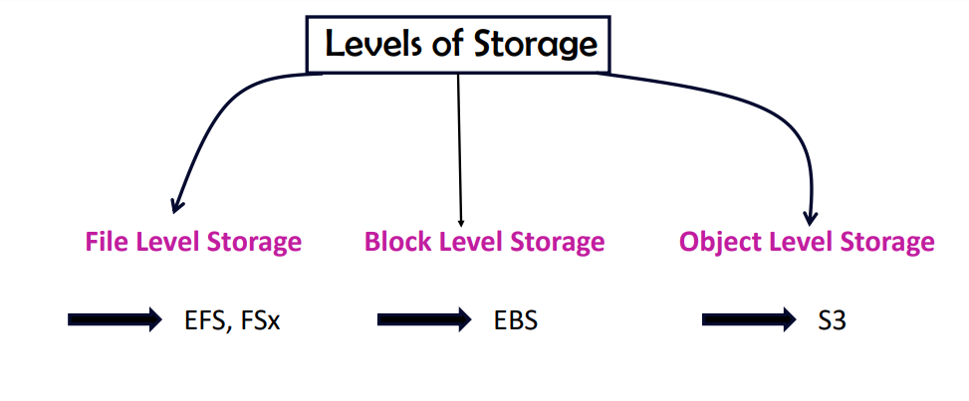

EFS : Linux operating system

Fsx : windows operating system

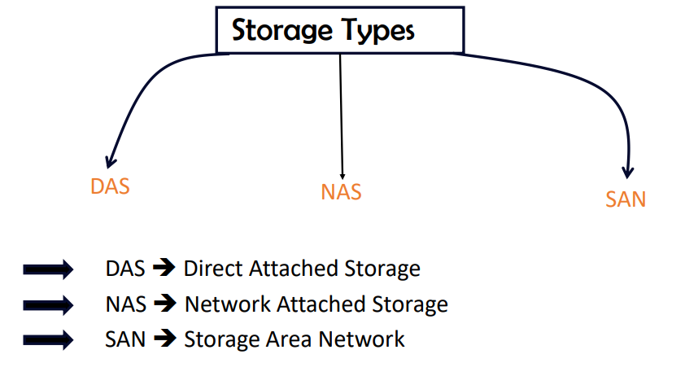

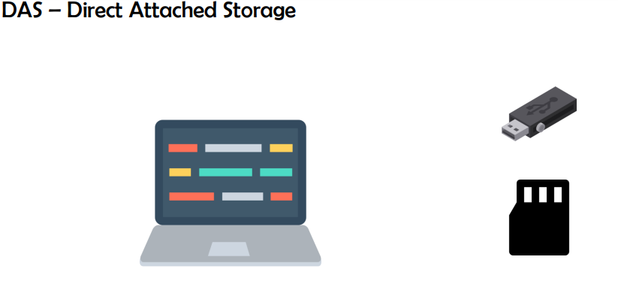

**DAS : according to the requirement what ever Is attached and removed is known as DAS ex Usb, Micro sd cards**

**In Aws DAS is Ec2 instance store is an example of DAS in Aws**

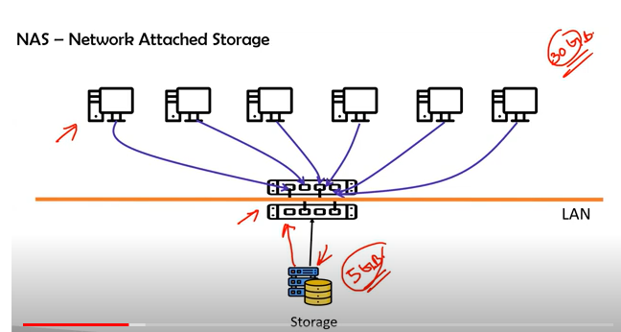

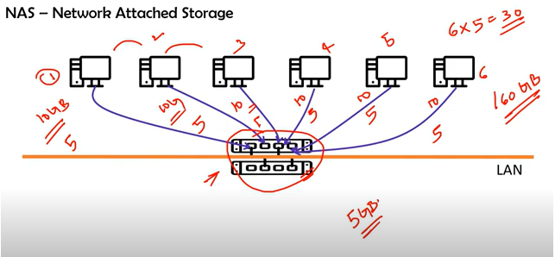

**NAS: If you have multiple servers and you need to share 1 file consisting of 5 gb data and server capacity is 10gb u cant go and add that file in each server storage gets wasted**

**So attaching storage over Network will be helpul so that servers can fetch the data from storage and space also would not be wasted**

* This is called NAS

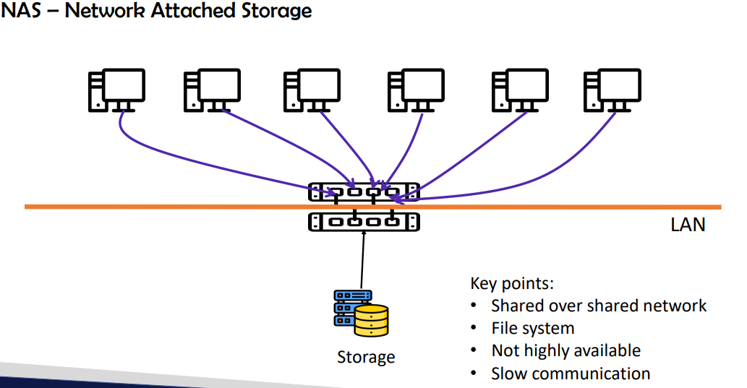

NAS examples in AWS :FSx,EFS.

* Usually NAS Is not highly available but AWS made it highly available
* In Nas only 1 switch is available if that switch fails entire server gets failed
* Cable is copper in NAS

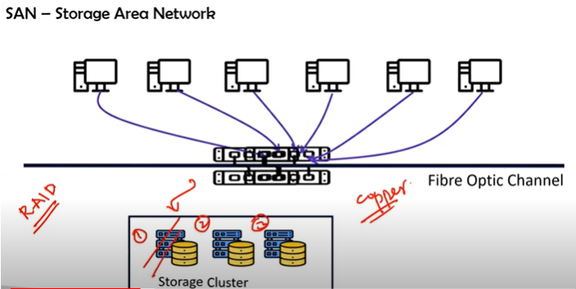

In SAN : high availability as there are multiple switches if one switch fails it shifts to another switch

* Fibre optic channel for fast performance
* Storage clustering (Raid 1(copy 1),Raid 2(copy 2) what ever data you store it makes a copy if one storage fails you can retrieve from another storage

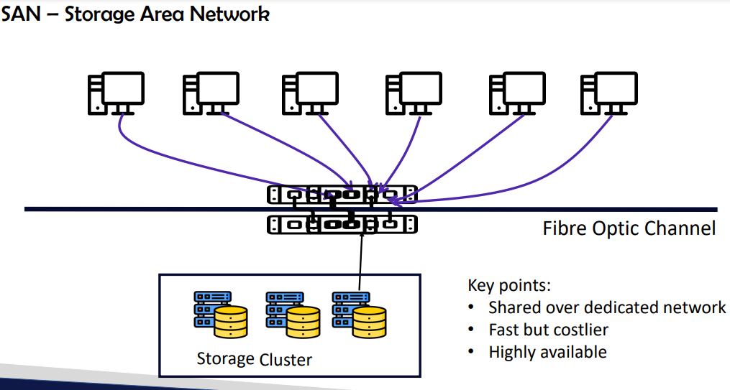

SAN example in AWS **EBS**

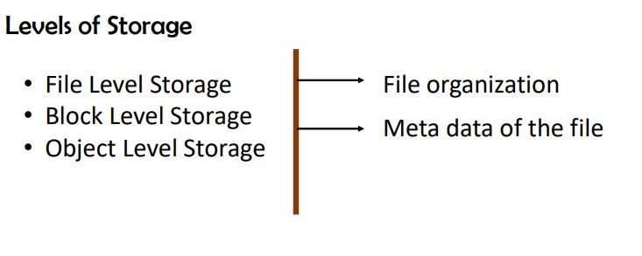

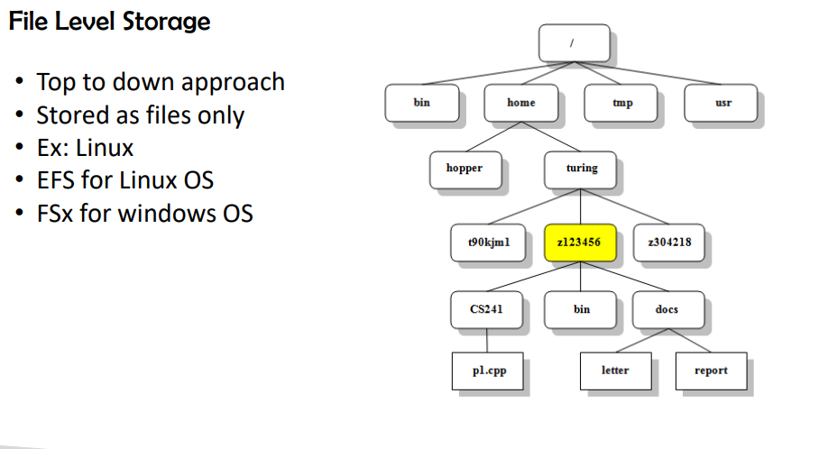

* In file level storage what ever data is uploaded it will be in file format only there wont be any seggregations

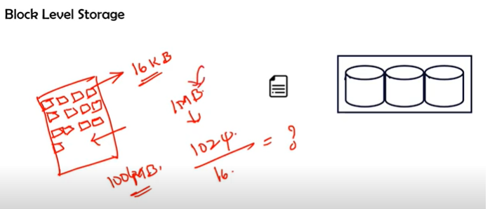

In block level storage data will be stored in the form of blocks

* Each block size in AWS is 16kb
* For ex 1Mb file u want to upload 1mb is 1024kb =1024kb/16kb

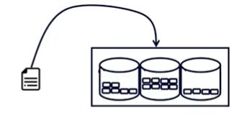

Data is stored in the form of blocks while retrieving it will collect all the blocks and sends us in file format

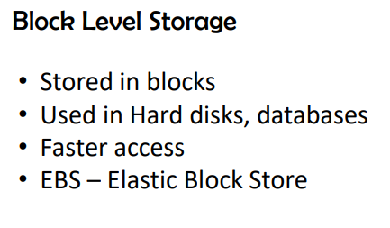

Each file data will be stored in different containers some blocks in container 1 some in container 2

**Object level storage**

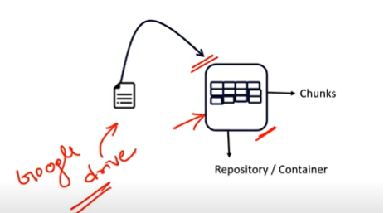

* In object level storage file is stored in the form of chunks in repositories /Containers
* One file data will be stored in one container another file storage in another container there wont be any connections between one repository to another repository
* Ex google drive,onedrive
* Pattern based search (.png, .jpg)
* Privacy policies we can set who can access the data

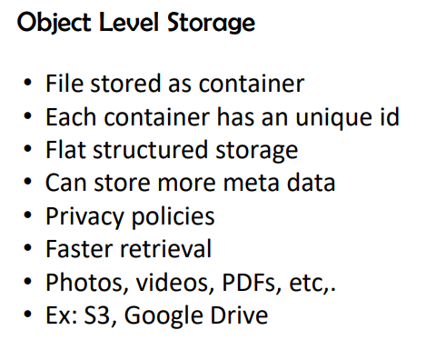

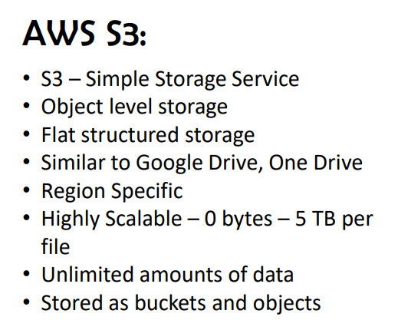

Costing : GB/month

Service wise data its global but what ever data you r storing is in region based

* In bucket creation region is specified

**Bucket creating steps**

1. **Bucket name(should be unique)**
2. **Region (in which region u want to store)**
3. **Object ownership**

* **ACL’S DISABLED(Recommended by AWS)**
* **ACLS ENABLED**

1. **Block public access settings**
2. **Bucket versioning (enabling or disabling)**
3. **Tags**
4. **Default encryption**
5. **CREATE Bucket and upload files**

**Best practice for bucket name -organizatin-project-app- random number**

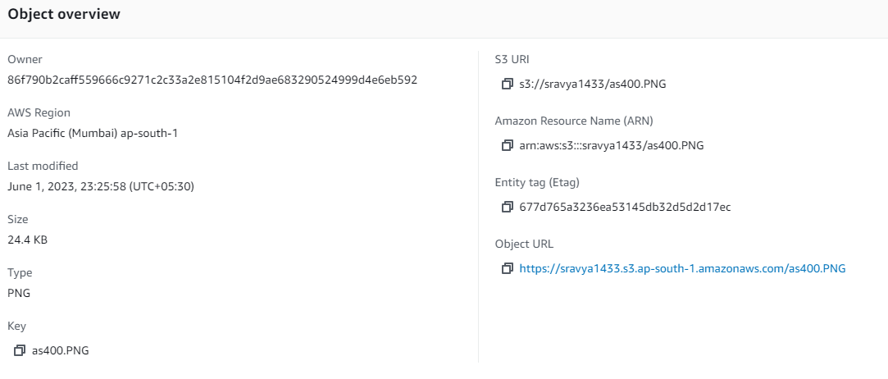

After uploading file you will get object url

Entity tag

ARN (Amazon resource name) will use in Iam custom policies if you want to give access for this particular bucket

If you paste that url in browser by default it wont gets opened

* For programmatic purpose we use s3 URI for upload and download the data
* Only for one file in bucket you can make in public from the entire bucket
* Permissions-> object ownership -> ACLS Enabled-> acknowledgement -> enabled still you cant access this file in public
* You need to enable public access
* Come back to the file in objects section click on actions make public acl -> save the changes

Then ur object url will work on chrome

* Bcz by default everything is private in aws until u make it public
* For giving public access to entire bucket files

Following is the program in permission tab->bucket policy

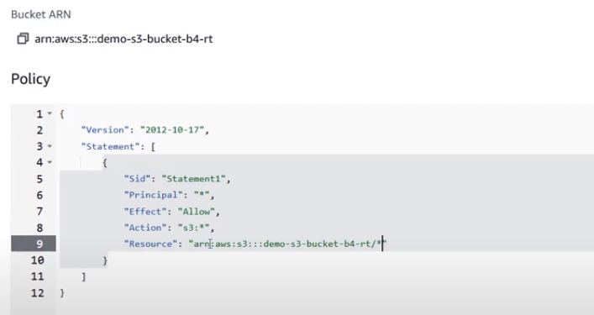

Bcz in production environment we have lots of files we cant go and give permissions for individual file

So for bucket policies if you mention this code it will get applied for all files in that bucket

{

"Version": "2012-10-17",

"Statement": [

{

"Sid": "Statement1",

"Principal": "*",(to whom you want to give acces ) * is for everyone

"Effect": "Allow",

"Action": "s3:*",(for which service )

"Resource": "arn:aws:s3:::sravya1433"(to which resource you want to give access

}

]

}

* For files you will give ACL’S enabled
* For buckets bucket policy
* Even though if you have created bucket policy and block public access is off still you cant be able to access the url as public access is high priority

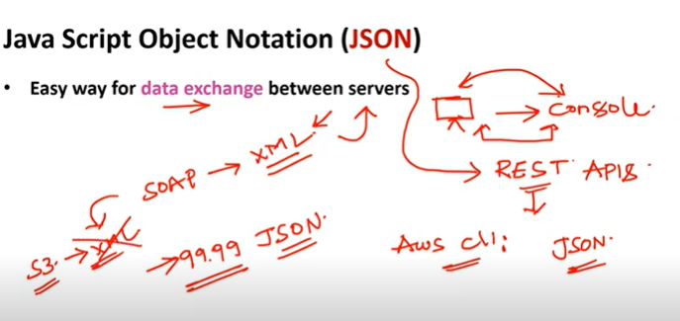

Json is used for data exchange between servers

For ex: from your laptop you are connecting to console

Between rest apis (use json)

* SCP(service control policies (to manage 4,5 accounts)

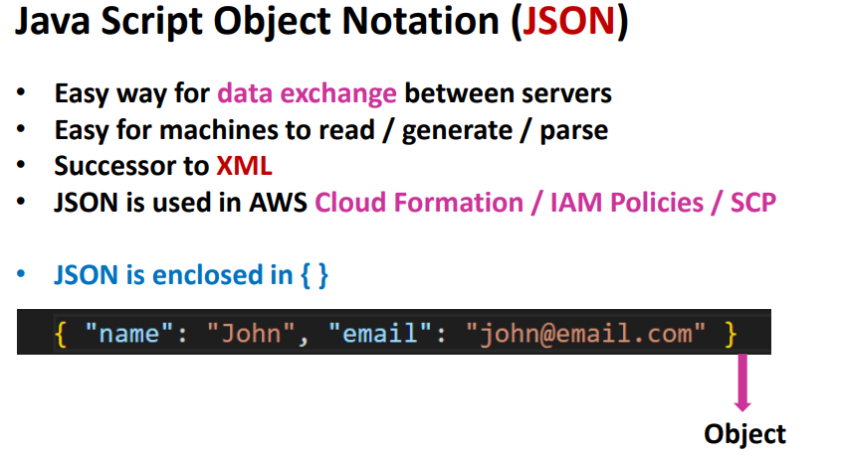

Json is enclosed in { } in python we call it as dictionary

Json formatter

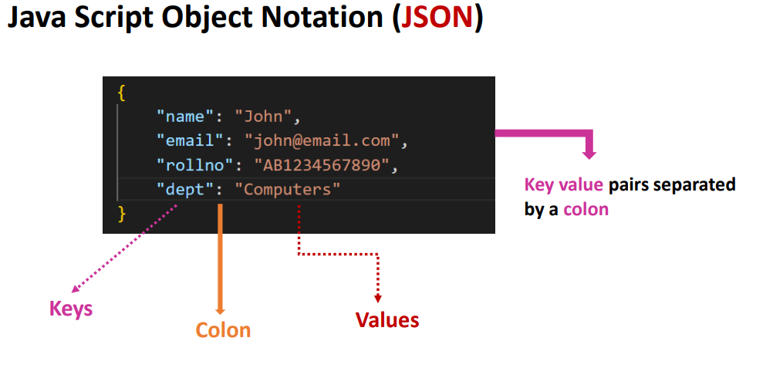

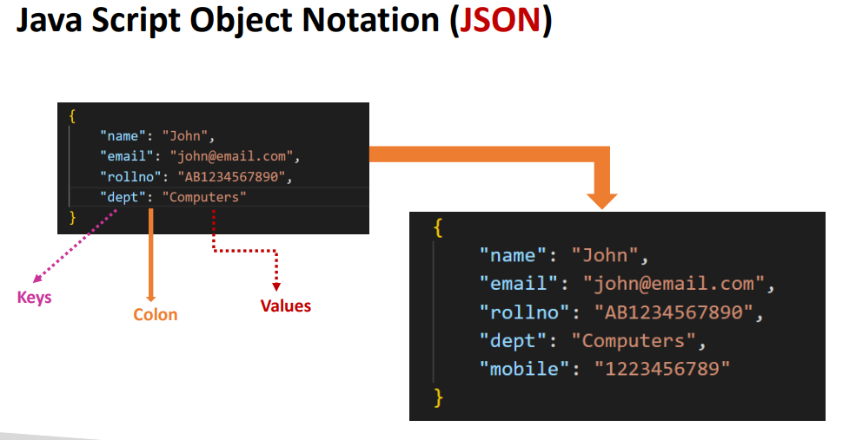

* Json keys left side would be string “ “

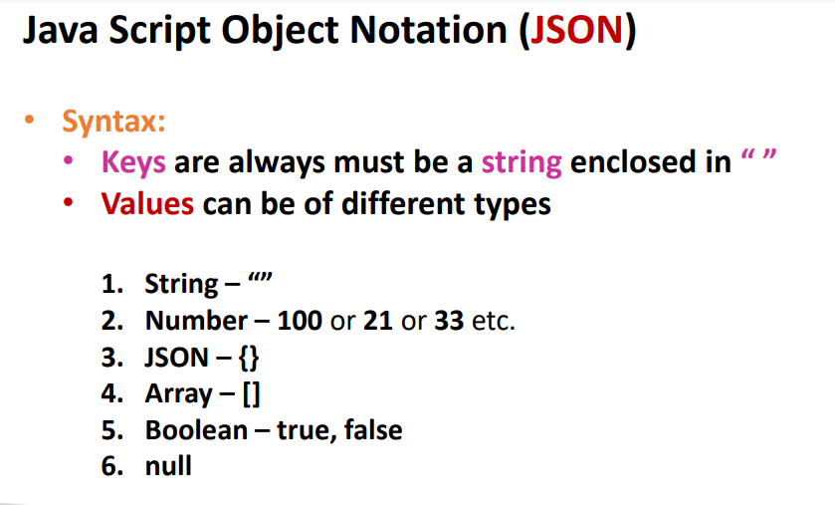

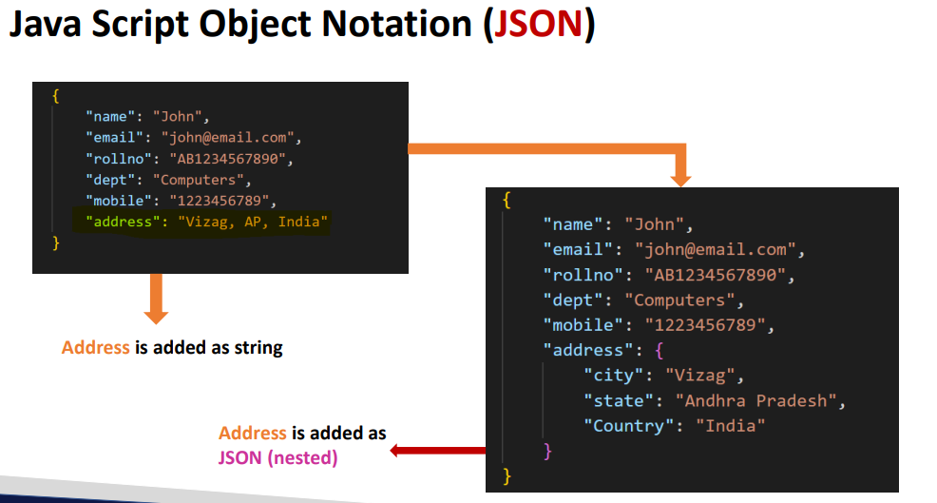

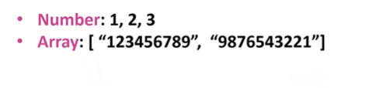

Array is used for similar types

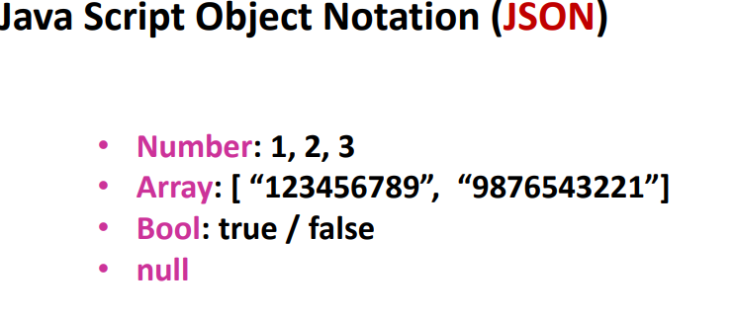

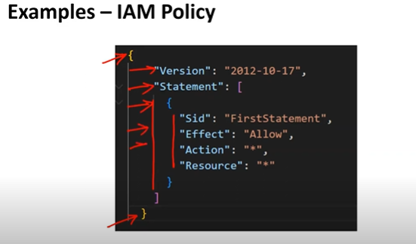

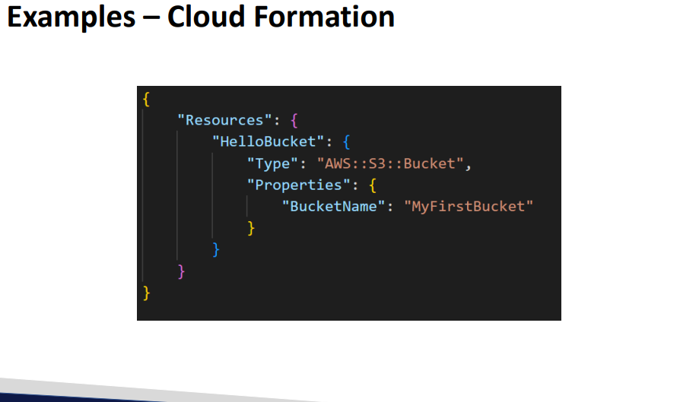

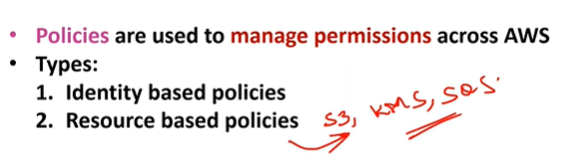

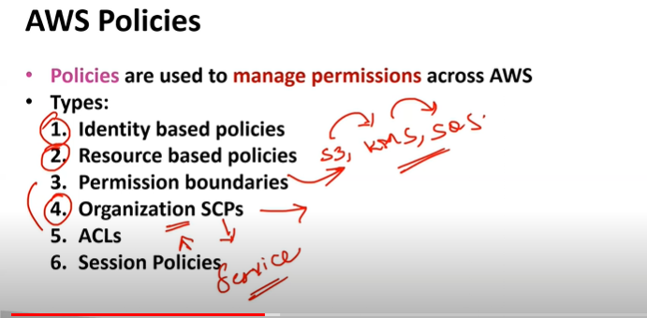

Identity based policies: are the policies of Iam like users groups roles

Resource based policy: the permissions which you give for services like public access to s3 is a resource based policy

* Resource based policy will not be there for all services only for few services it will be applicable ex: S3,SQS,KMS

LINK:

https://docs.aws.amazon.com/IAM/latest/UserGuide/access_policies.htmL

Organization scp’s to manage 4,5 accounts from one place we add those accounts to organization and for permission we use Service control policies

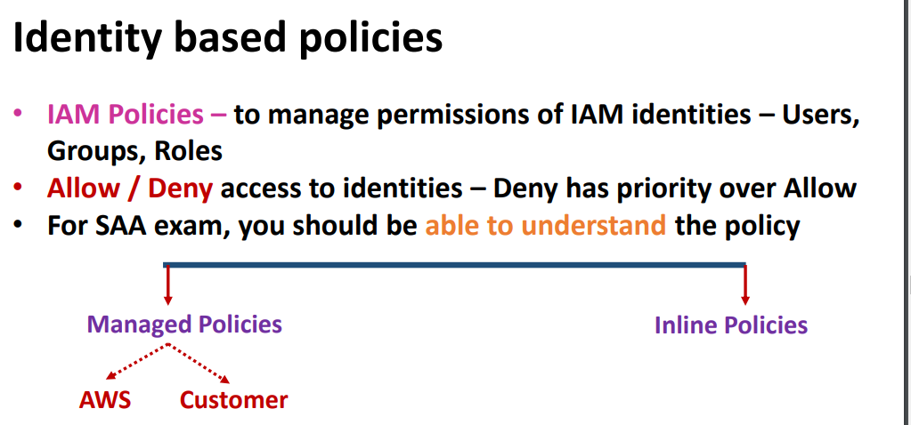

For all the services you will have full access and read access

Deny has more priority than allow

Link: <https://docs.aws.amazon.com/IAM/latest/UserGuide/access_policies.html>

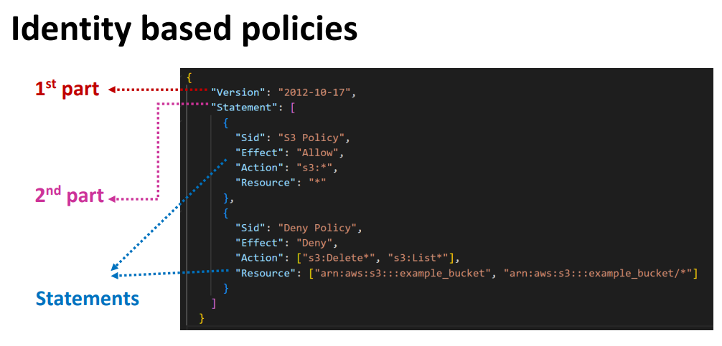

Link:https://docs.aws.amazon.com/IAM/latest/UserGuide/access_policies.html#policies_id-based

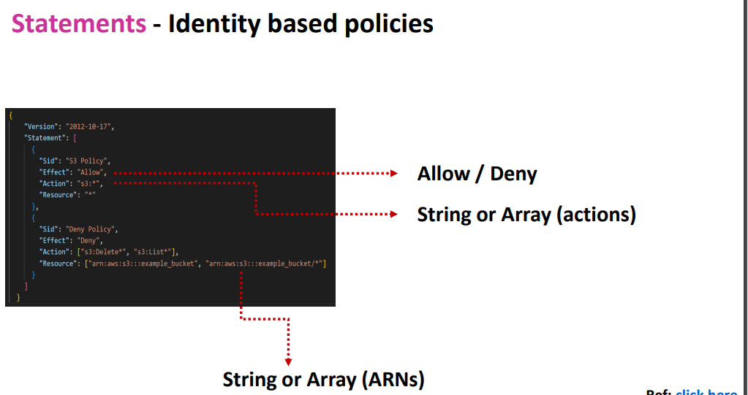

Effect : allow or deny

Action: string or array “*” represents all

CRUDLD(CREATE , READ, UPDATE , DELETE, LIST ,DESCRIBE)

* List is used for s3 bucket list I am users list Describe is used to specify

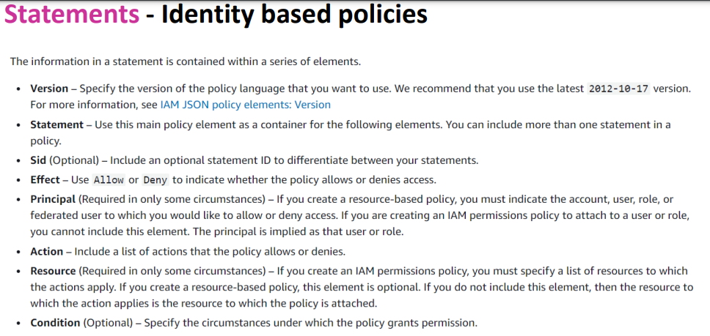

<https://docs.aws.amazon.com/IAM/latest/UserGuide/access_policies.html#policies_id-based>

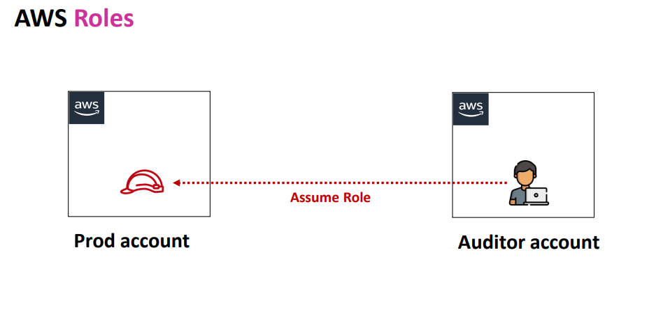

Auditor who has already aws act we only give role permission so that he can directly connect to production act

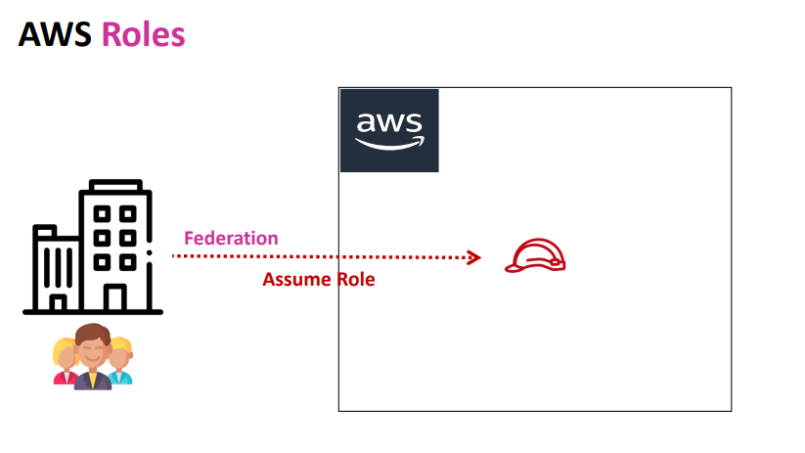

Active directory (Onpremise to aws ) is known as federation using assume role

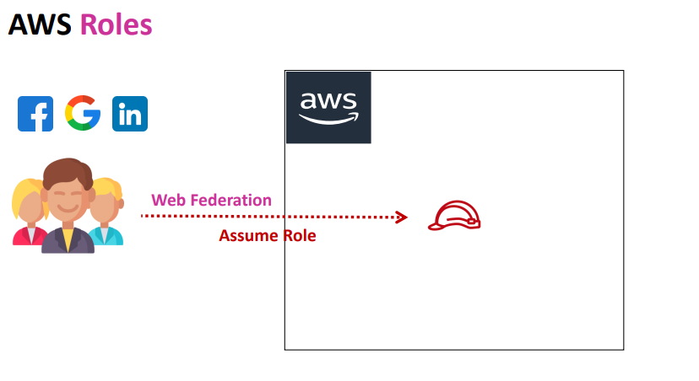

Social media to aws connectivity isknown as web federation with assume role

IAM Policies : demo

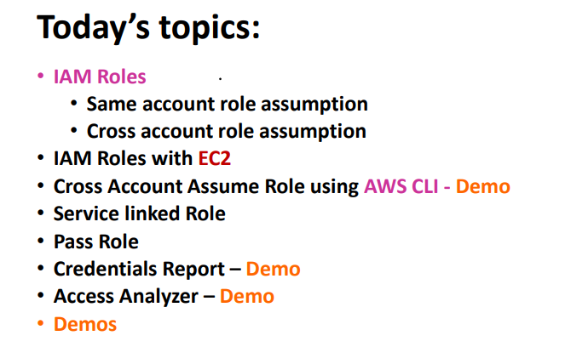

Inline policy is will not be aws managed or else customer managed policy

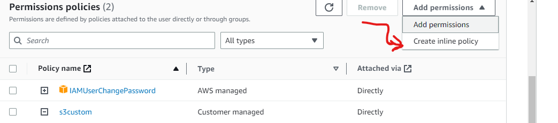

It will be only applicable to only 1 user and when u click on add permissions for that particular user u can able to see option called create inline policy

* In policy section you cant be able to see inline policy
* If its aws managed or custom policy it will be applicable for mulyiple users
* Where as inline policy is applicable only to the user which u r creating
* We will using aws managed or custom policies if we want to apply for groups & users
* Inline policy is to apply for specific user
* But performance will be same for inline and aws managed policies

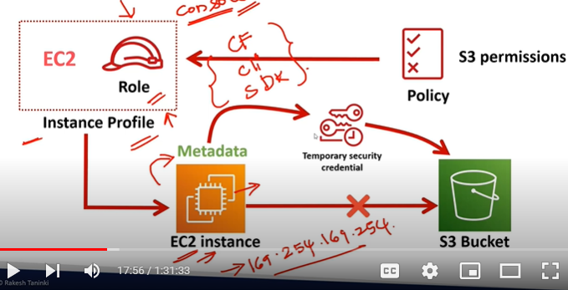

If you want to connect to s3 from Ec2 first u need to create Iam user then using those access keys you can connect to s3 bucket

* But as per best practctice you should not use access keys and secret keys all the time
* Instead of that you can create Iam role for EC2 if you can directly connect instance to I am role you need to have instance profile for that
* But when you create I am role using console aws will automatically create instance profile
* But when you create roles using cli,Cloud formation ,terraform it wont create instance profile automatically u need to create separately role and along with instance profile
* From Iam role you can get credentials for ec2 to get connected with s3
* First you will be creating Iam role by adding s3 permissions to it by instance profile you can connect
* Then that s3 permission will attach to iam role
* The ec2 gets temporary credentials from metadata
* Imp EC2 meta data will be stored in o

169.254.169.254 ip windows server or linux server what ever server it might be the metadata will only get stored in 169.254.169.254

* Meta data is nothing but details of server for ex: instance name , which vpc its running on and on which subnet its in
* For EC2 metadata we need to reach 169.254.169.254

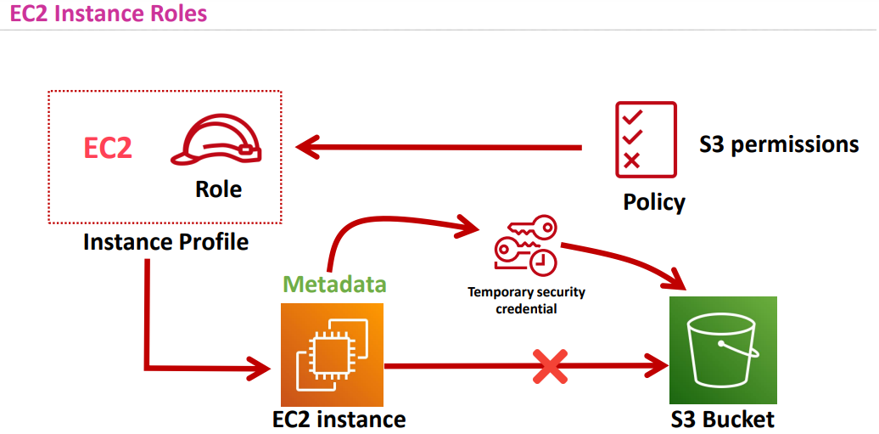

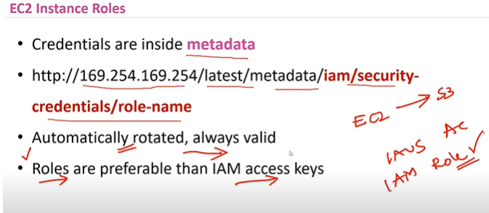

* Roles has high priority than access keys if you have in exam like if you want to connect EC2-> s3 which option you choose
* Options are

1. I am access keys
2. Iam roles (choose ans as Iam role)

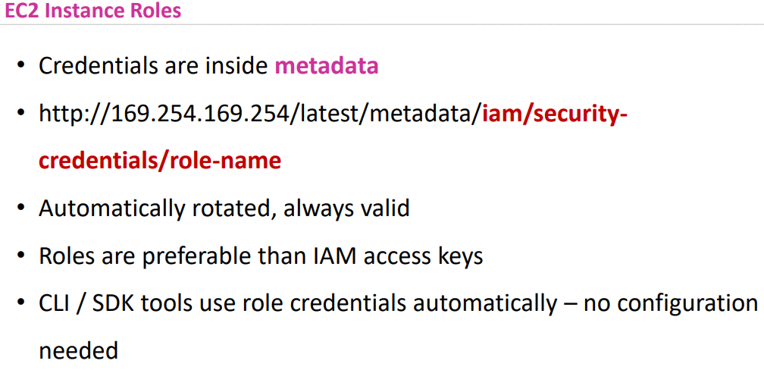

* Credentials can configure in different ways

1. Credentials.aws
2. Environment variables
3. Roles

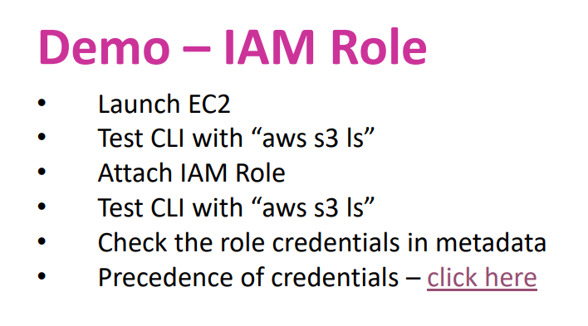

Link:https://docs.aws.amazon.com/cli/latest/userguide/cli-chap-configure.html#cli-configure-quickstart-precedence

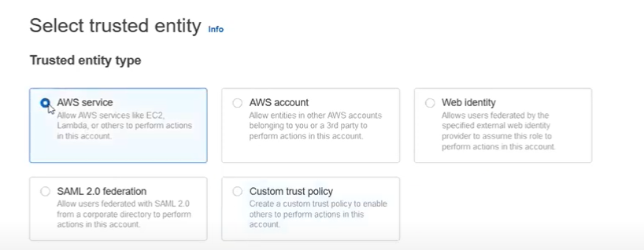

In Iam roles you have different options

1. AWS service- for connectivity between services inside aws
2. Aws account – for connectiving between different accounts
3. Web identity- connectors from social media to aws act ex: google ,fb etc
4. Saml 2.0 federation – Active directory (on premise to aws act
5. Custom trust policy- Iam from anywhere you can create

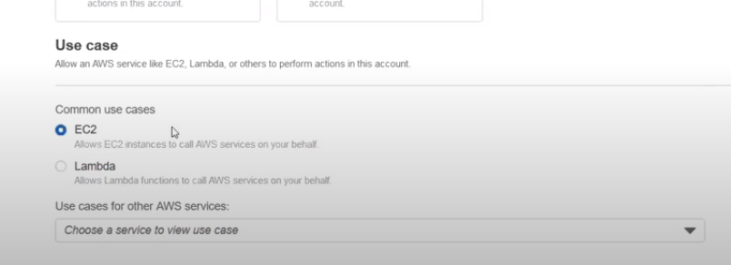

For which service u want to create role

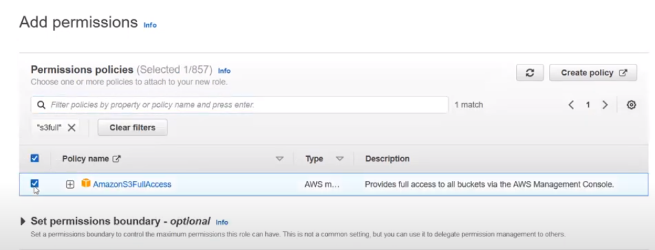

Role name-> create role

* As soon as you create role instance profile for ec2 also gets created

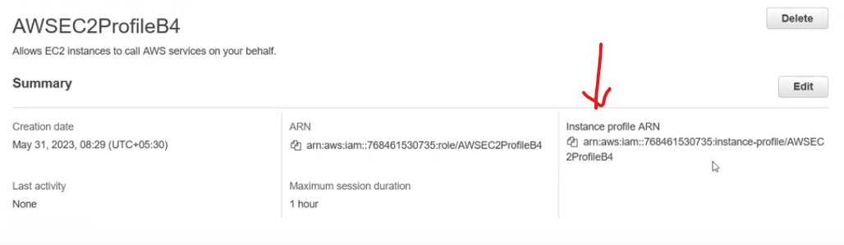

Profile arn is only for ec2 instance

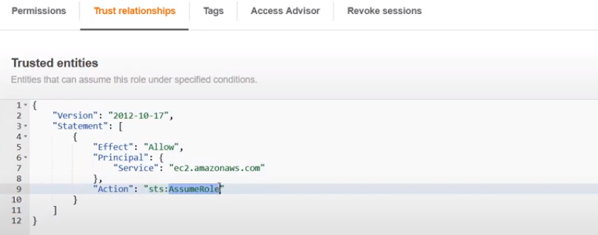

In service its ec2.amazon.com it’s a url for that particular service

Action: sts .assumerole( simple token service)

If we have this then only we can generate temporary credentials

Maximum session duration of role is 1hr to 12 hrs

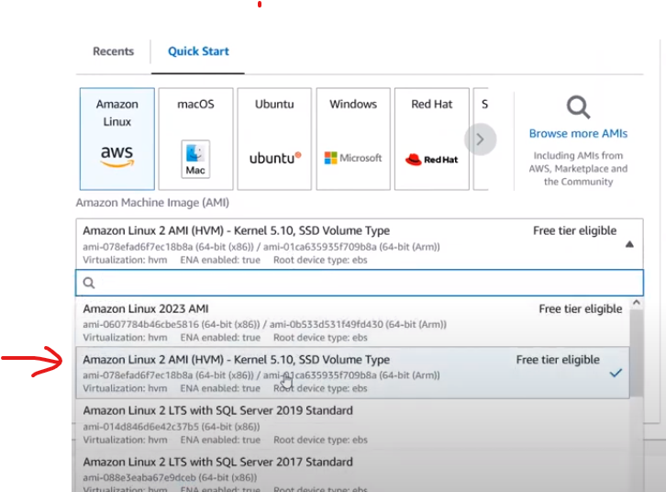

Create ec2 instance with this os

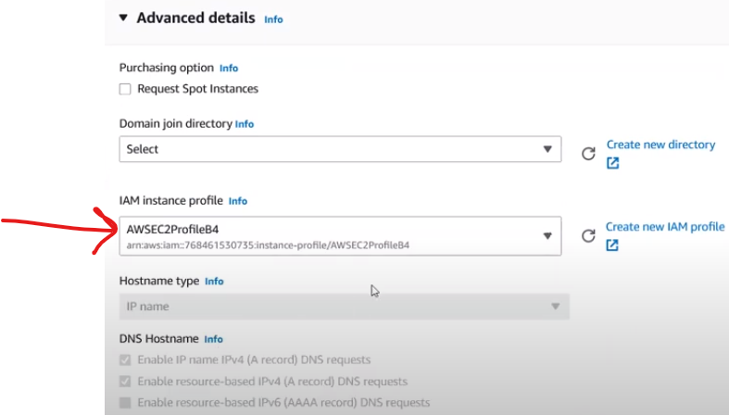

In advance options while create ec2 you will get option like iam instance profile which u have created

* Then click-> launch instance

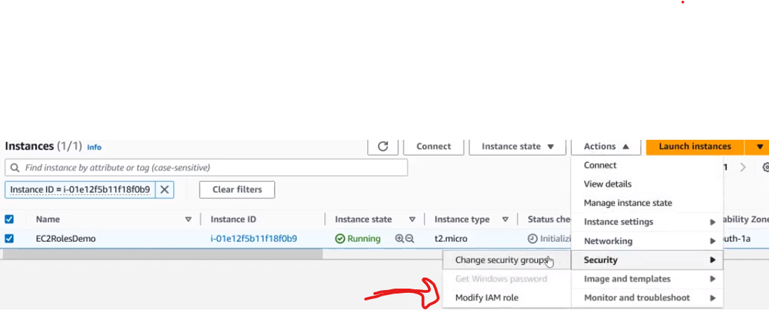

If you forgot to add iam role in ec2 you can later attach like shown in picture



From connect try to connect the server type the following command aws s3 ls

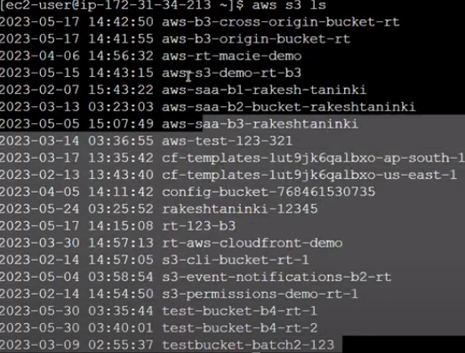

You will get bucket list like this



If you want check bucket files aws s3 ls s3:// bucket name

Automatically credentials got configured



If you type aws iam list users command it throws error as from ec2 you have only permissions for s3



For metadata

For metadata latest version type latest at the end of the command

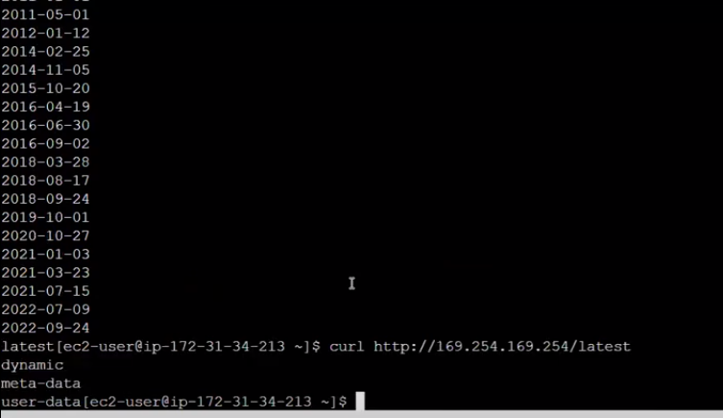

For extra details inside metadata if you want to check run these commands



For which role has been attached if you want info regarding that type below commands

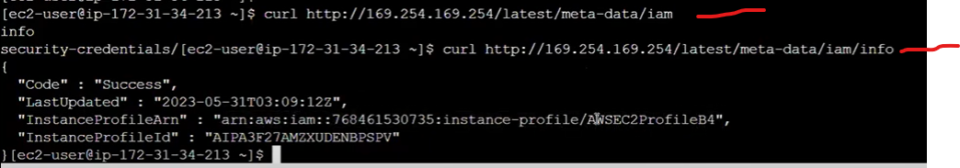

* Delete the instance after completeion of task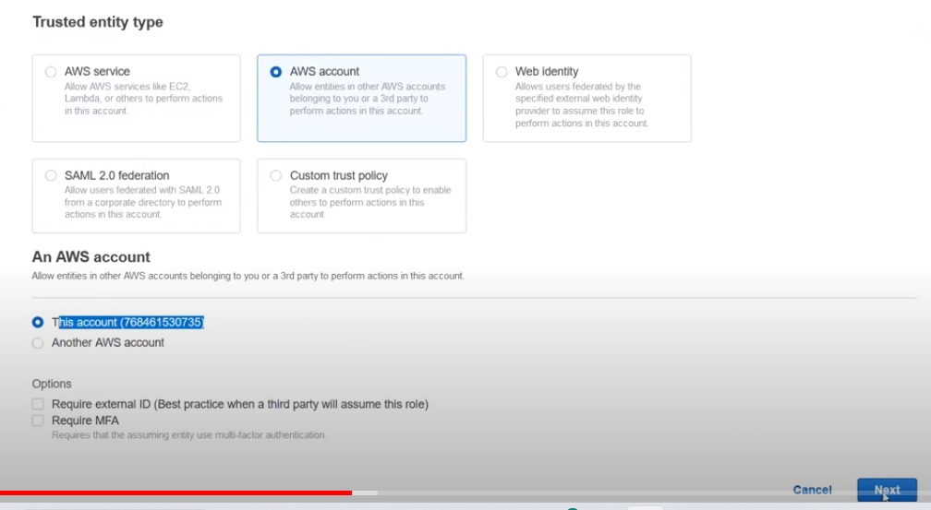
* Now demo is for roles – aws account

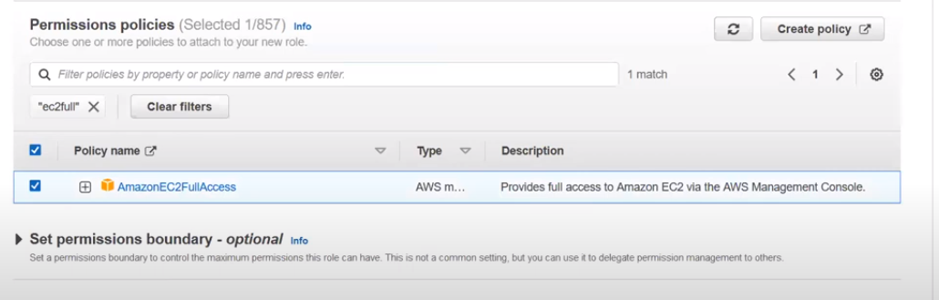

For same act in principal it shows ur own act id

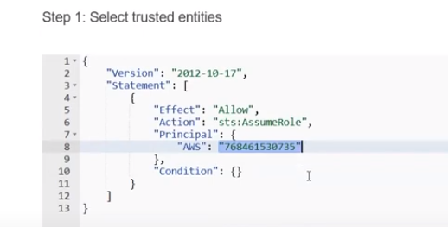

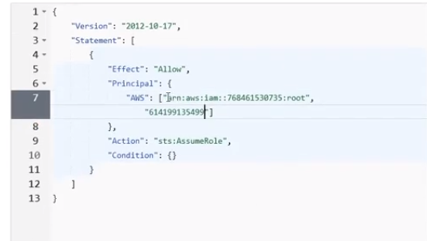

For another act you can add act id by creating array in principal section

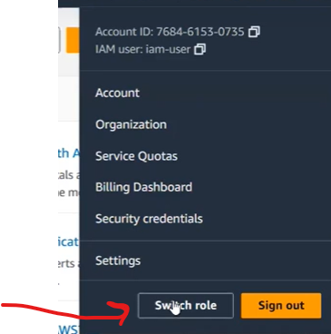

Switch role options will be there in only aws iam users act not In root act

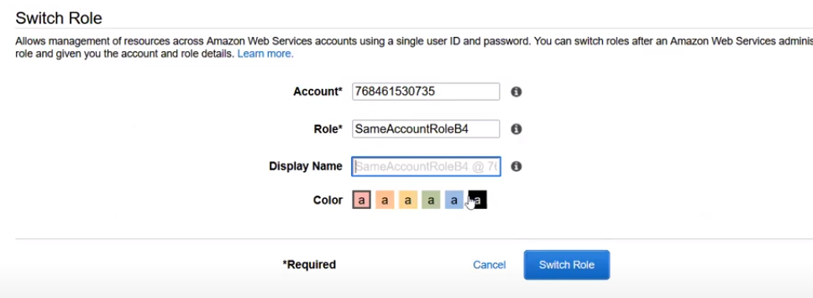

In switch role you can switch to your own act with role which you have created

.in switch role from the user which you have created the switch should have role permissions if not you cant switch to that role

* Switching the role u need to connect with account no and role name

Create inline policy for that particular iam user so that role gets assumed

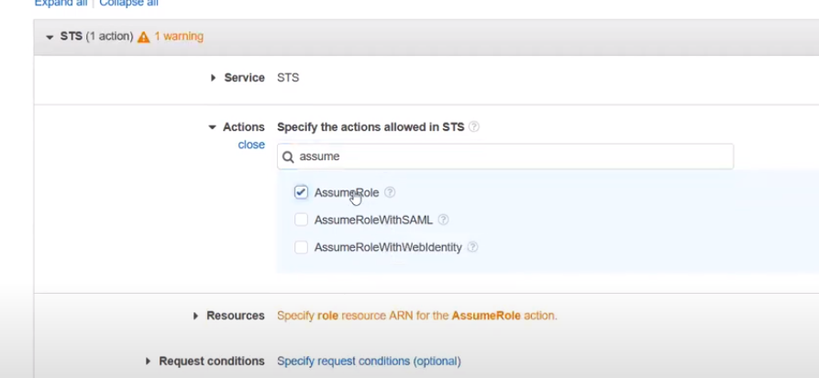

Iam role for cross act

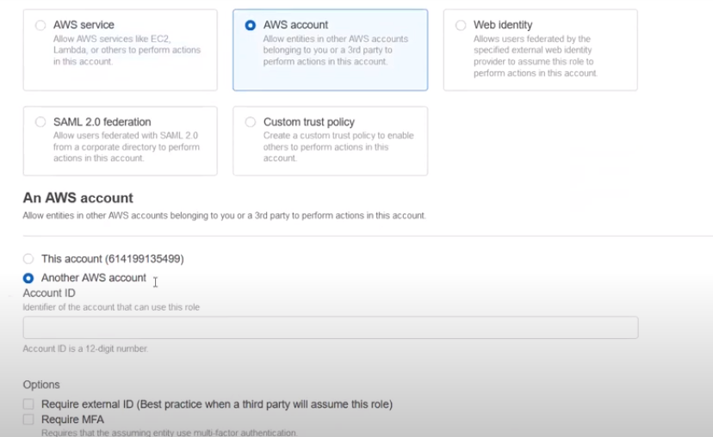

Create iam role for another act

In real time scenarios if ur organization has 10 acts u only create 1 user and give all 9 act iam roles permission to switch from one act to another act

* For Cli create iam user – with access keys

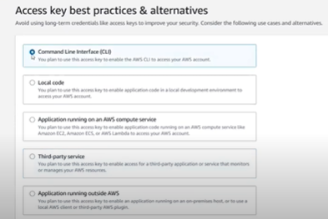

After creating access keys open cmd

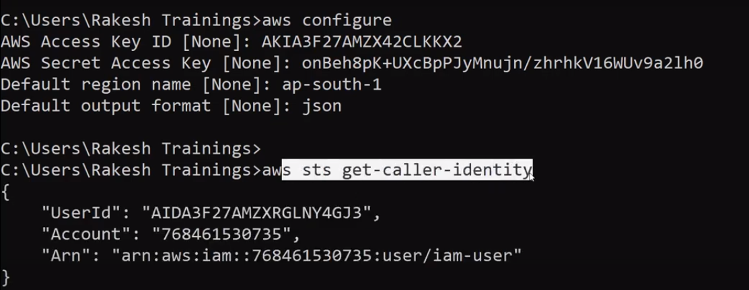

Aws configure & AWS sts get-caller-identity will give u act info from which act u logged in

commands

Cd .aws

Notepad credentials

For switch role cd..

Temporary credentials

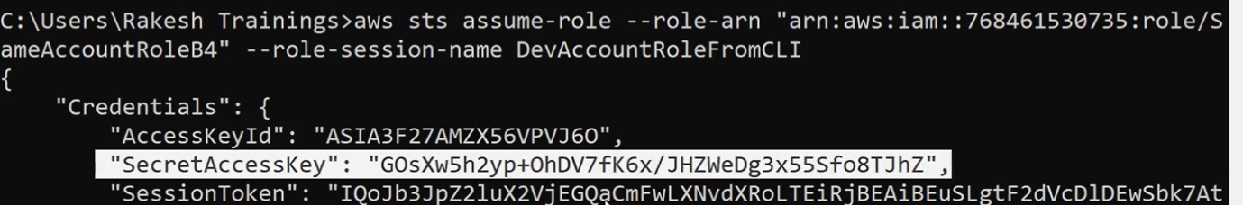

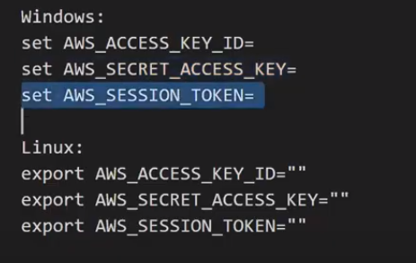

For automation

Cd .aws

Dir

Notepad credentials

Notepad config

In config file add profile assume role

Iam roles using cli

* As iam roles need user to switch act first we need to create user and need to create access keys for that particular user
* For configuration of aws need to open cmd and type aws configure command
* Then give access keys and secret keys to it
* 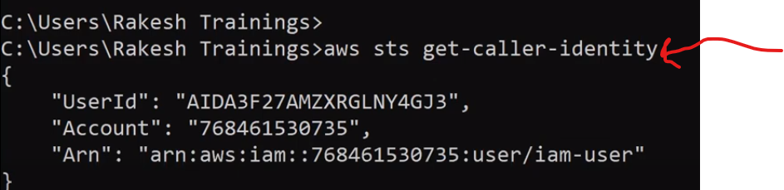

Aws sts get-caller-identity - to know your login identity (which user u logged into)

Cd .aws

Notepad credentials

Giving user assume role permissions for that particular user command

aws sts assume-role --role-arn "arn:aws:iam::123456789012:role/example-role" --role-session-name AWSCLI-Session ->session name

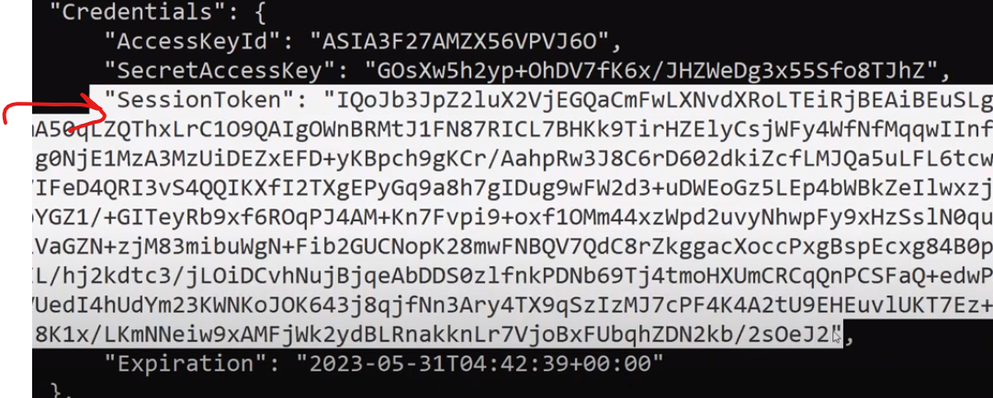

For every session token gets generated for temporary pupose and u will also get expiration details

* Directly u cannot switch as its cli so for confirmation again type command aws sts get-caller-identity
* For switching u need to configure it in environment variables in another command prompt
* If u configure aws configure again it will over ride the credententials so only for that particular session we are using
* set environment variables
* Windows:
* set AWS_ACCESS_KEY_ID=
* set AWS_SECRET_ACCESS_KEY=
* set AWS_SESSION_TOKEN=

linux:

export AWS_ACCESS_KEY_ID=""

export AWS_SECRET_ACCESS_KEY=""

export AWS_SESSION_TOKEN=""

* what ever u configure in environment variables it has more priority
* after expiration u need new credentials
* for automation of credentials
* cd .aws
* dir
* notepad config in config file u need to config role

[profile assumerole]

role_arn = arn:aws:iam::768461530735:role/SameAccountRoleB4 (role details)

source_profile = dev-admin-user (user name)

* take another cmd and type aws sts get-caller-identity - - profile assumerole (you will get temporary credentials as you have automated)
* notepad credentials

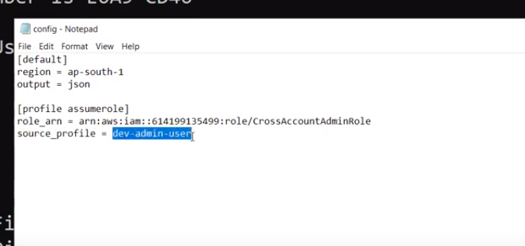

Credential Report ( for ex you have lots of users in your organization so ) so you want to check there credentials for all the users

* you can generate the report it will be in csv format
* you can see all the details in that particular report

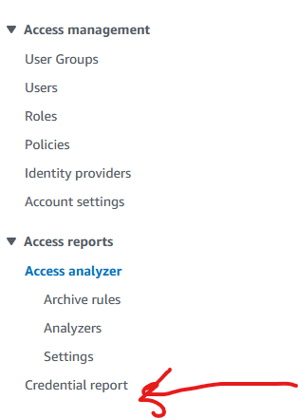

**Access analyzer**: it analyses the security issues of iam and s3

For example s3 bucket shoulnot be public if our s3 bucket is in public it shows it in access analyzer

* in Iam if we give access to another act then also it shows that info in access analyzer
* for the first time if your are creating access analyser it needs 30 to 40 mins for findings
* and you can resolve the issues by clicking archive if you intendly done if not you need to remove the access and next need to rescan
* security hub service is also for security findings
* Service linked roles: In aws we don’t have direct access to connect from one service to another service for that purpose we are creating roles in that
* Aws automitally creates service linked roles when you activate that service for ex: if you activate
* 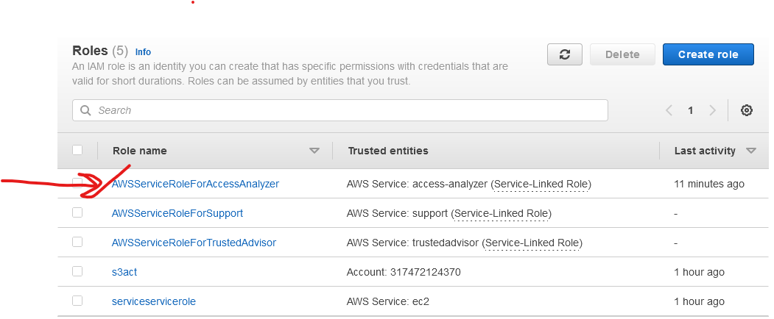
* As soon as you activate access analyzer aws creates service linked role naming AWSserviceroleforAccessAnalyzer
* Pass Role : if you are creating an Iam role for particular service you need to have passrole permission to acttach that role to service if not role doesn’t wrk on that service
* Assume role”: Assume role is for temporary credentials pass role is for attaching roles to service

**Organisation:** To manage multiple aws accounts easily

.in real time we have multiple accounts so for billing purpose we need to login to each act and check billing

* To erase that issue will add those accounts to organization by considering one of the act as head act

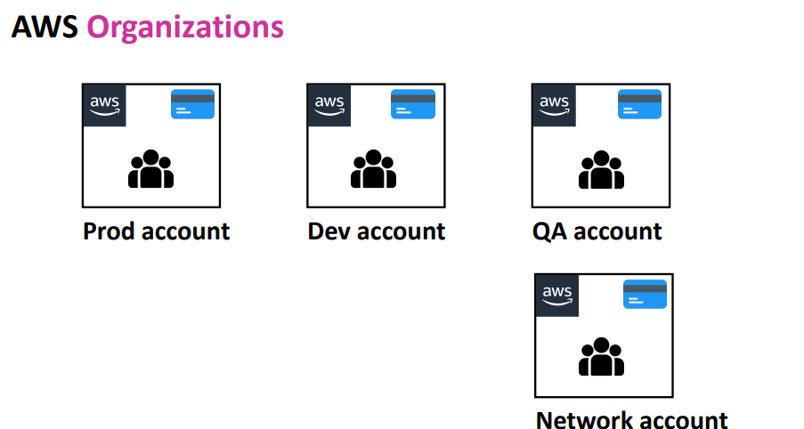

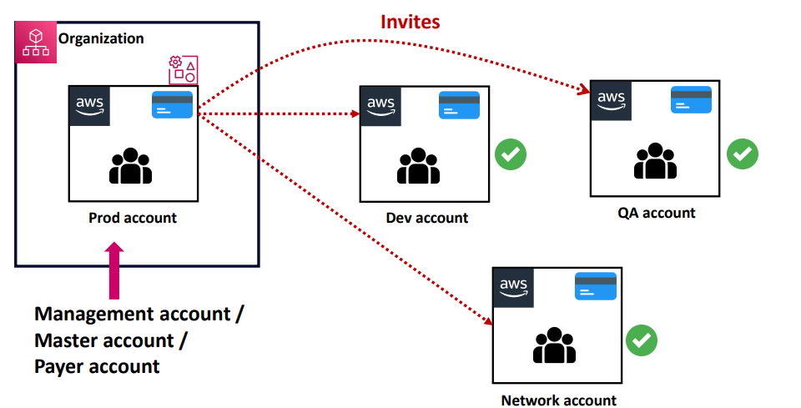

Considering pro act as head account we call it as Management account/Master account/Payer account

* From management account we send invites to another accounts like dev,Qa,Network account and make sure that to those accounts which u r sending invites should not not be in any other organization act
* Once other accounts which got request they can deny or accept the request and those accounts which accepts the request will be part of organization

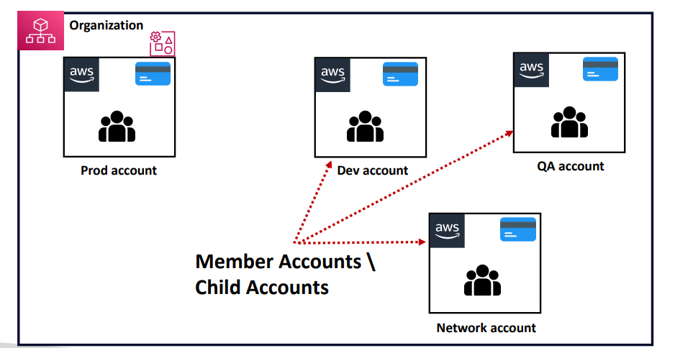

From Master account you can control other account permissions even regions , service access everything you can control

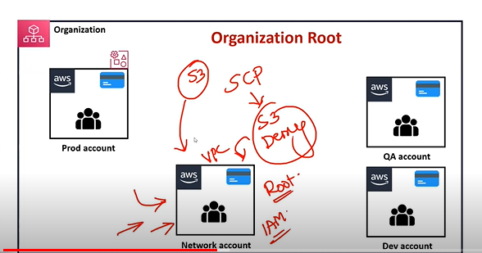

By using SCP: service control policy we control other accounts for ex: network acct should access only vpc permissions and other services should not be able to access we define same in scp

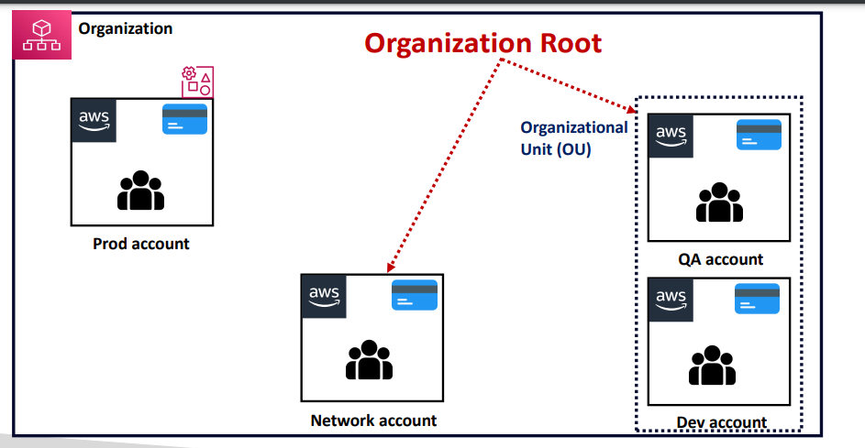

We can group the accounts to one unit(SIMILAR ACCOUNTS) to make easier

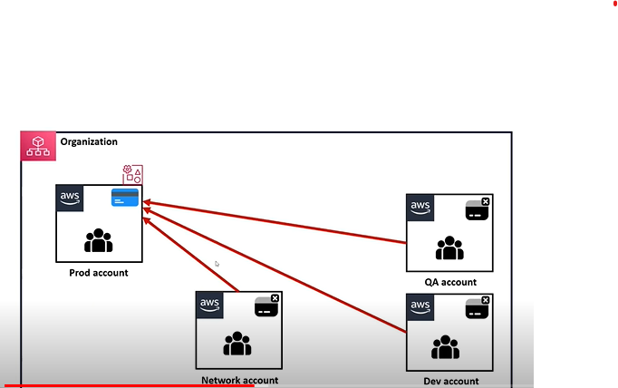

Billing responsible will be prod account

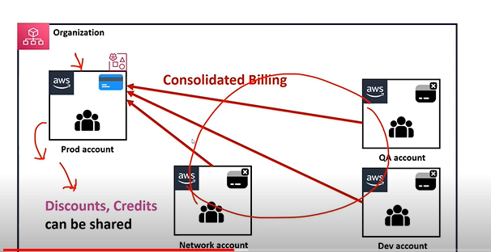

Credits from prod acct can be shared within the organization

If you create new act in organization it wont ask card details as billing will be managed by prod act

* In organization free tier will be shared by multiple organization

Yo wont get multiple free tier

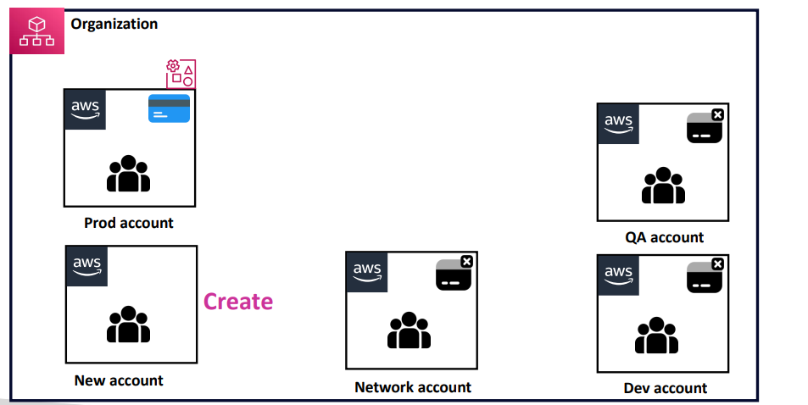

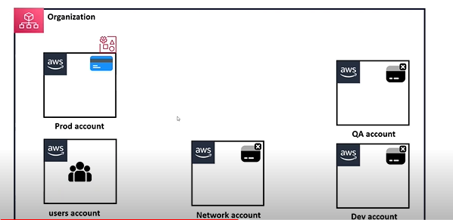

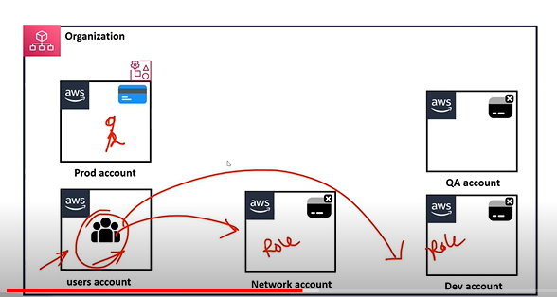

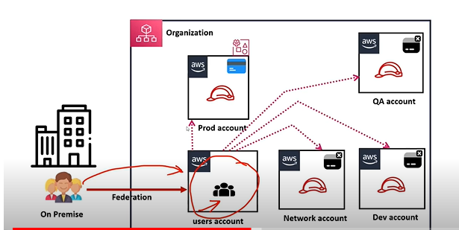

Multi organizations wont be possible for single act

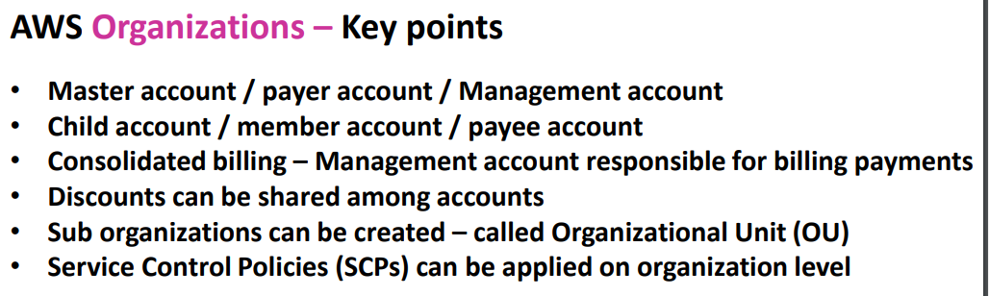

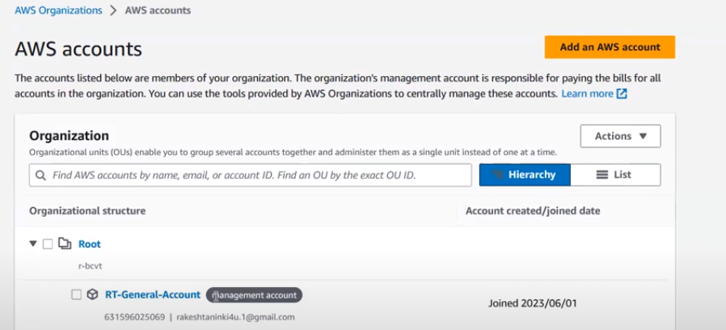

The account which ur creating organization will be management account

* From add accounts option you can add accounts

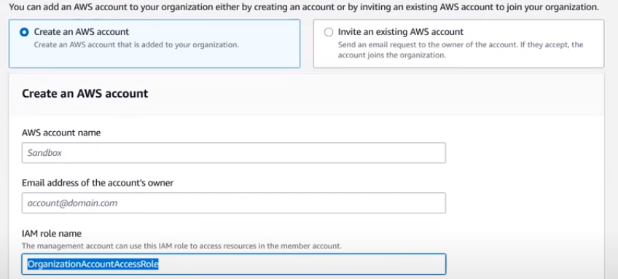

You can invite or else create new account

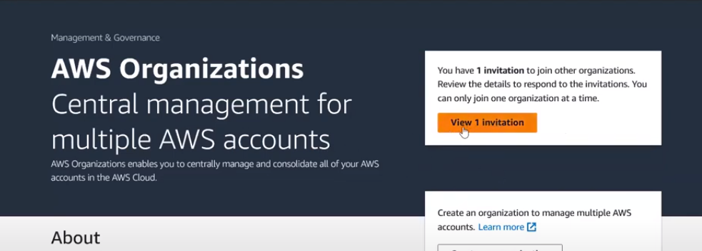

After sending an invitation to other accounts login to other accounts and go to organization tabs u will find invitations

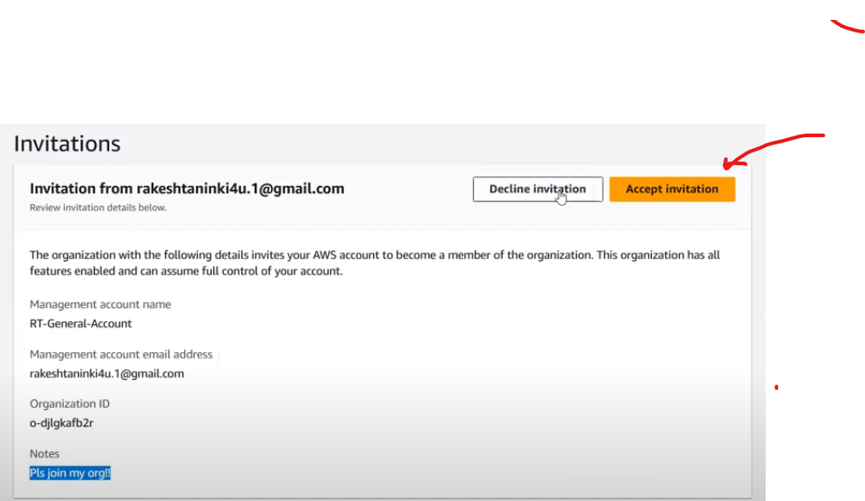

Other accounts can accept or decline invitation

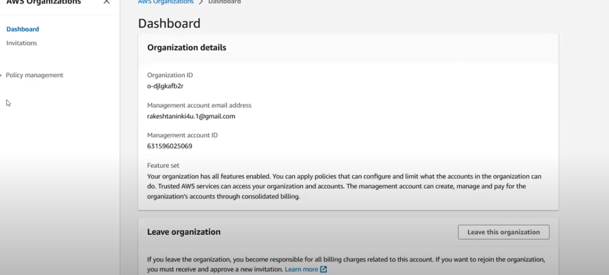

After accepting the invitations you don’t have much options in the dashboard as management account

You will have option called leave management as well

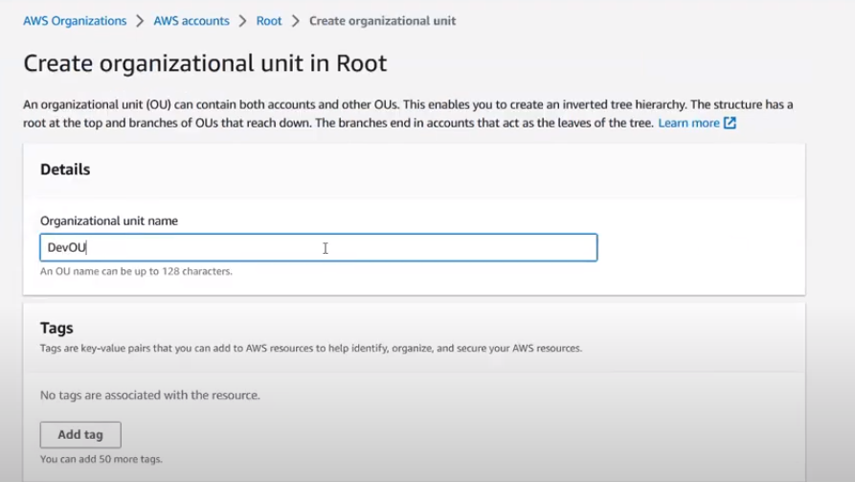

U will get option called create organization unit

In that unit u can add accounts by selecting that account and click on move

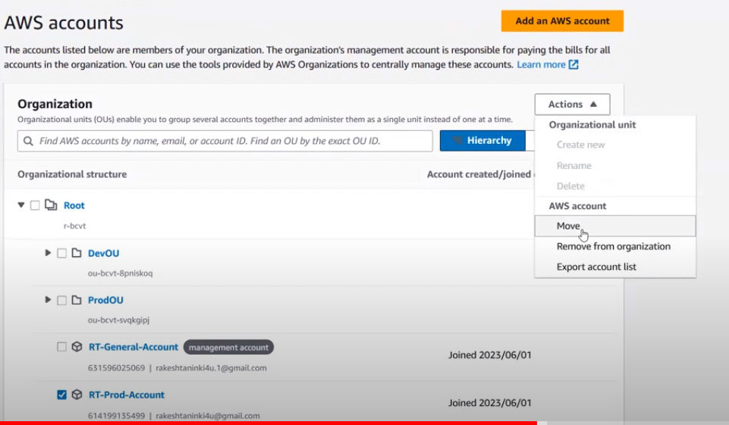

Service control policies are the policies which controls the permissions

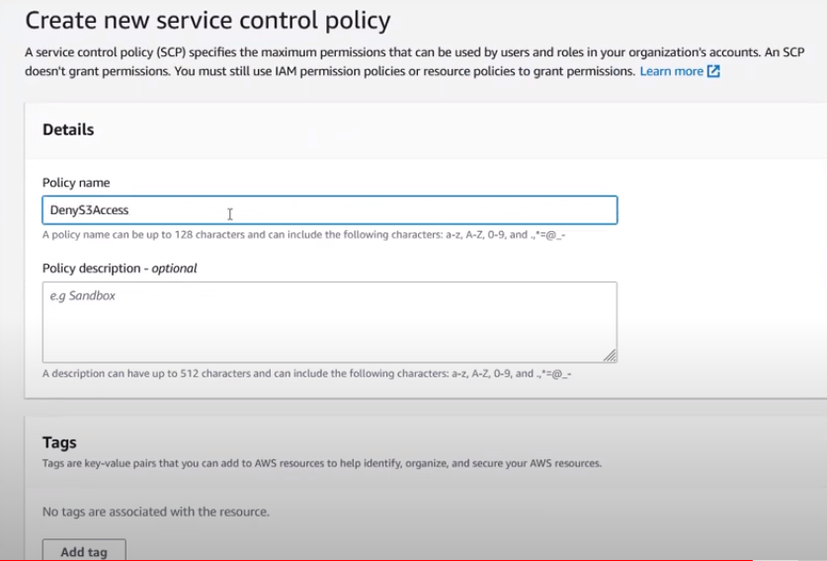

After creating service control policies you can attach that policy to the account

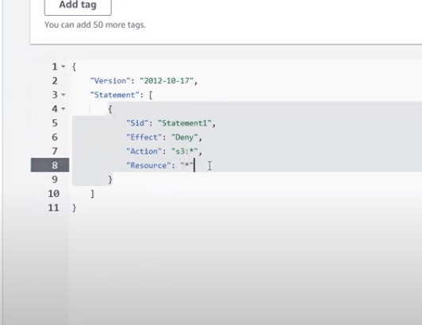

Create one more policy i.e leave organization policy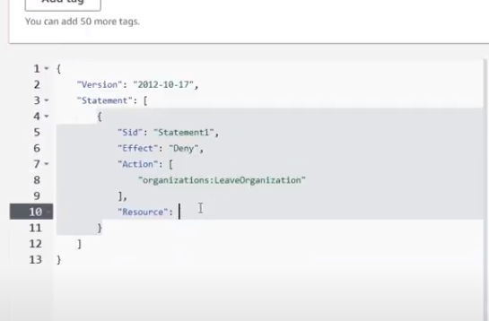

And attach those policies to the accounts and it shows you pop up saying that you don’t have permissions

* From management account u can create roles to switch from one act to another act
* Scp’s has more priority when compare to Iam roles
* Scp’s is applied entire account level

**Cloud Watch** : Resource Monitoring like how much cpu is utilized, how much ram is utilized , how much storage is utilized etc etc

**Cloud trial** : Its account level for example if we have many users in account cloud trail specifies who created ec2 instance , who has deleted that instance etc etc

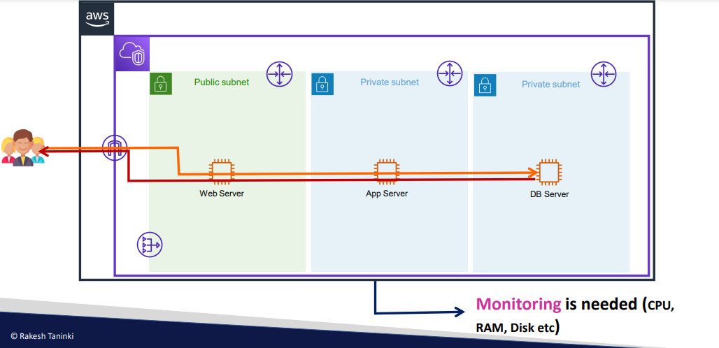

Cpu ,ram,disk is known as metrics information

* In real time we have multiple servers so we cant login to each act and check this utilization info
* So we use cloud watch to resolve this issue
* Cloudwatch,nagios,datadog etc etc are the tools which we use to monitor the resources
* 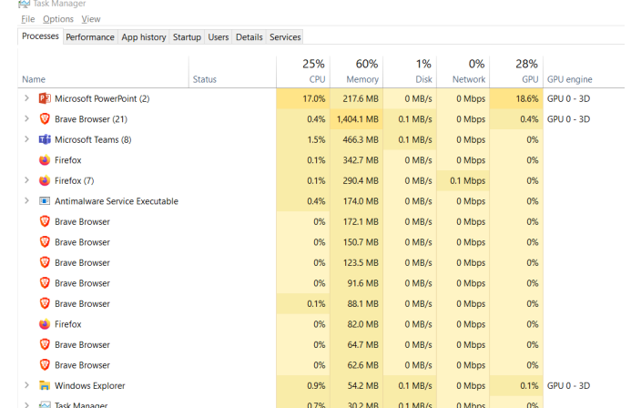

In windows we have task manager to see the performance dashboard

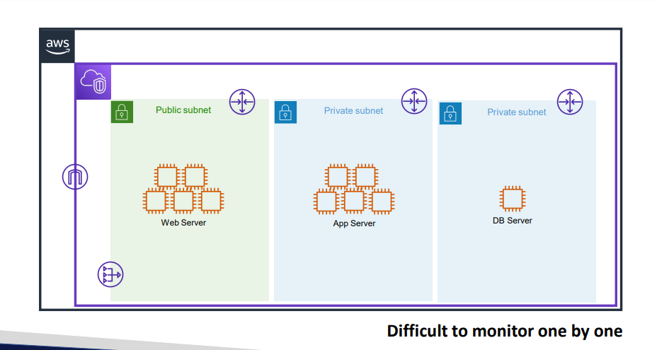

* In aws we have cloud watch
* 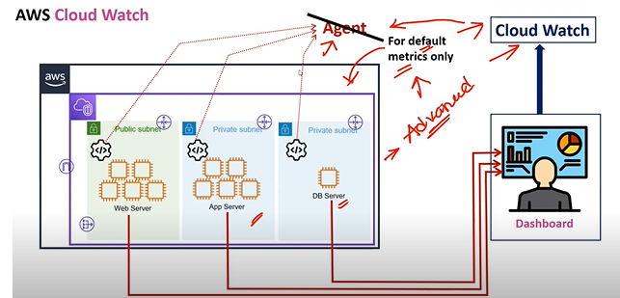
* So directly if use other than aws tools like nagios etc etc for metrics monitoring we need Software called agent which pushes metrics info from aws to dashboard
* Even in cloudwatch we need agent for advanced metrics
* Without agent it only gives some metrics

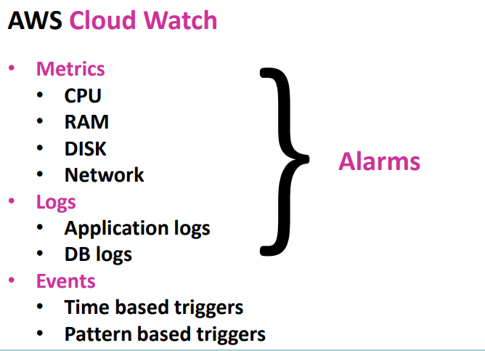

Logs : if there is any error who is running that application currently those kind of info will be stored in logs even for logs we need to have agent… we can the data storage ho long it needs to store

* Events if your server wants to run in only specific time like ur business hours are 10 am -5pm u r server should run only at that specific time that would be beneficial for saving purpose

That we can create in events for automation

* In windows we use task scheduler and in linux we use cron jobs for job automation in aws we events
* 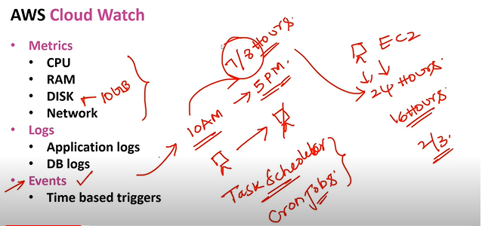
* 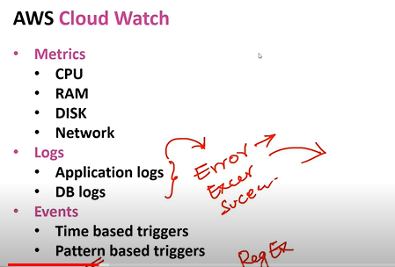

Time based triggers : u are setting some time to run the jobs

**Pattern based triggers** are for ex we have logs and we get error in applications at that time developers need get triggered immediately so we need to set pattern based

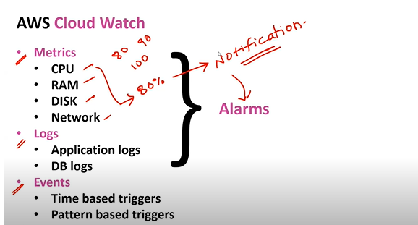

* Using alarms we can get notifications if metrics performance gets exceeded
* 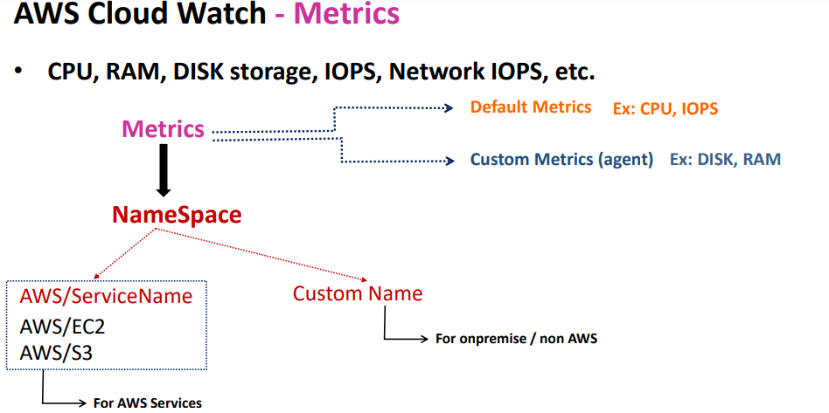
* For every metrics we need to create namespace

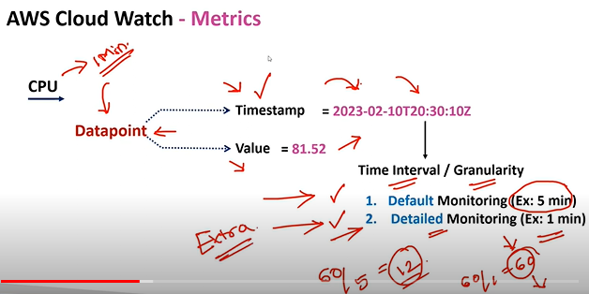

In detailed monitoring aws charges extra amount when compare to default monitoring

* In datapoints we are only getting performance but ifwe want to know for which server metrics is high then in dimentions we can get that data

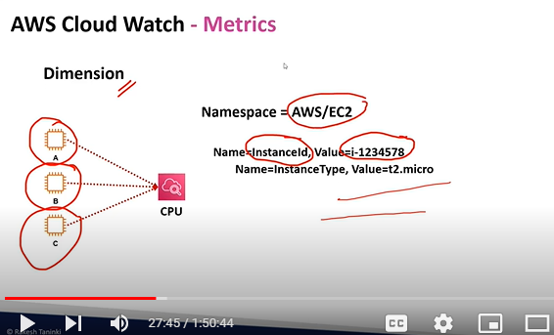

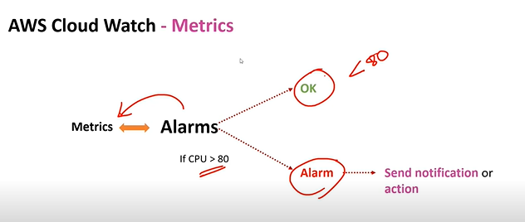

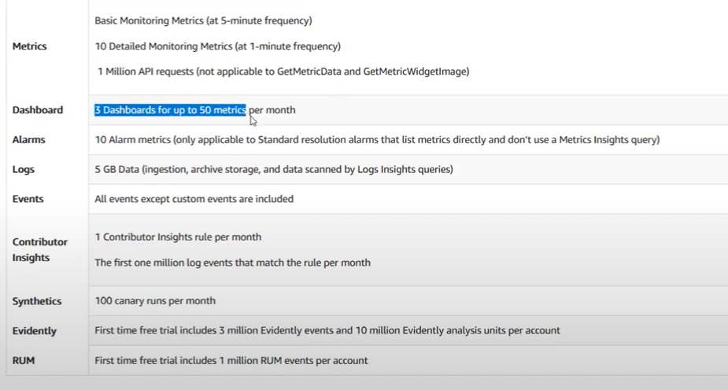

**DEMO:**

**1: STEP 1 CREATE EC2 SERVERS WITH DETAILED MONITORING ENABLE**

**2: Check the metrics in cloudwatch service for the instance you have created by instance id**

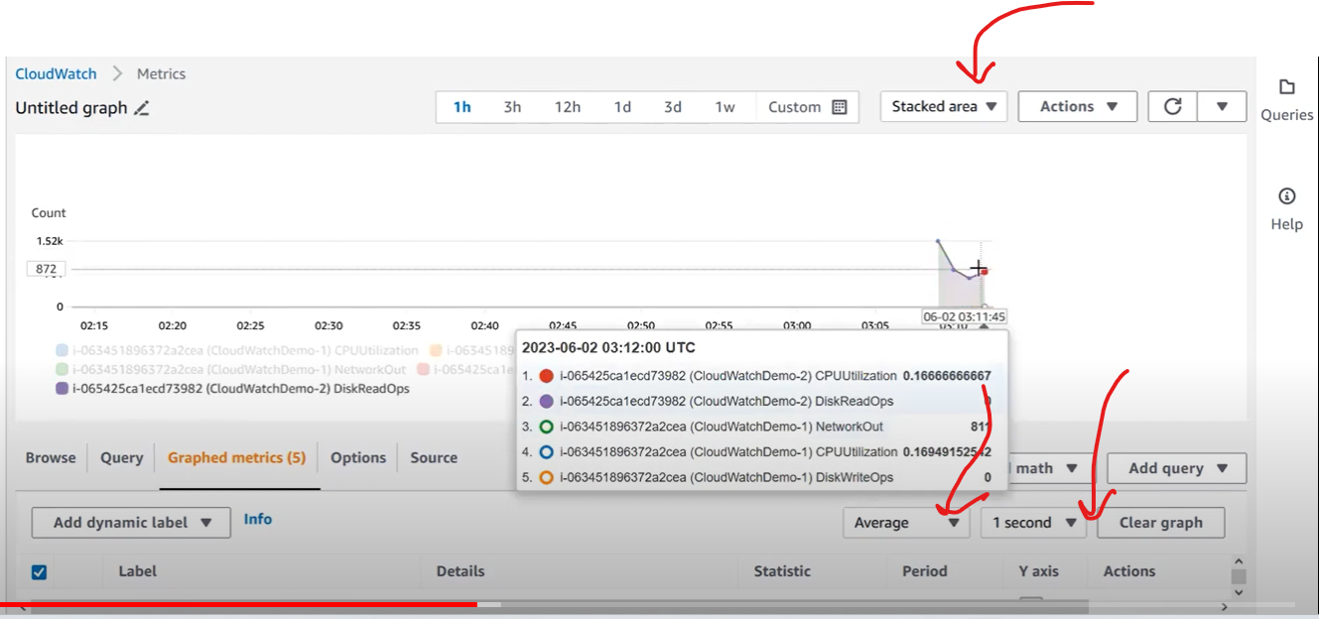

**If you want to create a dashboard**

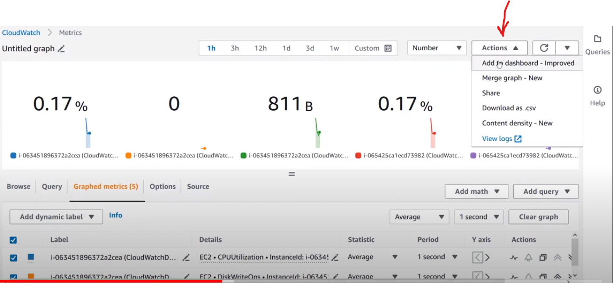

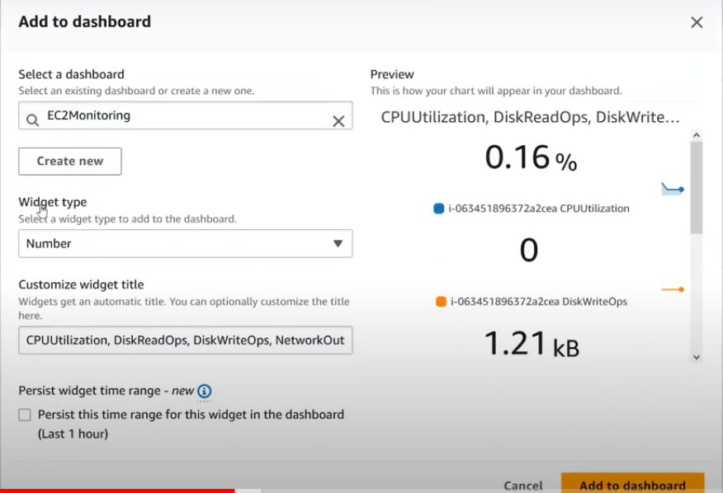

If you want to share the dashboard click on save and share

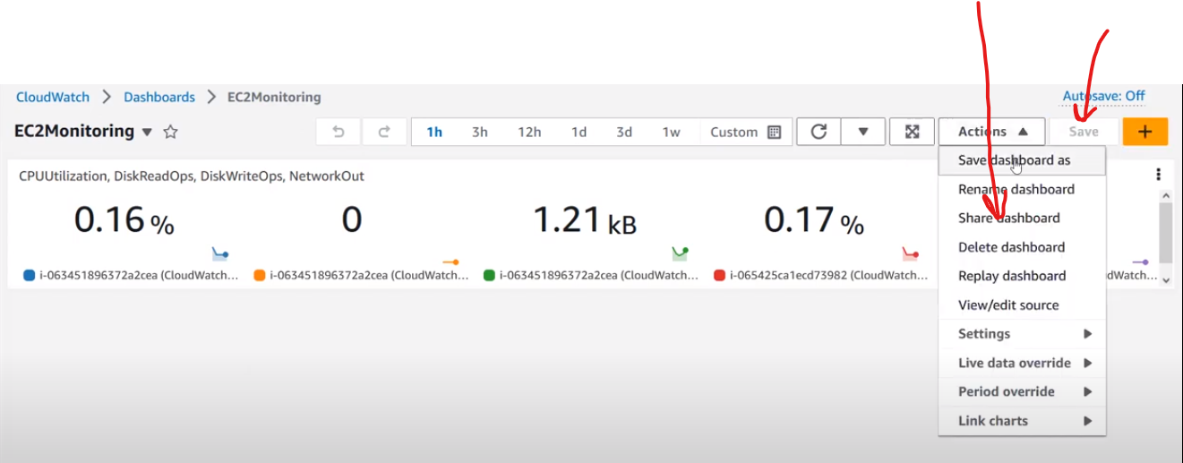

We can share publicly or privately

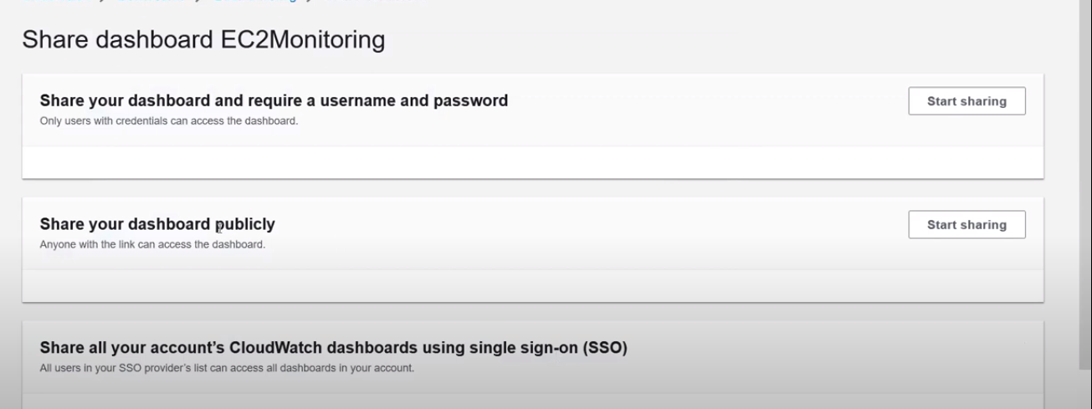

For editing instance id

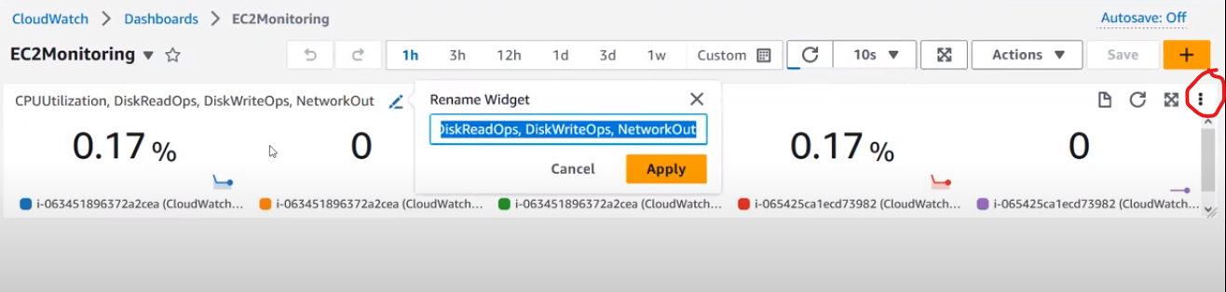

Create alarm in alarm section

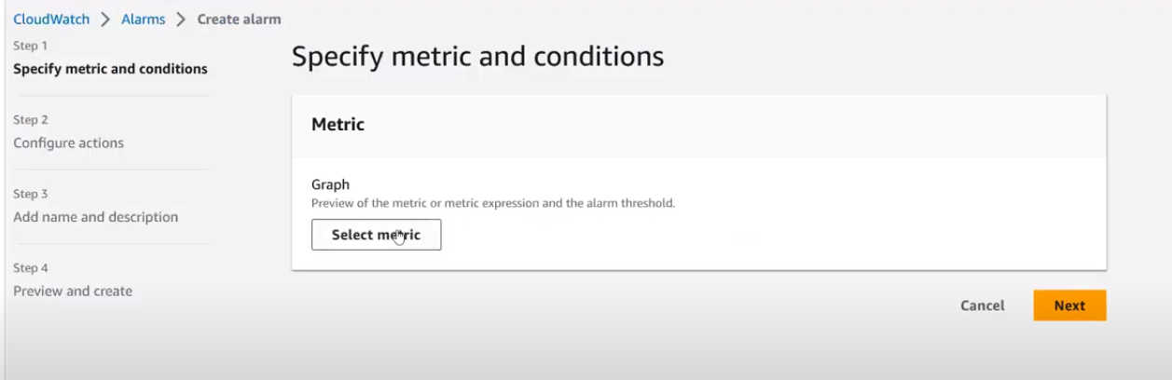

For every alarm you need to select metric

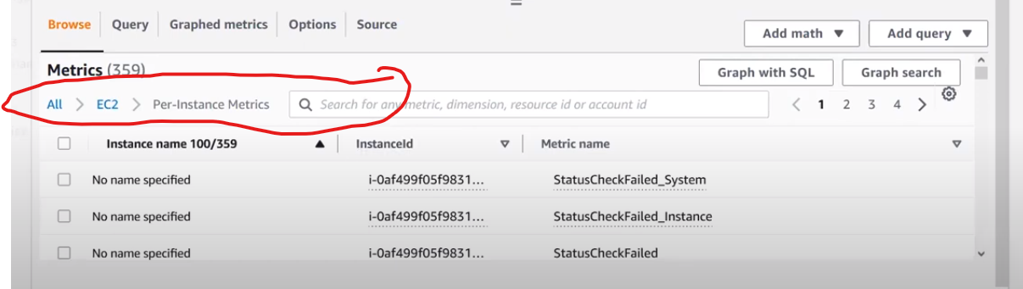

In metrics select -> Ec2-> perinstance metrics-> instance id of your servers

In cpu metrics

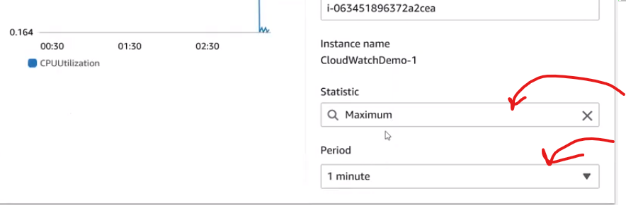

We are keeping a condition with in a 1 min of time max util > 50 % trigger alarm

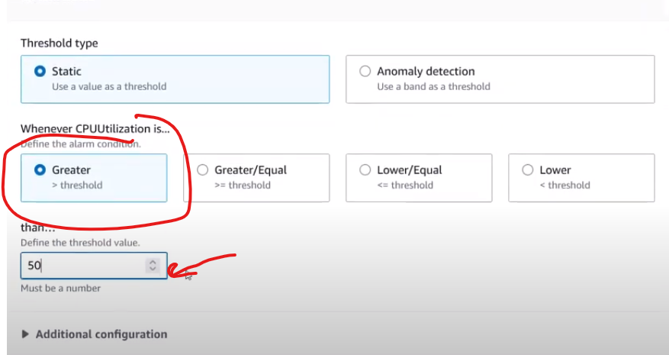

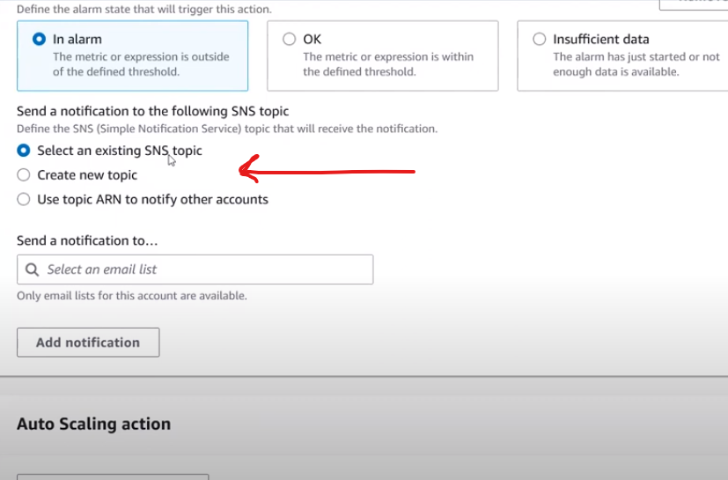

If you want a notification from service we use simple notification service in aws

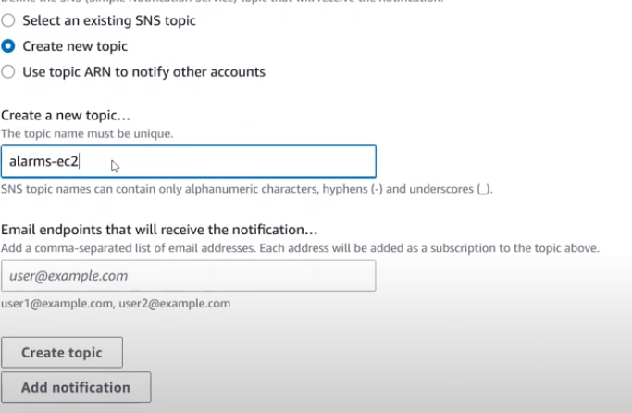

To increase server performance we are using 3 commands

sudo amazon-linux-extras install epel -y

sudo yum install stress -y (yum is a package)

stress -c 1 -t 3600 (1c for 3600 secs to run)

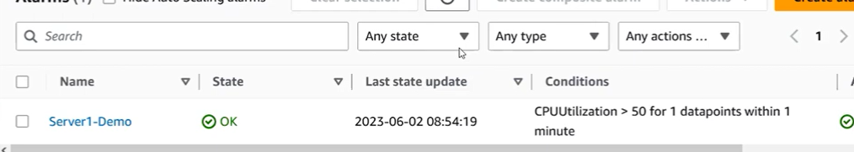

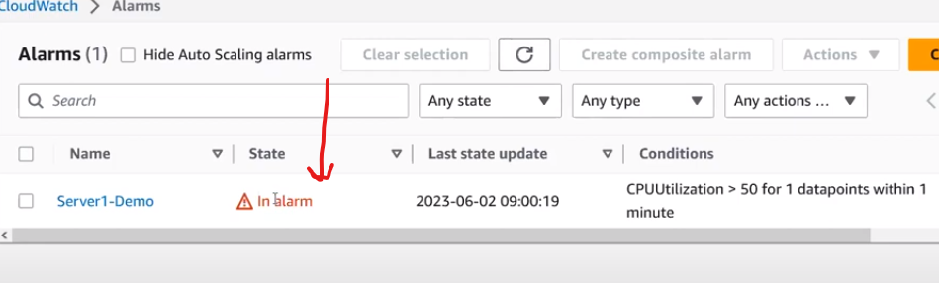

Check your email id for trigger message or mobile no which you gave while creating alarm

After demo delete servers,alarm, dashboards

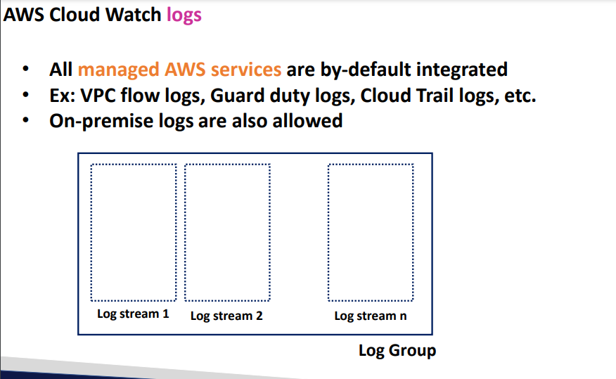

Log group is application level

* Log stream is server level
* Like log stream 1, log stream 2 etc etc ………. Log stream n

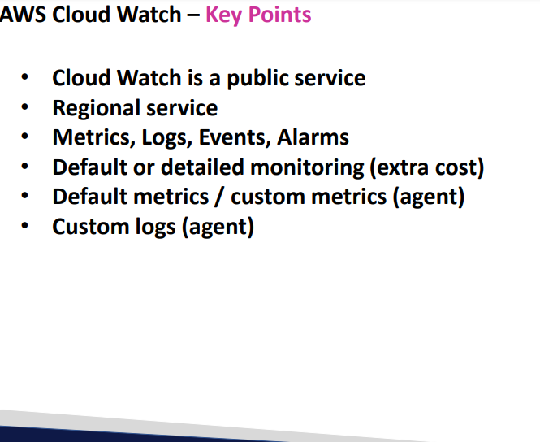

**Cloud Trail**

1. **Each and every activity is stored in cloud trail**

**For ex : if someone has deleted Ec2 server in cloud trail we can get the info of that particular peron who has deleted the data**

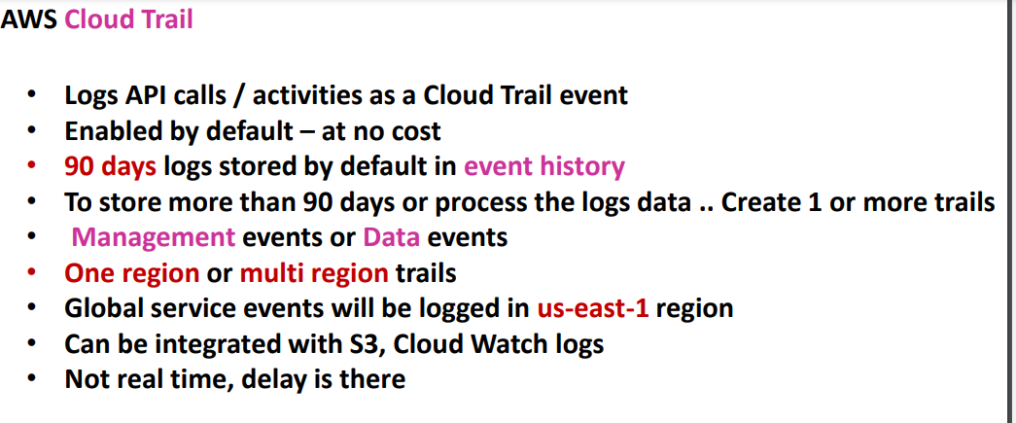

**By default aws stores the logs for 90 days for free of cost if u want more than 90 days data u need to create custom logs**

* **Two types of managements are there**

1. **Management events**
2. **Data Events**

* **Management events are the events**

1. **Delete or create or updating the resources comes under management resource**

**Like Ec2, S3,Vpc,subnet**

1. **S3 is a resource and inside the s3 buckets files will be stored those are called data**
2. **By default 90 days logs we only get management events logs**
3. **Data events are the events uploading files deleting files in s3 buckets those are called data logs**
4. **In organization level u can create trials how all the account trials will be stored only 1 act i.e for the act which u have created in that act u can able to see**
5. **Global service events will be stored in north virginia region**
6. **I am is a global service so those events will be stored in north virgina region**
7. **Logs can be integrated to s3 or cloud watch logs**
8. **As soon as you create the log there will be 5 mins delay**

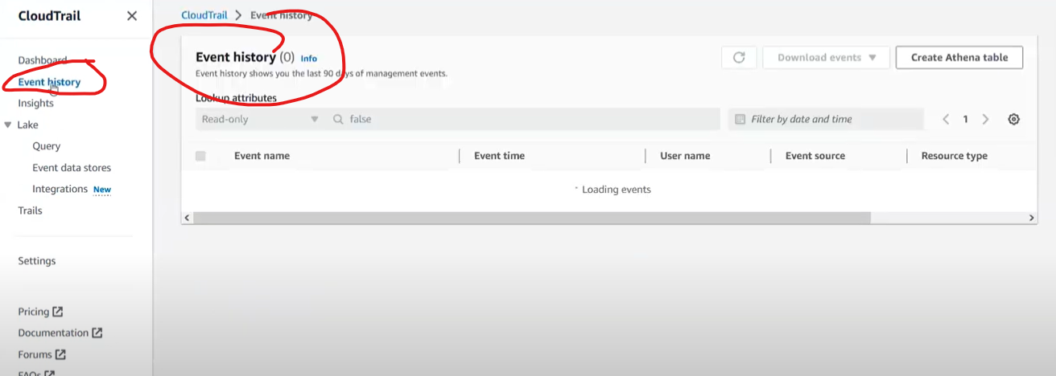

**In event history you will get to know the history of 90 days which is by default**

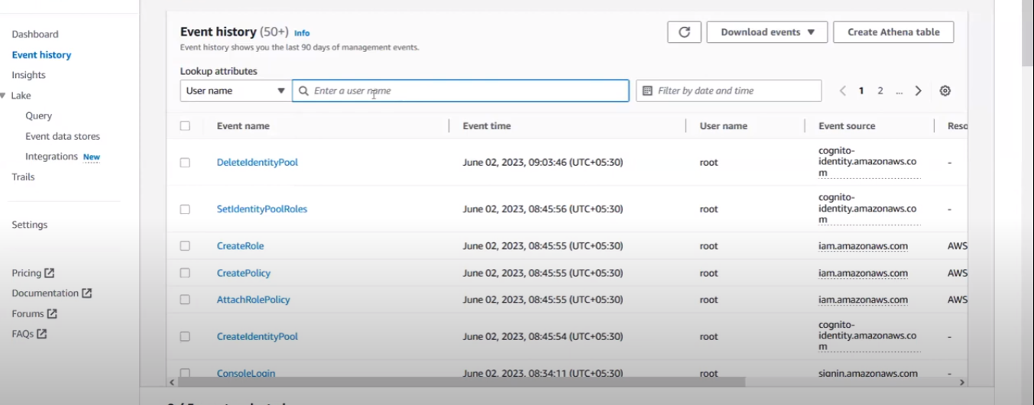

**Even you can filter user name as well**

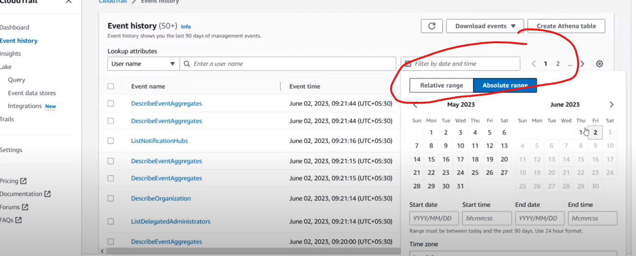

**You can filter time**

**Create custom trial**

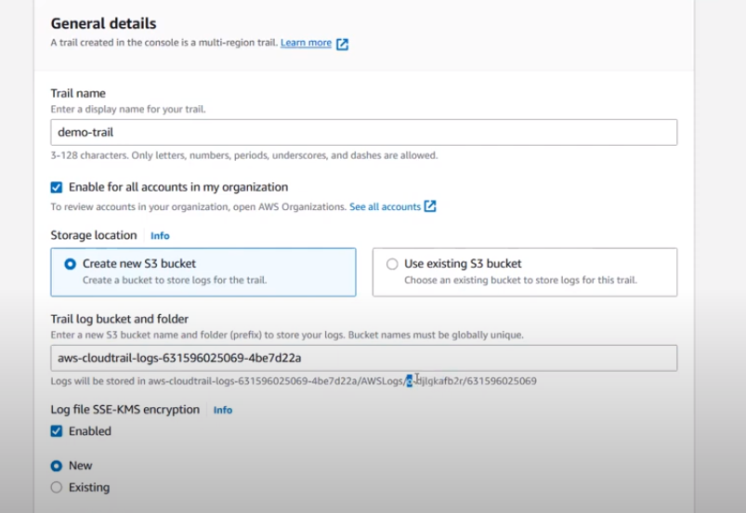

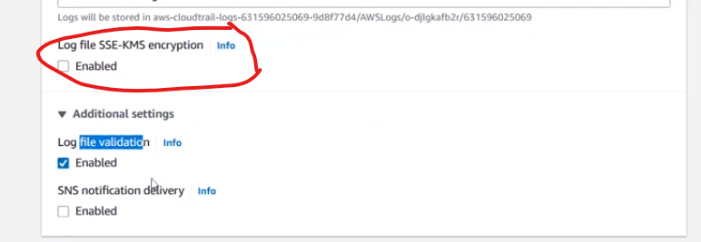

**For log file security we enabling log file encryption**

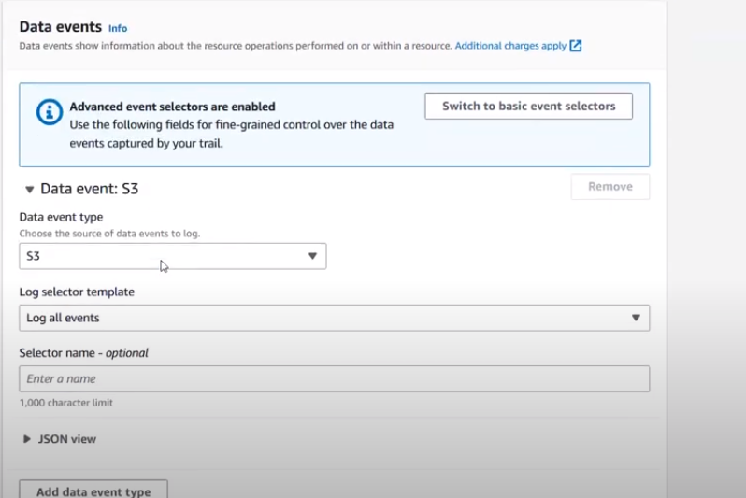

**In data events you can collect for multiple files or else custom files for that particular service**

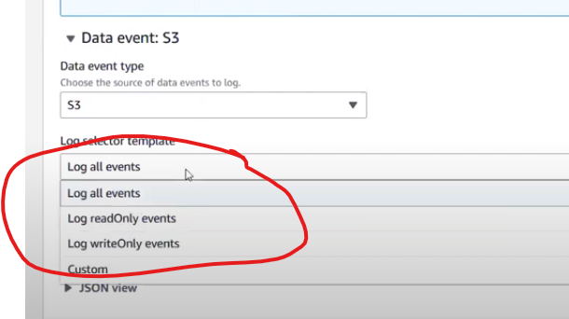

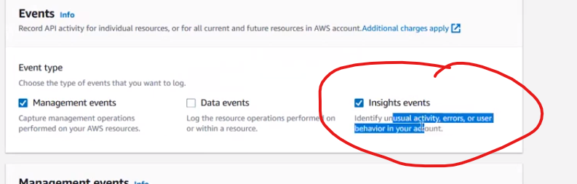

**Unusual activity or errors or user behaviour will be stored in insight events**

**By default aws created integration between cloud watch and cloud trail**

**In cloud trail what ever you have created you can check those logs in s3 buckets**

**And install json gun zip fill in firefox**

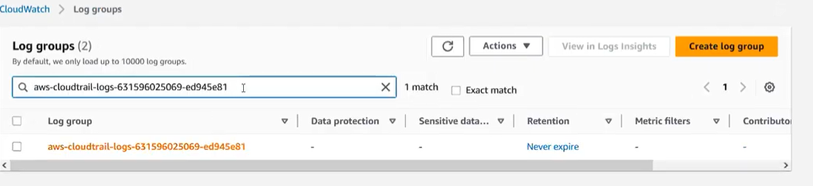

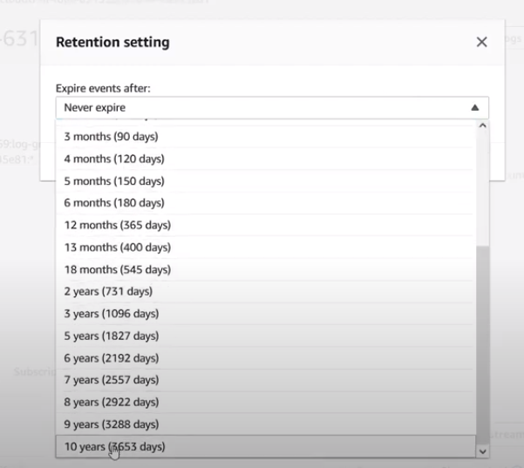

**In logs you can edit when it can expire**

**In realtime for logs visualization**

**They will pull data of logs in to sumologic or splunk etc etc for logs visualization**

**Cloud formation**

**It’s a Infrastructure as a code which is only useful for AWS**

* **Cloudformation supports Yaml/json**
* **For multicloud we generally use terraform**
* **Terraform supports Yaml that too in Hashicorp format**
* **SAM is advanced version of Cloudformation**

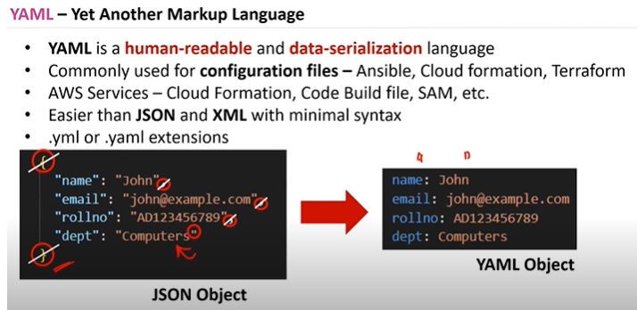

**For iam policies it wont support json**

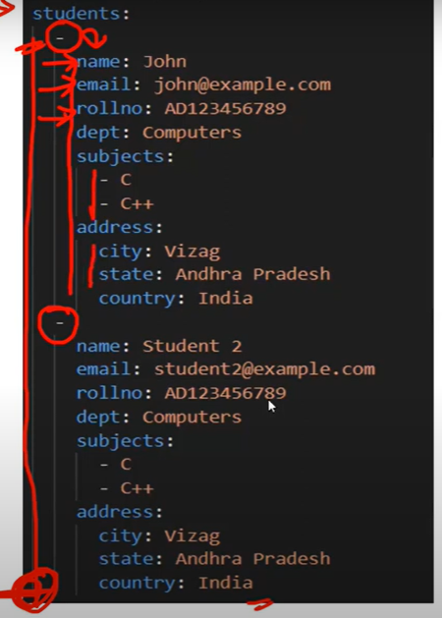

**It s called intendation**

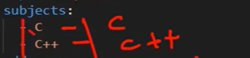

**This is list format in Yaml**

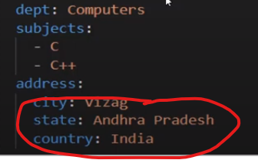 **This is nested json type**

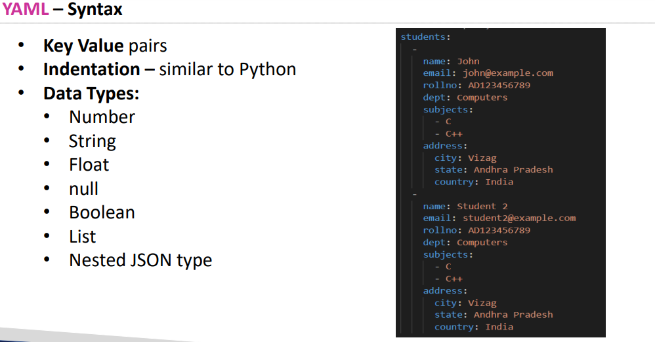

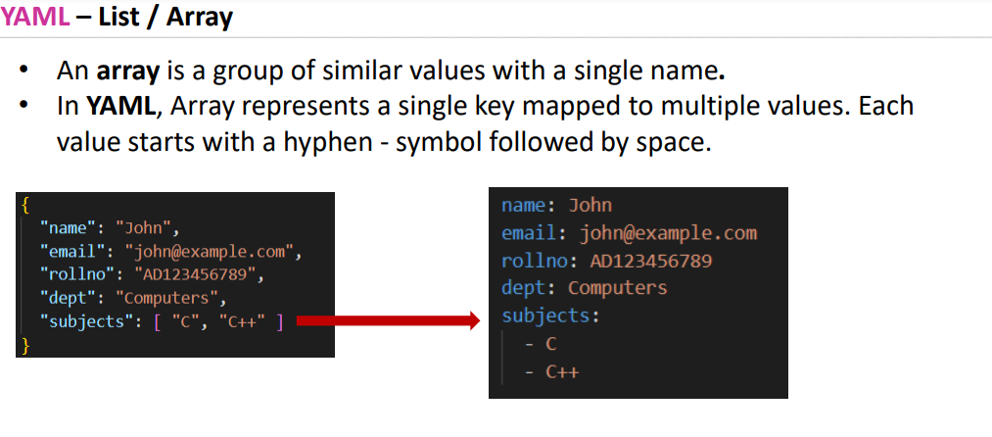

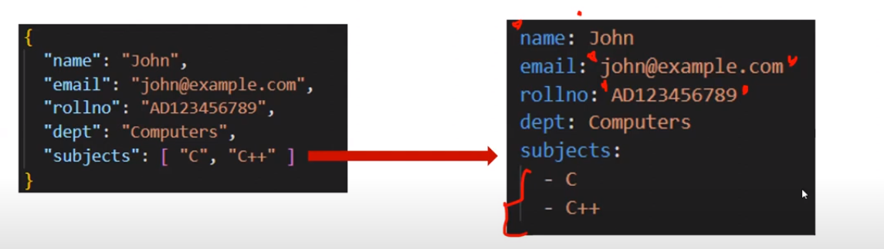

**For beutification purpose we can keep strings “ “ in yaml as well that too for write side values**

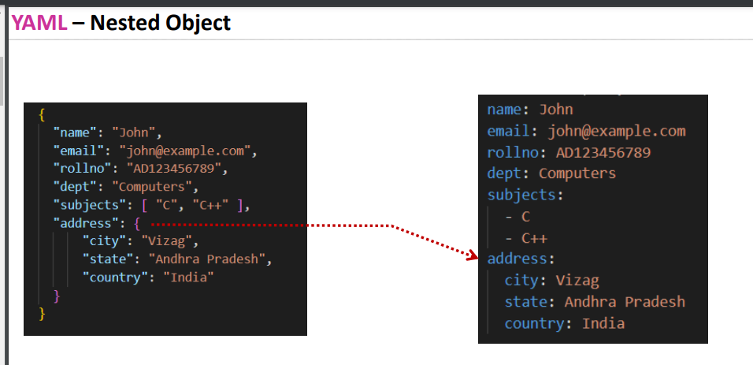

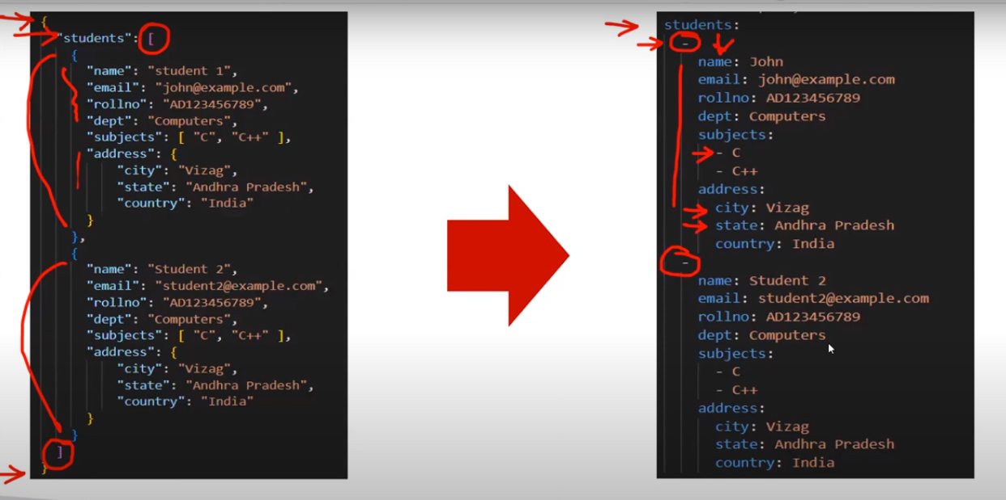

**Yaml is case sensitive**

* **Policies support json in aws**

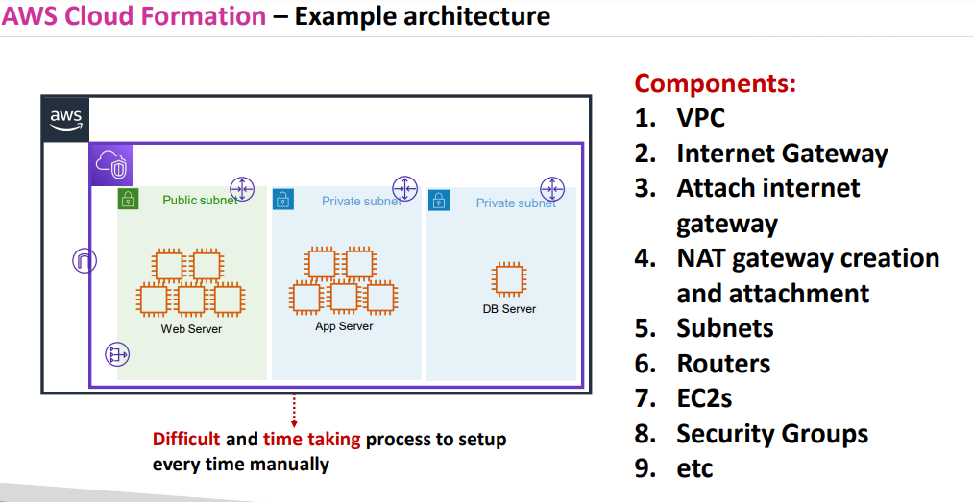

* **Manual setup will be time taking and there wont be any consistency**

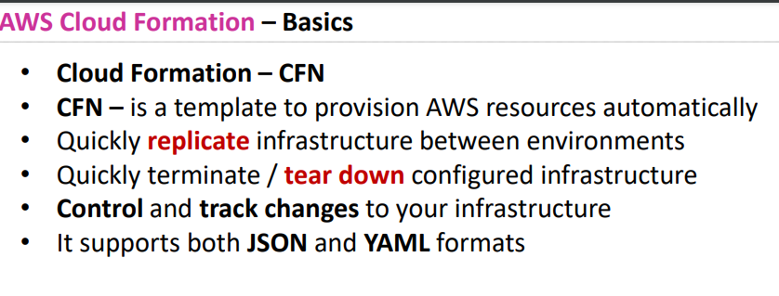

**CFN is a template for configuring resources**

* **For ex u r creating s3 bucket u will configure bucket name etc etc**
* **Control and track changes will be tracked easily as this code will be deployed in git so what ever is added in that particular stage in your projects that will be tracked**
* **For ex : you only added igw later after 20 days someone came and asked you to add nat gateway this kind of tracking will be maintained**

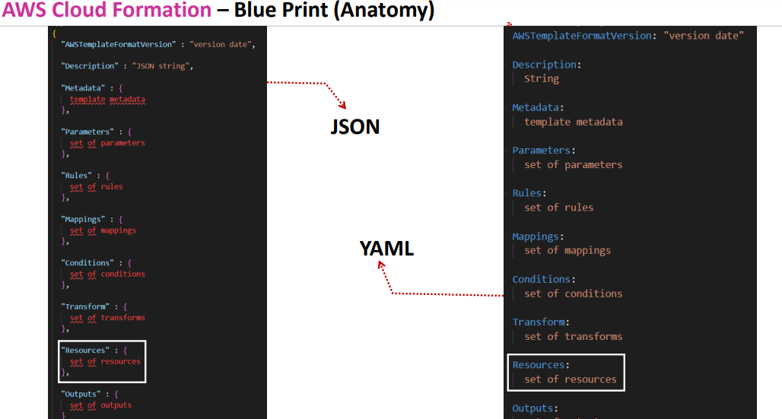

**Only resources section is important while creating resources in cloud formation or terraform what ever it might be rest all are optional**

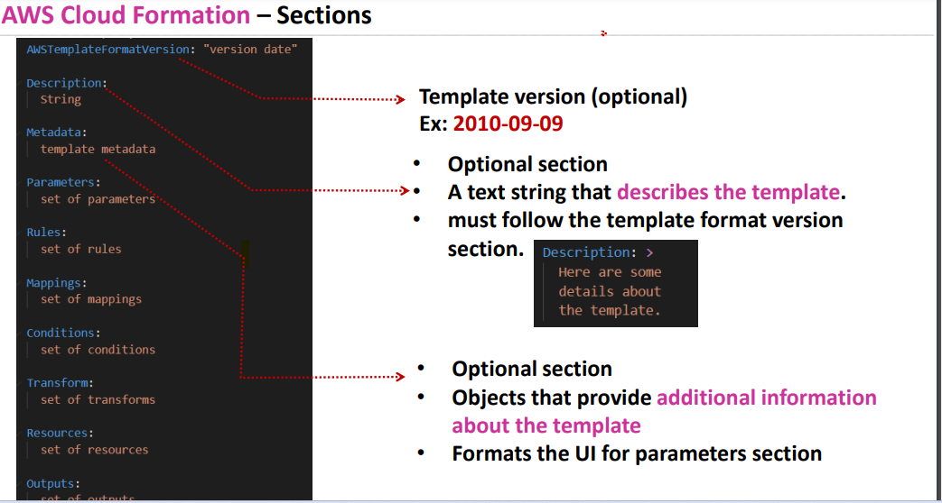

**Description should always be placed below the aws templateformat version if not error throws**

**Meta data section is only useful when cloudformation created through console**

**In real time environment you have different purposes like prod , dev, testing**

**So you cant create different templates for all the three sections**

**For ex in production u don’t need too much of cpu and ram**

**For dev u need little less cpu when compare to testing so you will mention parameters using rules and conditions**

**Like if production team = create 2 c 8 ram**

**Meta data should be there when ever there is a parameter**

* **What kind and what type**

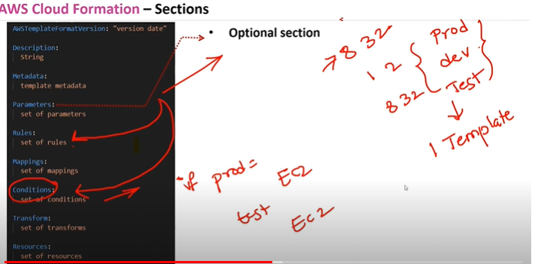

**Then cloud formations decides based on those conditions what to create**

**Conditions will be based on parameters**

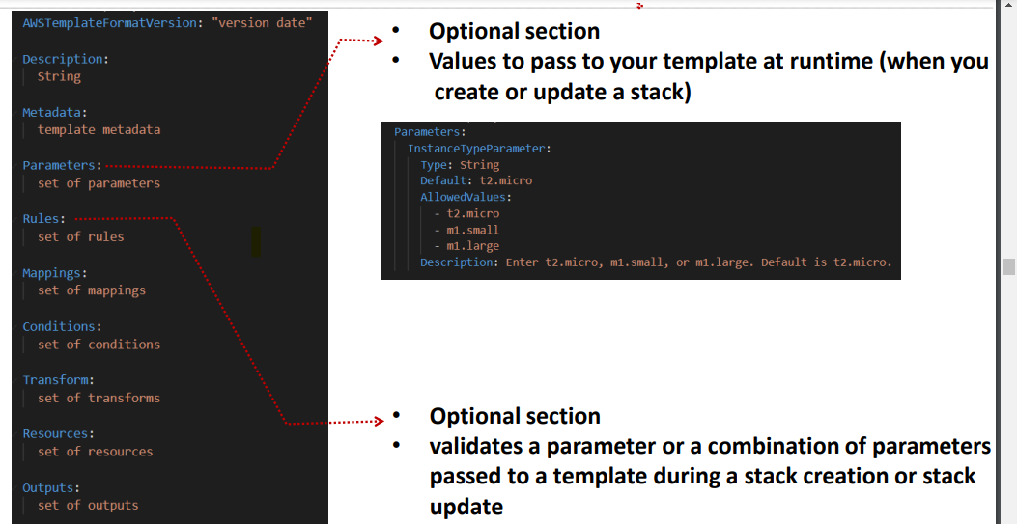

**Rules are optional its only useful for checking conditions or validating the parameters**

**.for ex for login or sign up its asks us to enter the email id and format like gmail.com or .in if its in that format then only it allows if not it throws the error**

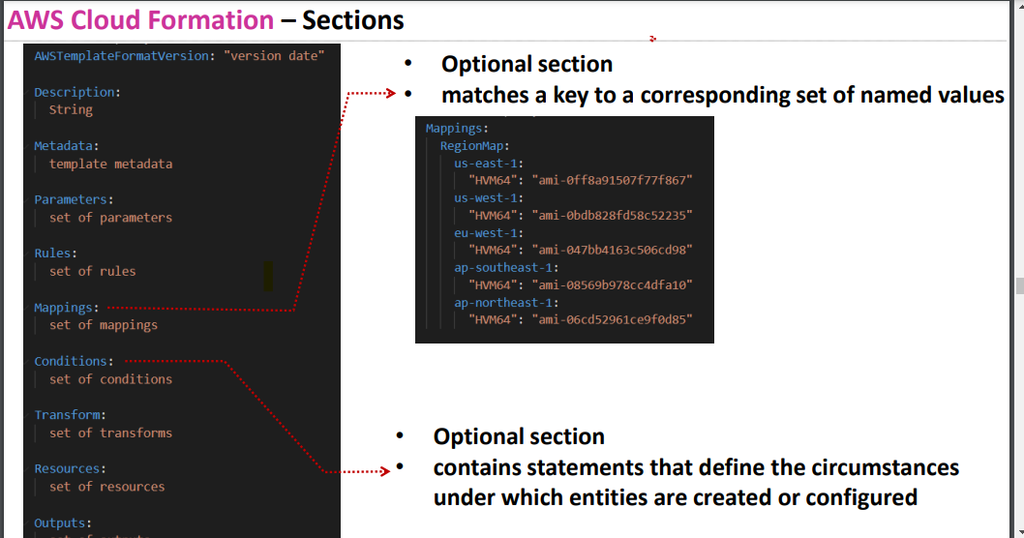

**Mappings ex : If u want to deploy an instance a region based ami id’s gets differed**

* **So in template if you give different id ‘s based on region when you enter the region it will map to that particular ami**
* **Resources, parameter, output**
* 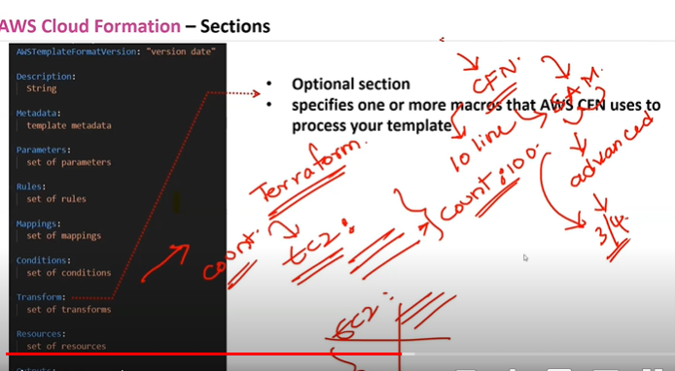
* **In Sam advanced version of Cloud formation if cloudformation has 10 lines**
* **SAM ha 3-4 lines of codes**
* **Transform:if u want to create 10 resources using same configuration u will have count option in transform**
* **In terraform also u will have count option**
* **So No to write the code 100 times**

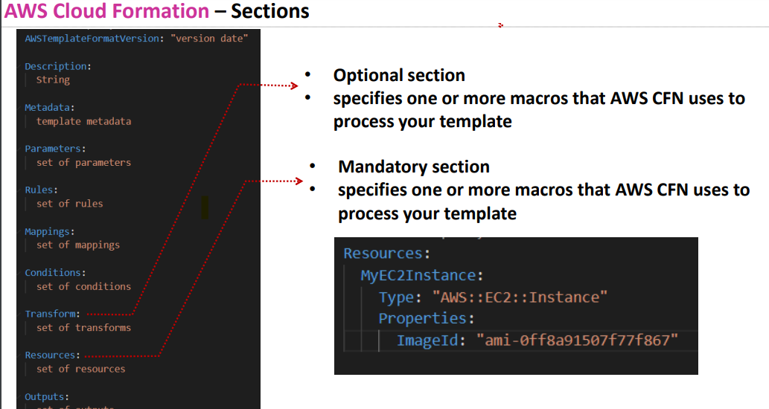

**Resource section is important**

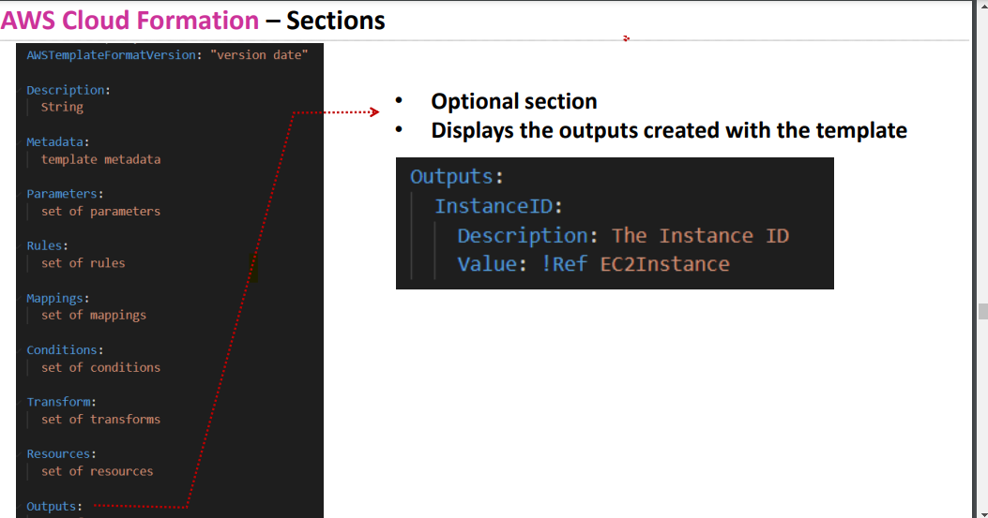

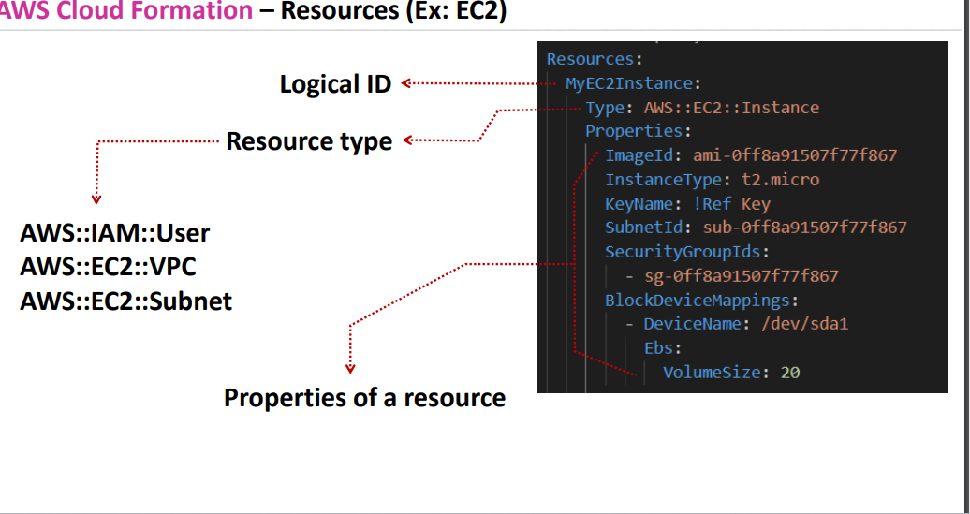

**Type and properties are imp**

**Logical Id should be named as per ur convenience**

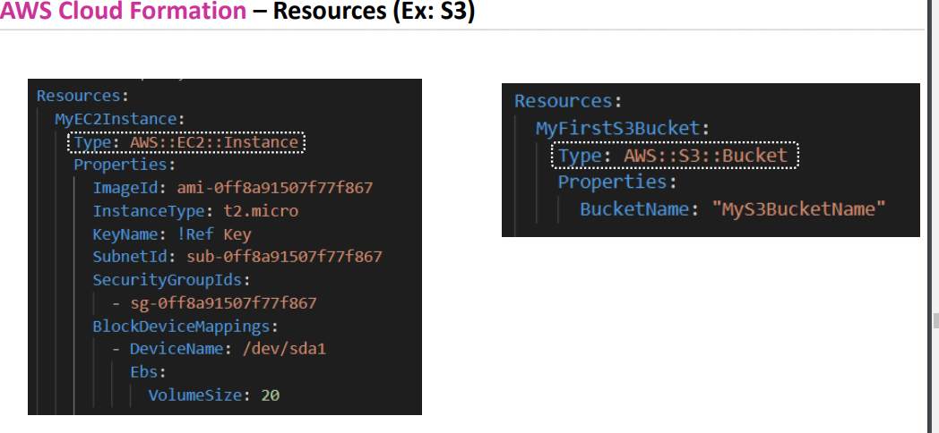

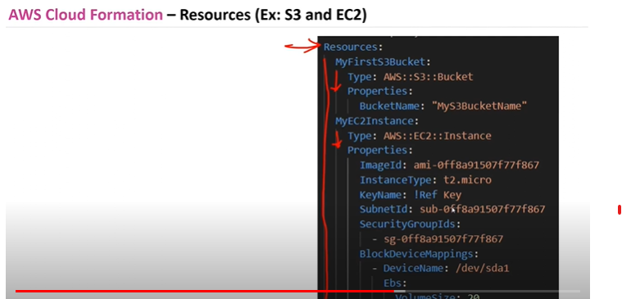

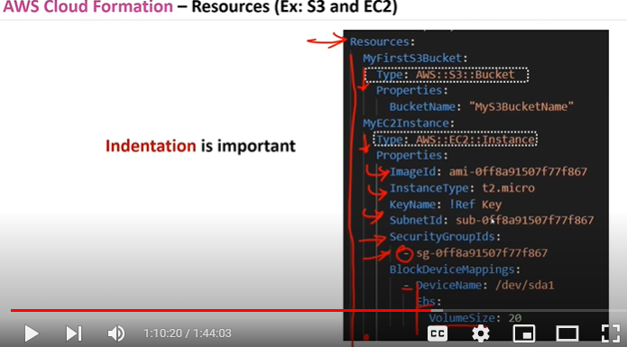

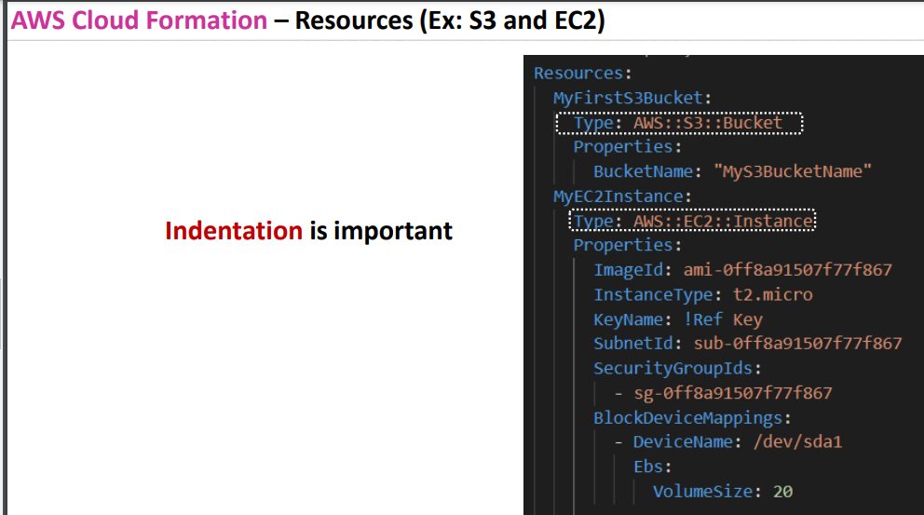

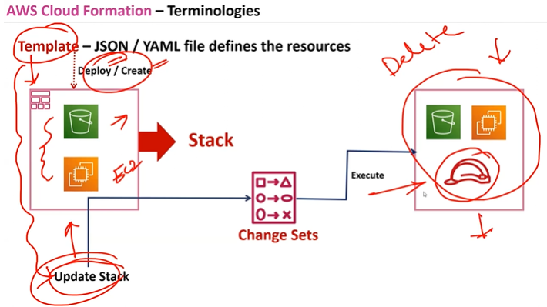

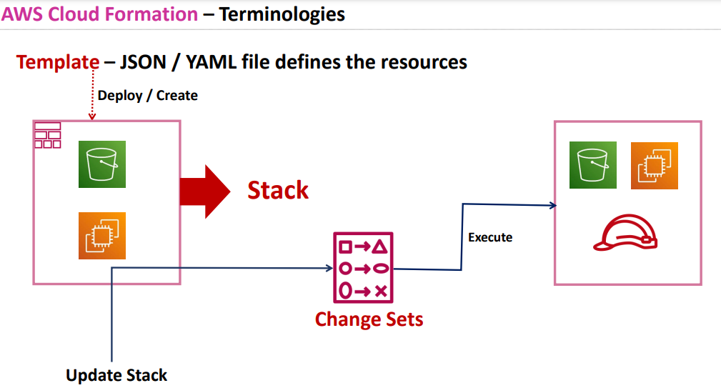

**From template you will either deploy or create the resources**

**Those are called stacks and when u update the stack that means changes in existing stacks will convert to change sets and then execute**

**Yaml extension should be added in visual studio for beautification**

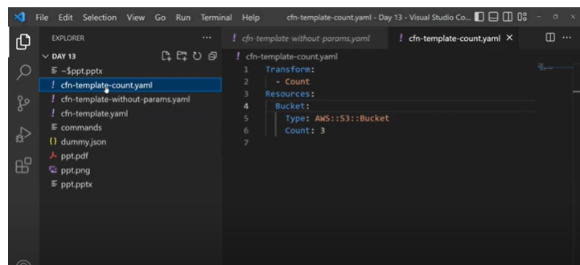

**Cfn-template yaml -with parameter**

**Cfn-template-count.yaml- using count**

**Cfn template -without parameter.yaml**

**After creating templates uploading those templates in stack**

**Aws cloud formation template reference**

* **In template reference it shows both in yaml format and json format and also it gives info regarding whether that attribute is required or not**
* **In return values u will get reference documents of outputs**
* 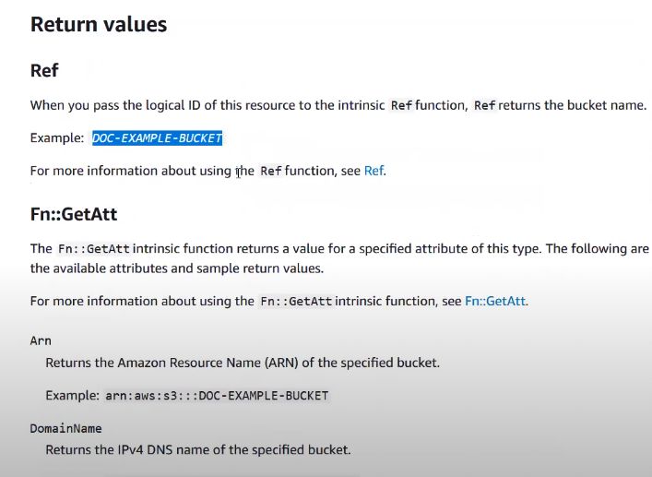
* **AWS s3 is providing option to host a website in s3**
* **In ec2 cost will be more based on core and gb but in s3 the pricing will be based on gb so the cost will be very less when compare to Ec2**
* **But if u are hosting a website in Ec2 based on customer size u need maintain core and ram if not server gets down but in s3 everything is managed by aws**
* 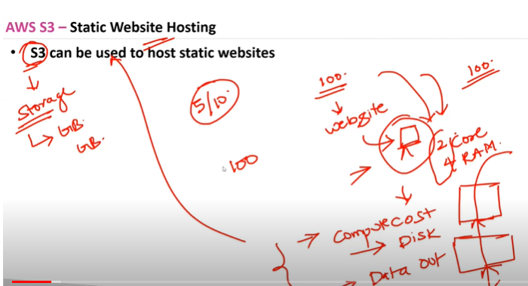
* 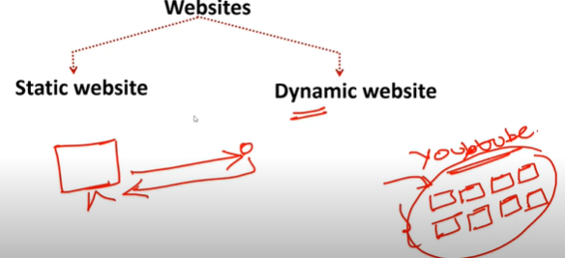

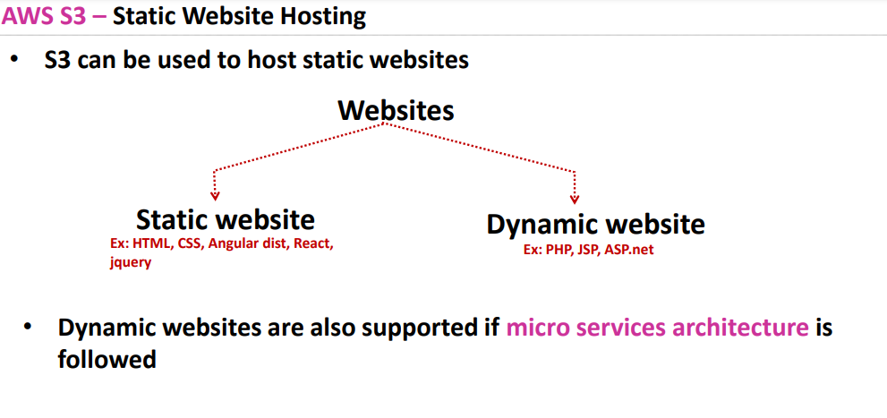

**Static website is a website which does not change its view based on your search**

* **Dynamic website example youtube based on your serach its results gets changed and will bring those results from database and gives to you**
* **PHP,JSP,ASP.net are server side scripting languages**
* **Dynamic websites are also supported in static websites by integrating with rest apis so when you click or search the apis gets thos data from the server and gives you the result**
* **Static websites are client side scripting languages**
* **If s3 is enabled for static website it has endpoints**
* 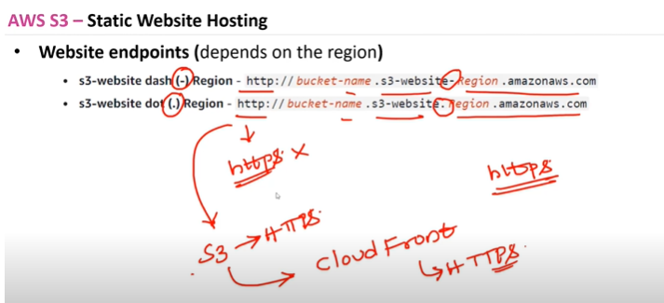

**S3 doesnot support https**

**If you want https u need to add it explicitly using cloud front**

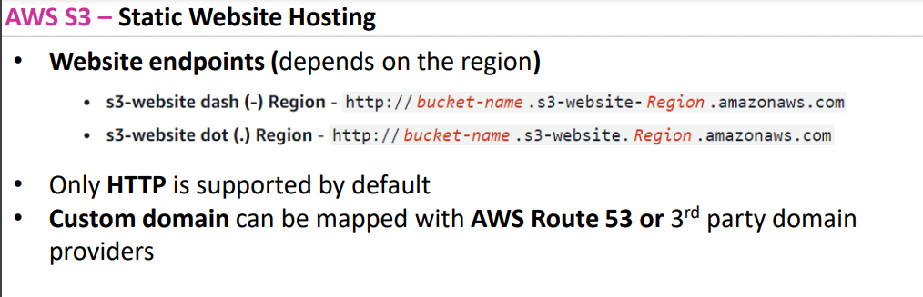

**Java based websites are not supported by s3 as its based on spring boot**

**. for this again front end u need to add rest apis then it will support**

1. **Create a bucket and enable public access**
2. **After creating bucket go to properties tab and in below there will be option called**
3. 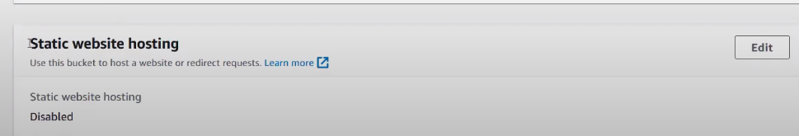
4. 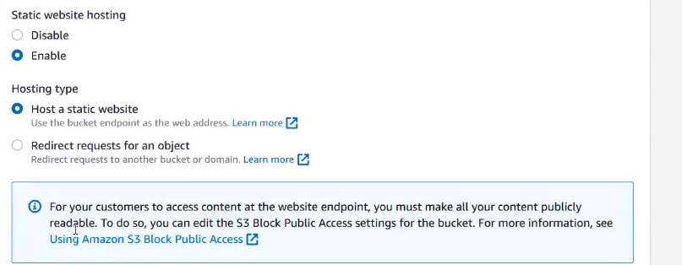

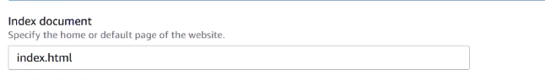

**In permission tab**

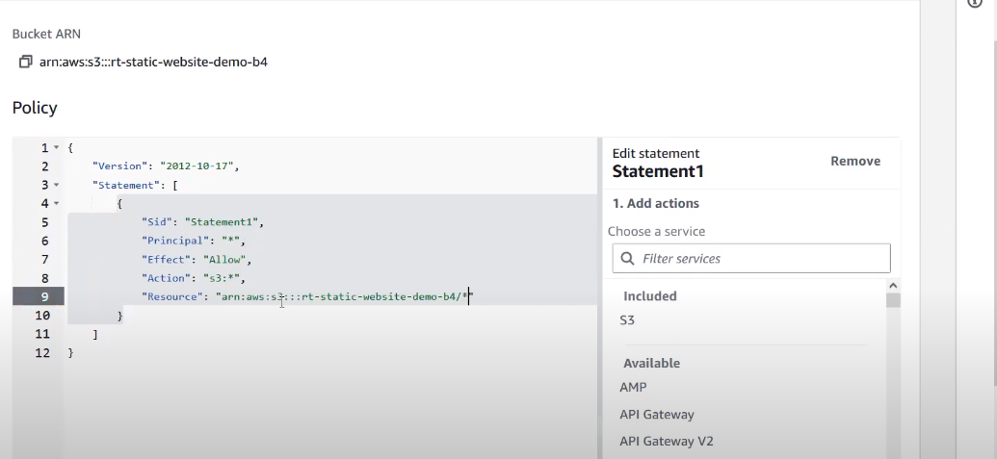

* **HTML 5 free template downloads in browser**
* **Through drag and drop upload those files**
* **Then go that s3 url and browse**
* 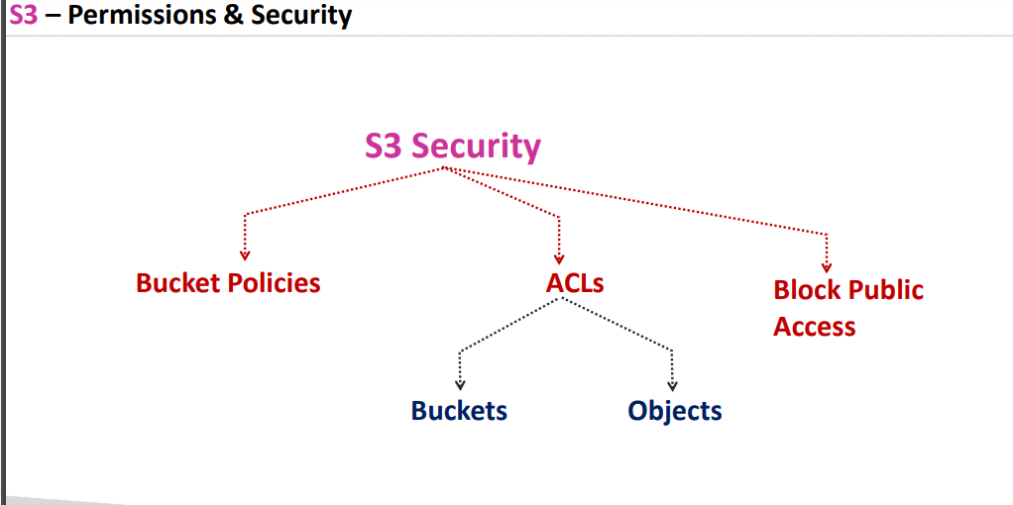

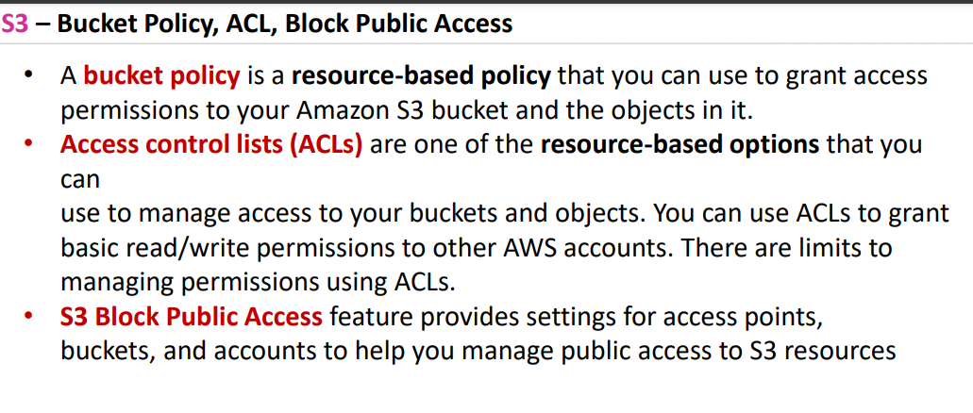

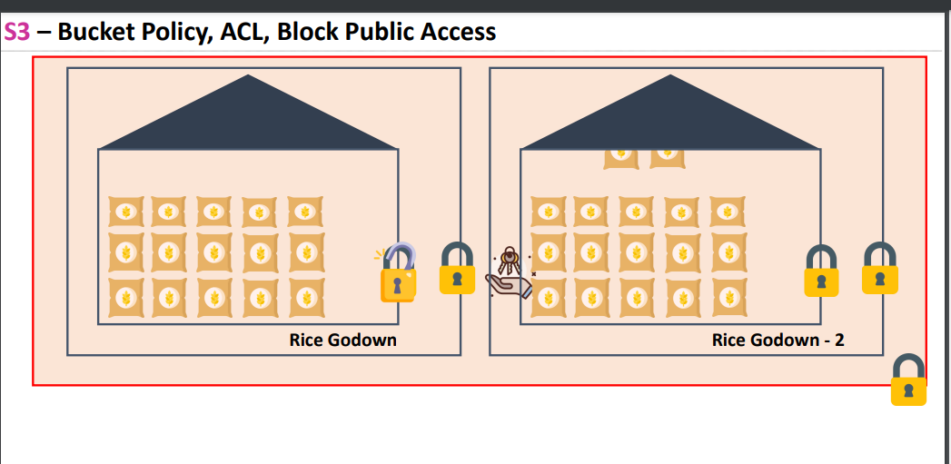

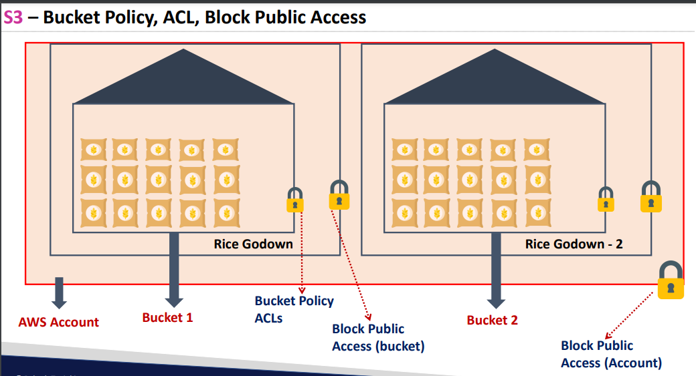

**S3 Is providing cross act bucket access**

* **In organizations we have multiple accounts instead of creating roles for s3 bucket**
* **Its allowing to access s3 bucket from one act to another act**

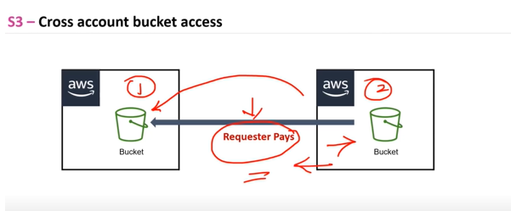

**Get request put request like that aws will charge for 1000 requests so that charge should be paid by the requestor**

**Demo for bucket permissions**

1. **Create bucket**
2. **Add files into that bucket**
3. **Copy that bucket url and browse as bydefault bucket don’t have permissions**
4. **For giving permissions first you need give bucket policy for that object to make it public**

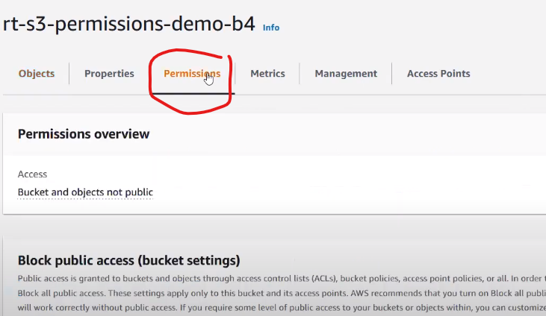

**Save the changes**

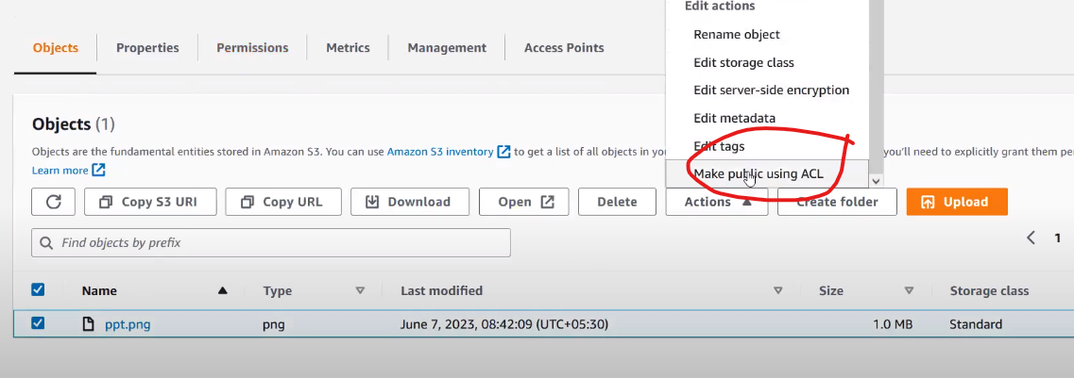

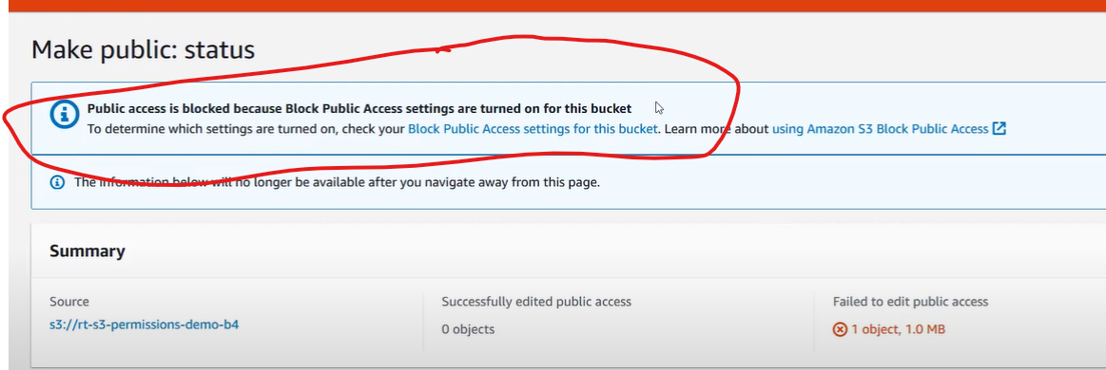

**This error will be throwed**

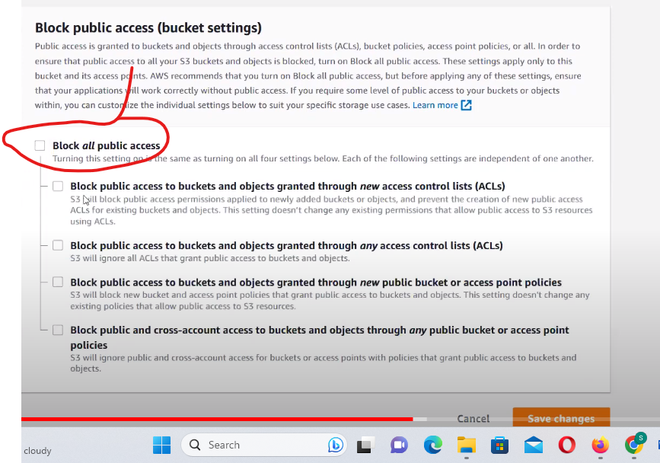

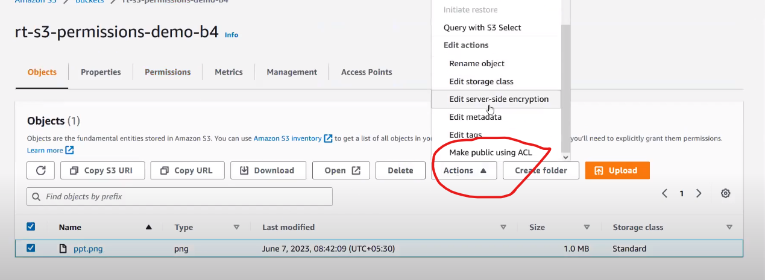

**he**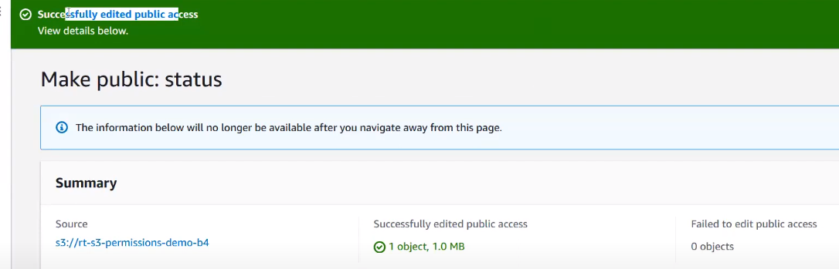

**Now it got succeded**

**1st level lock is block public access should be disabled and then acl’s should be disabled then it works**

* **In real time you need to block public access**

**Check giving permissions only on acl’s disabled and try to run the bucket it doesnot work as we have blocked publice access**

* **Check with bucket policy keeping public access disabled and ARN’s enabled**
* 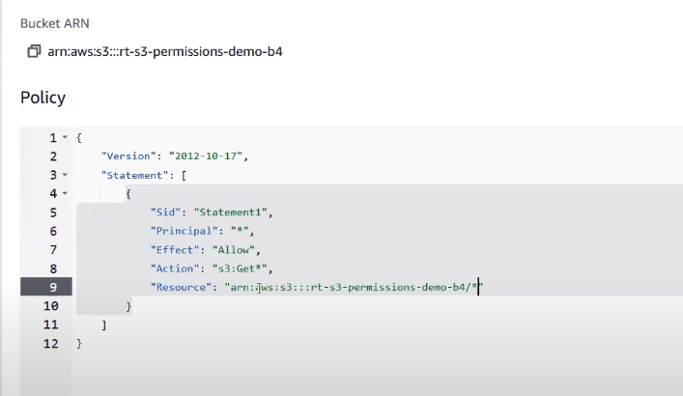

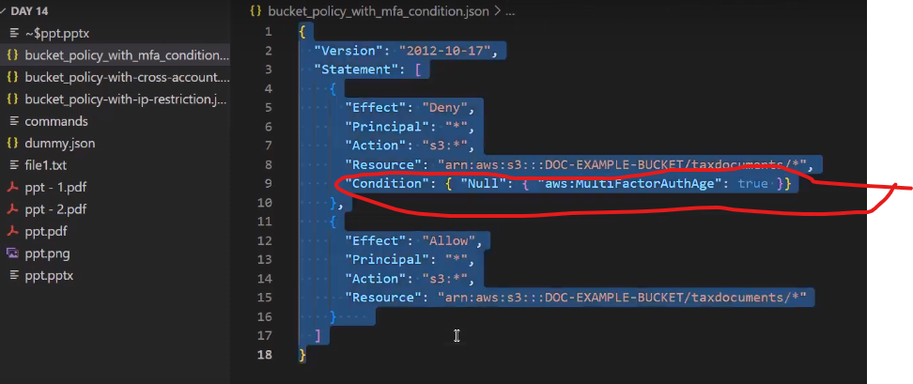

**Bucket policy with mfa condition**

* **Access gets denied only if mfa value is null**

**Cross act bucket access Demo**

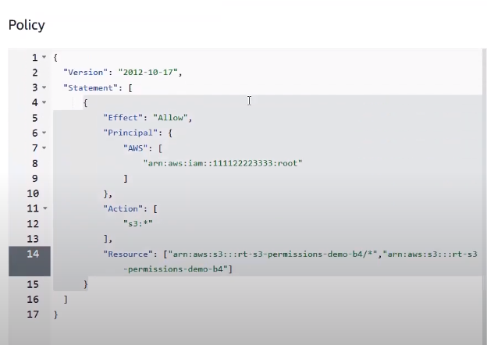

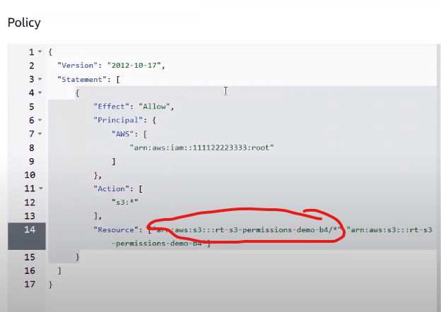

**Marked one need to be replaced and root act need to be replaced**

**And check whether cross act is accessible to s3 or not**

**. To access s3 in cross account you need to take one of the bucket url and replace the bucket name in that particular url that’s a cheet code**

* **Using cloudshell u can access s3 cross account**
* **In cross act open cloud shell and and type the command aws s3 ls s3://bucket arn**
* **Ip based condition demo allowing only 1 ip and rest ips action should be denied**
* {
* "Version": "2012-10-17",
* "Statement": [
* {
* "Action": "s3:GetObject",
* "Effect": "Deny",
* "Resource": [
* "arn:aws:s3:::DOC-EXAMPLE-BUCKET",
* "arn:aws:s3:::DOC-EXAMPLE-BUCKET/*"
* ],
* "Condition": {
* "NotIpAddress": {
* "aws:SourceIp": [
* "11.11.11.11/32"
* ]
* }
* },
* "Principal": "*"
* },
* {
* "Action": "s3:*",
* "Effect": "Allow",
* "Resource": [
* "arn:aws:s3:::DOC-EXAMPLE-BUCKET",
* "arn:aws:s3:::DOC-EXAMPLE-BUCKET/*"
* ],
* "Principal": "*"
* }
* ]
* }

**In the above code concept is only for that particular bucket access should be allowed only for that particular ip address if not denied**

* **All the bucket policy and block public access is blocked still u can give temporary access through presigned url’s**
* 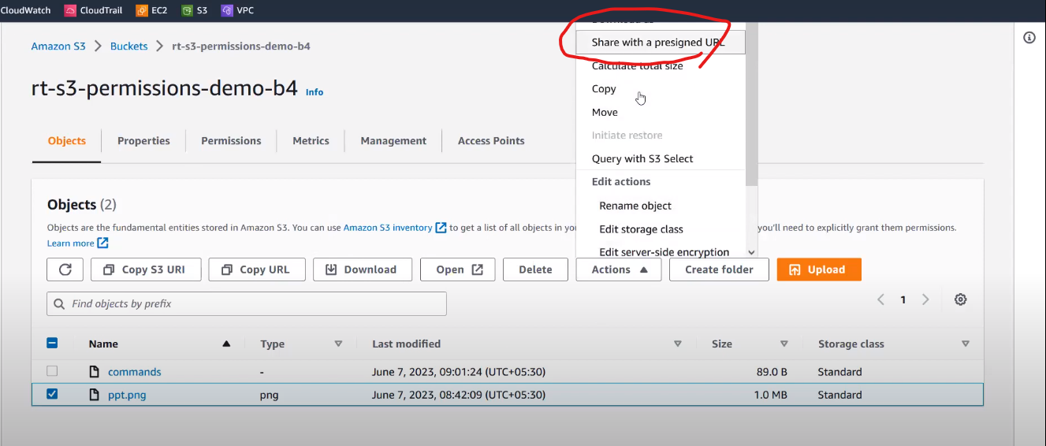

**Click on that and set the timings of that particular object till how much time it should be public**

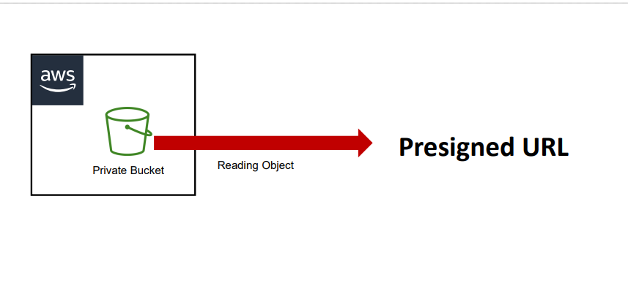

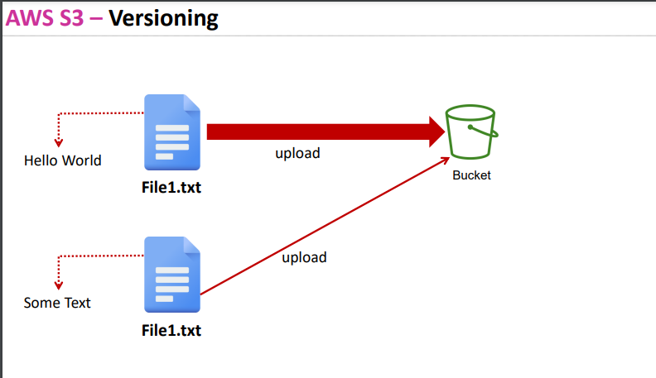

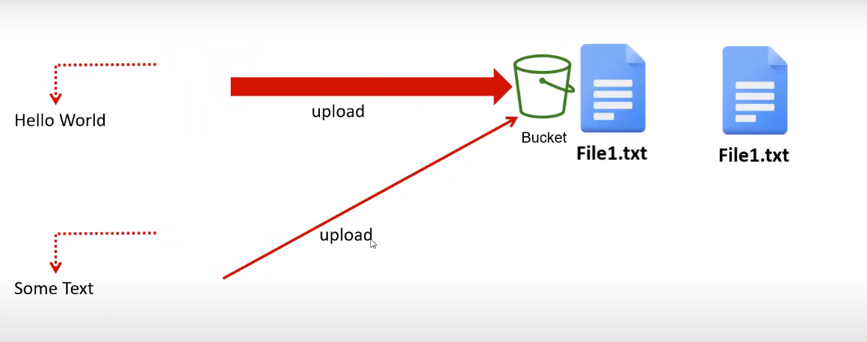

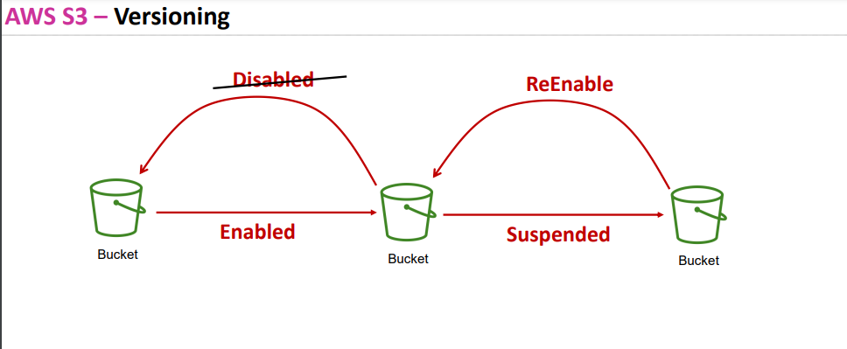

**Imp question After creating versioning even after deleting that particular file your file wont get deleted aws will add some delete marker to that particular file**

* **If you want to delete it permanently again on that particular file click on actions delete – permanently**
* **Once you suspend the version again you will get null versions and when ever u upload the same file again recently added file gets over rided**
* **And previous versions will be there as it is**
* **Imp Question And for deleting files you can maintain security by enabling MFA Authentication for modifying MFA DELETE Settings use aws cli ,AWS SDK,or amazon S3 Rest Api**
* **By maintaining this security only after Giving Multi factor authentication you can delete the file**